Term: Autumn
Subject: DT – Sewing / Textiles
Unit: Christmas decorations
LO/SC | Knowledge organiser
LO: To explore and investigate a range of existing products.  I can investigate a range of Christmas tree decorations  I can sketch my favourite decoration  I can explain its function, and why I like it  I can comment on the intended audience  I can comment on any noticeable symbolism  I can consider how it has been made (including reinforcement)  Challenge: I can identify a decoration, which I do not like and give reasons why | Vocabulary  Sketch - a rough or unfinished drawing or painting, often made to assist in making a more finished picture  Function - an activity that is natural to or the purpose of a person or thing  Intended audience - Intended audience is defined as the group of people for which a service or product is designed.  Symbolism - the use of symbols to represent ideas or qualities.  Reinforcement – the action or process of reinforcing or strengthening.  Symbolism at Christmas  https://www.twinkl.co.uk/resource/t2-t-72347-ks2-symbols-of-christmas-information-powerpoint  - https://www.lifewithgremlins.com/christmas-symbols-meanings/
LO: To use a wider range of tools and equipment to perform practical tasks (joining and finishing).  I can remember how to use running stitch and back stitch  I have experimented with blanket stitch  I have experimented with overstitching  I know what a seam allowance is and can explain its importance  I can tried joining different materials  I can give reasons why different needles may be used  Challenge: I can attach simple applique decorations, e.g a button or sequin | Running stitch  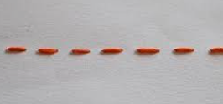  Back stitch  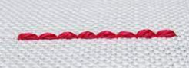  Blanket stitching  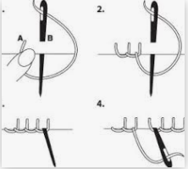  https://www.youtube.com/watch?v=p-_P3ETtbDc  Overstitching  https://www.youtube.com/watch?v=GUT2VPVMy3E  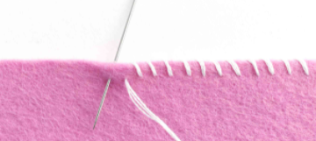
LO: To generate, develop, model and communicate their ideas through discussion, annotated sketches and pattern pieces.  I can follow the design criteria to create a number of designs which are innovative, functional, appealing products that are fit for purpose that are aimed at particular individuals or groups  I can produce an annotated diagram of my chosen idea  I can produce pattern pieces on tracing paper  I can modify my design and pattern pieces if the need arises  Challenge: I can record any issues / modifications that arise on my diagram. | Vocabulary  Innovative – an original design  Functional – havng a special activity, purpose or task.  Appealling – attractive or /and interesting  Pattern pieces – Templates are a shaped piece of rigid material used as an outline for processes such as cutting out, shaping, or drilling. Patterns are a template used in sewing, from which the parts of a garment are traced onto fabric before being cut out and then put together; they are usually made of paper.  Modify – improve / build on original  Annotated diagrams:  PLEASE ADD A GOOD EXAMPLE FROM ONE OF YOUR STUDENTS
LO: To apply their understanding of how to strengthen, stiffen and reinforce more complex structures.  I can explore appropriate methods to strengthen, stiffen and reinforce  I can record which method I will use  I can explain my choice  Challenge: Give reasons why other methods have not been selected | Vocabulary  Strengthen – In the mechanics of materials, the strength of a material is its ability to withstand an applied load without failure or plastic deformation.  Stiffen – Stiffness is the rigidness of any object or material.  Reinforce – to give added strength or support  - Explore using types of card, layers of material and stuffing.
LO: To select from and use a wider range of materials and components, according to their functional properties and aesthetic qualities.  I can select textiles for their functional and aesthetic qualities  I can use a wider range of components to add to the overall aesthetics  I can accurately measure, mark out, cut and shape materials and components  I can pin and tack material pieces together (with support if needed)  I can accurately assemble, join and combine materials and components  I have produced a clearly identifiable Christmas tree decoration  Challenge: Demonstrate resilience when tackling problems | Vocabulary  Component – a part or element of a larger whole  Aesthetic qualities – refers to the overall visual effects of the design  Pin and Tack – hold materials in place with pins – tacking is loose stitches to hold materials in place which are then removed.  Applique –sewing technique in which fabric patches are layered on a foundation fabric, then stitched in place by hand or machine with the raw edges turned under or covered with decorative stitching.  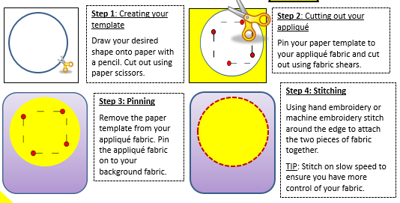  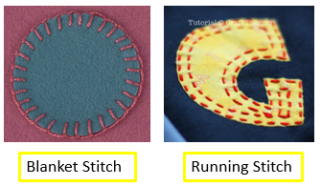  Embellishments - a decorative detail or feature added to something to make it more attractive: Sequins, beads, buttons, ribbons.  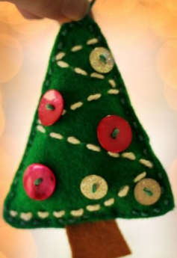  Seam allowance:  Seam allowance is the area between the fabric edge and the stitching line on two pieces of material being sewn together.  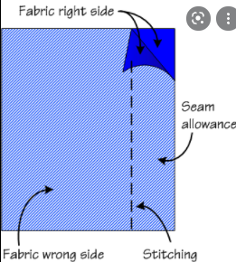  Measure and cut accurately to 1cm.  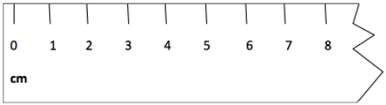
LO: To evaluate their ideas and products against the design criteria.
I can use the design criteria to evaluate my product
I can identify the strengths of my decoration
I can identify the areas of development for my product
I can explain what I would do differently if the chance arose
Challenge: Consider the views of others when evaluating my product

