Term: 3 (Summer)
Subject: DT
Unit: Resistant Materials (Woodwork)
LO/SC | Knowledge organiser
LO: To investigate and analyse how products are made  I can suggest how products have been made  I can discuss the functionality and aesthetics of materials and methods of construction  I can show how products have been made through sketches and annotations  Challenge: I can make suggestions on how the manufacture of products could be improved | Key Vocab:  Functionality – ability to suit its purpose  Aesthetics – The look of a product, taking into account shape, form, colour etc.  Construction – how something is made  Manufacture – The making of a product on a large scale using machinery
LO: To understand that mechanical systems have an input, process and output  I know what an axle is and does  I can identify the purpose of parts involved in axles  I can use the terms input, process and output correctly when explaining how axles work  Challenge: I can accurately draw and label an axle mechanism | Axle – the rod or shaft that rotates the wheel (s) on vehicles.  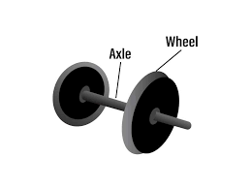  Axle mechanism –  https://www.youtube.com/watch?v=q7c2j2MzD_E  Input – push the axle  Process – axle rotates  Output – wheels rotate and the vehicle moves  Rotary Motion – moving in a circle, e.g. a bicycle wheel
LO: To understand and use electrical systems in my product [for example, series circuits incorporating switches, bulbs, buzzers and motors]  I can propose realistic suggestions as to how to achieve new design criteria  I can create a simple circuit to add an upgrade to the chariot  I can use the terms input, process and output correctly when explaining how the circuit works  I can suggest ways to attach the circuit to the structure  Challenge : To present upgrade through sketches and notes | Circuits (linked to KO for Science) 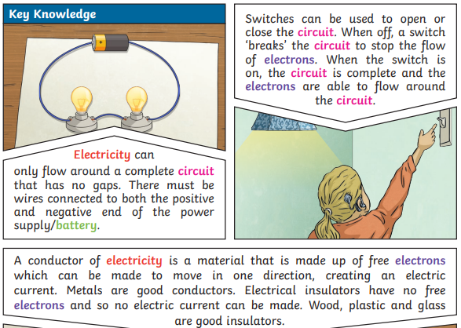  Power supply – battery  Componenets – bulbs / buzzers  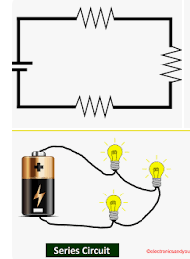  Connecting wires – conductors  Series circuit - A series circuit comprises a path along which the whole current flows through each component.
LO: To make strong, stiff shell structures  I can explain the need for a strong, stiff shell  I can explore ways use card to strengthen the structure  I can suggest other ways in which my product could be reinforced  Challenge: I can choose materials based on their functionality and aesthetic qualities and explain my selections | Shell structure – where the whole structure holds itself together, e.g egg boxes, aeroplane fuselage….  Frame structure – constructed from individual pieces linked together to create a strong unit, e.g. climbing frame, pylon etc.  Strong - physical property of a material. Strength is the ability of an object to resist deformation when stress is applied  Stiff - physical property of a material. Stiffness is the ability of an object to withstand stress without breaking.  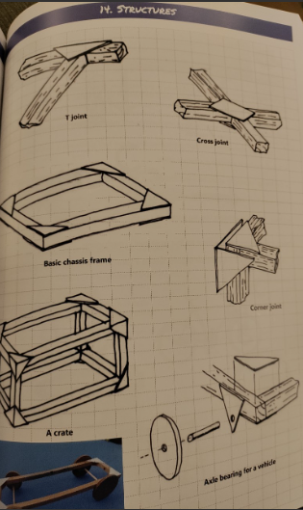  Reinforcement ideas: Triangulation – triangles are the strongest frame shape and architects and designers more often than not build triangular shapes into their structures (roof trusses, dock side cranes, pylons, farm gates, step ladders, bicycles frames…etc.  (use lollipop sticks and paper fasteners to demonstrate the strength of the triangle)  Curved structures (domes and arches)– used in architecture since ancient times as they are a strong shape. Taj Mahal, Igloos, mosques, temples, bridges etc…  Jinx system – using card triangles to create a frame.
LO: To model and communicate ideas of final design in an orthographic projection  I can draw the front view of my product  I can draw the side view of my product  I can draw an aerial view of my product  I can annotate drawings to explain my design choices  Challenge: To draw projections to scale | 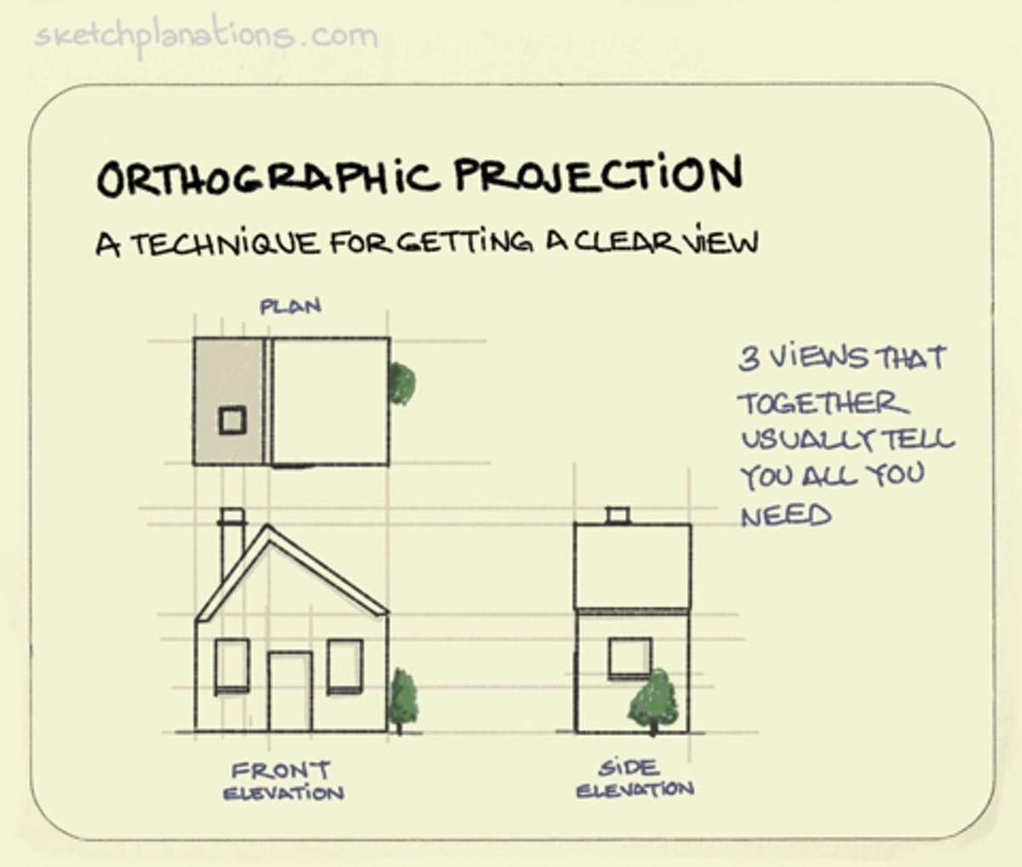  Orthographic projection:  To scale: 1cm : 1cm
LO: To measure, mark out, cut and shape materials and components with some accuracy
I can use a ruler to accurately measure and mark the pieces for my product
I can safely, and accurately use a handsaw to cut to the nearest 1cm
Challenge: I can make adjustments to my work, as the need arises
LO: To use design criteria to evaluate my completed product
I can evaluate my product against the design criteria
I can identify areas of strength and weakness in my work
I can specify how my product meets the needs of the user
I know what I would do differently, if I did the project again
Challenge: Explain how I would adapt my design for a specific/alternative audience

