Term: Spring
Subject: DT
Unit: Sewing – Personal shield
LO/SC | Knowledge organiser
LO: To carry out research to develop design criteria  I can identify specific symbols used and explain why they have been chosen  I can consider how to make designs original  I can consider how to appeal to different audiences  Challenge: Consider which design is most effective and why | Vocabulary  Heraldry – Heraldry is about showing people who you are. In England it started in the later 1100s, when knights began to wear helmets which covered their faces, and they couldn't be recognised. So they began to paint unique combinations of colours, shapes and animals, called their 'arms', on their shields and banners. Only one person was allowed to use these arms, so when people saw a knight wearing them in a battle or tournament, they could tell who he was.  Coat of arms – coat of arms, the principal part of a system of hereditary symbols dating back to early medieval Europe, used primarily to establish identity in battle. Arms evolved to denote family descent, adoption, alliance, property ownership, and, eventually, profession.  Sheild - symbolic of the importance of the family coat of arms.  https://www.twinkl.co.uk/resource/t2-t-16425-ks2-tudor-shields-information-powerpoint  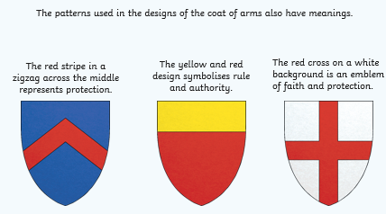  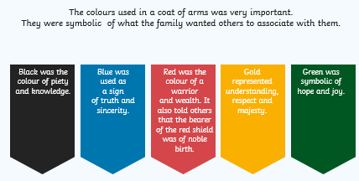
LO: To select from and use a wider range of tools to perform practical tasks accurately  I can use a range of stitching  I can attach applique decorations  I can attach a button  Challenge: Explore different sized needles and threads and explain when each is more suitable | Running stitch –  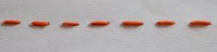  Back stitch –  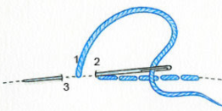  Blanket stitch –  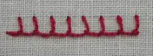  Overstitch –  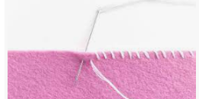  Cross Stitch – https://www.youtube.com/watch?v=wOK48Z7u0WA  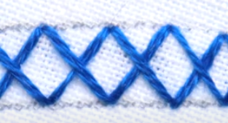  Applique – sewing technique in which fabric patches are layered on a foundation fabric, then stitched in place by hand or machine with the raw edges turned under or covered with decorative stitching.  Attaching a button - https://www.youtube.com/watch?v=8mIGGn3AS1E
LO: To generate, develop, and communicate my ideas through computer-aided design  I can produce a mood board about myself  I can explain my choices  Challenge: Identify others from their mood boards and explain reasons behind choices | Mood board –  A moodboard is a visual ool that communicates our concepts and visual ideas. It is a well thought out and planned arrangement of images, materials, pieces of text, etc. that is intended to evoke or project a particular style or concept. It can include just about anything — photography, designs or illustrations, color palettes, textures, descriptive words — anything that helps you define the direction of your project.
LO: To generate, develop, and communicate my ideas through discussion, annotated sketches and exploded diagrams.  I can follow the Success Criteria to sketch and model some designs for my personal shield  I can use elements from my mood board and explain my choices  I can develop my chosen idea in depth  Challenge: I can produce an exploded diagram | Exploded diagram – Exploded views show how the component parts of a product relate to each other. These are widely used to support the assembly of products, for maintenance activities and when building flat pack furniture at home. Producing an exploded view develops drawing skills, whilst simultaneously allowing concepts such as dimensions, proportion and scale to be introduced in a practical context.  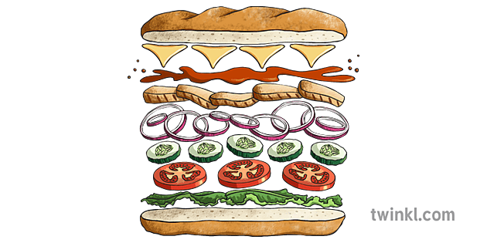  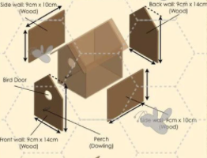
LO: To evaluate my ideas against design criteria and consider the views of others to improve my work.
I can identify where my design meets the Design Criteria
I can identify which areas of the Design Criteria my design does not fully meet
I can give suggestions to others about how they could improve their designs
I can act upon the advice given by others to adapt my design
Challenge: Can explain why I did or did not accept the advice given to me, using vocabulary appropriate to the project

LO: To create a prototype for my project  I can transfer pattern onto (tracing) paper  I can cut pieces accurately  I can assemble the pattern pieces to recreate the design  Challenge: To make modifications to match design brief if the need arises | Vocabulary  Pattern pieces - Patterns are a template used in sewing, from which the parts of a garment are traced onto fabric before being cut out and then put together; they are usually made of paper.
LO: TO create and evaluate my final product  I can use my pattern pieces to create the final product  I can use a range of stitches for joining and aesthetic purposes  I can include elements of applique and attach them at the correct stage in the making process  I can honestly evaluate my product, referring to the skills I have used / improved on / need to be better at  Challenge: How would the design need to be adapted for a different family member / friend? | Running / back / over / blanket /cross  Attach to pieces prior to conneting the piece to the main shield.  Creative design, measuring, stitching for joining and decoration(accuracy and range), making modifications off of the advice of others…

