Term: Autumn
Subject: DT
Unit: Woodwork – Moving Toys
LO/SC | Knowledge organiser
LO: To research how cam mechanisms work  I can identify the parts of a mechanism  I can explain the function of each part  I can compare how different cams effect movement  Challenge: Communicate preferences over cam choices, giving reasons | Vocabulary  Cam - A cam is a rotating or sliding piece in a mechanical linkage used especially in transforming rotary motion into linear motion  Pivot – the hole in the cam  mechanisms - a system of parts working together in a machine  function - what a given entity does  Cam mechanisms:  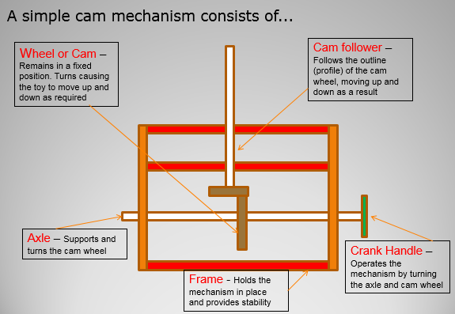  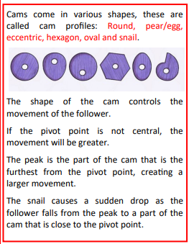
LO: To apply knowledge of existing products to the design process  I can investigate products / images to collect ideas and create own design criteria  I can consider audience and show their impact on design  I can communicate ideas through cross sectional and exploded diagrams using the correct vocabulary appropriate to project  EXT: To create a design involving more than one moving part |   Cross sectional diagram:  A cross-section shows the shape of a feature (such as a mountain)  viewed from the side, as if cut through with a knife.  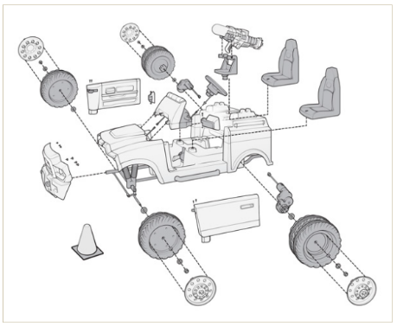  Exploded diagram:  Exploded diagrams show how a product can be assembled and how the separate parts fit together, with dotted lines showing where the parts slide into place
LO: To accurately measure and mark out materials and components  I can use a given unit of measure  I can mark the wood correctly and neatly  I can consider if the measures given are reasonable  Challenge: I can record the steps that I have taken | Measure to accurately to the nearest mm  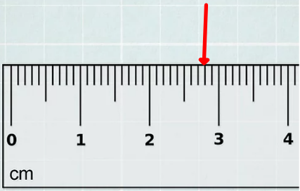
LO: To accurately assemble, join and combine materials and components  I can cut accurately and safely  I can create a framework to support a mechanism  I can fix the parts together correctly (according to my design)  I can consider how to strengthen and reinforce the joins / structure  I can use mechanical systems such as cams, pulleys and gears.  Challenge: To produce a poster about safety when working with wood | 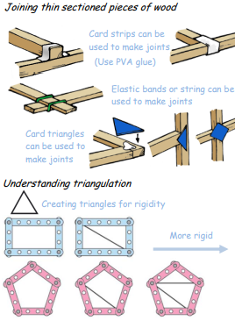  Strengthening and reinforcing joints…
LO: To design innovative, functional, appealing products that are fit for purpose and that are aimed at particular individuals or groups  I can consider my audience and how this impacts my design  I can create a moving part, which is proportional to the frame  I can accurately apply a range of finishing techniques to ensure the product is aesthetically pleasing  I can justify decisions about materials and methods of construction  Challenge: I can record the steps that I have taken using the correct vocabulary appropriate to project | Vocabulary  Innovative – an original design  Functional – havng a special activity, purpose or task.  Proportional – corresponding in size to something else / other parts  Finishing techniques – techniques applied to product to create final look- sanding / varnishing / painiting / decorating etc
LO: I can evaluate the successfulness of my product and that of another.
I can refer back to my Design Success Criteria
I can identify what went well with my product
I can identify weaknesses in my product
I can give reasons for my thoughts
I can make suggestions on what I would do differently next time, and which skills I need to work on
I can use the correct vocabulary appropriate to project
EXT: Critique a peer’s product.

