Term: Summer Term
Subject: DT
Unit: Food Technology : Veggie Burgers
LO/SC | Knowledge organiser
LO: To understand and apply the principles of a healthy and varied diet.  I know what constitutes a healthy balanced diet  I can identify food groups  I can explain what nutritional value these ingredients have  I can explain how vegetarians receive all the nutrition they need without eating meat. | What is a healthy, balanced diet?  Eating a healthy, balanced diet is an important part of maintaining good health, and can help you feel your best.  This means eating a wide variety of foods in the right proportions, and consuming the right amount of food and drink to achieve and maintain a healthy body weight.  Food groups:  Carbohydrates – Carbohydrates are broken down by the body into simple sugars. These sugars circulate in the bloodstream and are used by the body's cells for energy. The brain also uses one of these simple sugars (glucose) as its primary energy source. This is why children need carbohydrates to stay alert and active throughout the day.  Proteins – Protein is essential for building, maintaining, and repairing the tissues in our body. As well as providing us with protein, these foods contain other essential nutrients.  Fruit & Veg – Fruit and vegetables are a good source of vitamins and minerals, including folate, vitamin C and potassium. They're an excellent source of dietary fibre, which can help to maintain a healthy gut and prevent constipation and other digestion problems. A diet high in fibre can also reduce your risk of bowel cancer.  Dairy – Milk and dairy products are an important part of a young child's diet. They're a good source of energy and protein, and contain a wide range of vitamins and minerals, including calcium. These will help young children build bones and keep teeth healthy.  Fats - Fat helps a kid's body grow like it should. Fats fuel the body and help absorb some vitamins. They also are the building blocks of hormones and they insulate the body.  Vegetarians – Can still access all food groups.  - Dairy or dairy alternatives are needed for calcium. ...  - Eat beans, pulses, eggs and other sources of protein.  Useful resources:https://www.foodafactoflife.org.uk/3-5-years/healthy-eating/eatwell-guide/  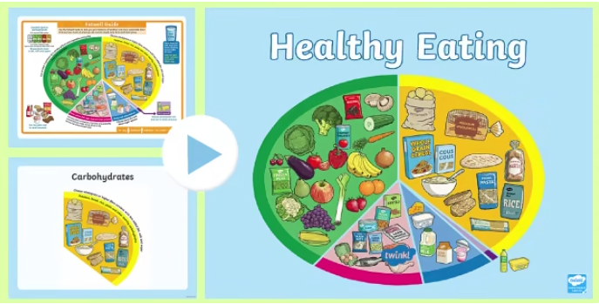
LO: To use a range of tools and techniques such as peeling, chopping, slicing, grating and mixing.  I can correctly identify a range of kitchen tools  I can cut and shape ingredients using a range of tools  I can use a range of tools safely  I can produce evenly sized pieces using different techniques: chopping, slicing, grating, dicing, julienne | Chop – cut something into pieces  Slice– a thin piece cut from a larger portion  Grate – reduce (food) to small shreds by rubbing it on a grater  Peel – remove the outer covering or skin from (a fruit or vegetable)  Dice – small cubes of food  Julienne – cut (food) into short, thin strips  Brunoise – a mixture of finely diced vegetables fried in butter  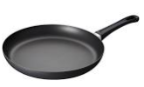  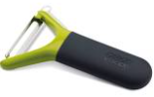  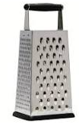  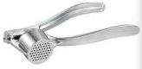  
LO: To investigate and analyse vegetarian ingredients  I can try new flavours  I can share my likes and dislikes  I can explain my likes and dislikes  I can use correct vocabulary appropriate to the project: bitter, sweet, sour, sharp, powdery, chewy, perfumed, lumpy, smooth etc.  I can identify flavour combinations that would appeal to others | Flavour combinations: matching foods together which create a beneficial / delectable flavour  Bitter - a sharp, pungent taste or smell; not sweet.  Sweet - the pleasant taste characteristic of sugar or honey  Sour – an acidic taste like lemon or vinegar  Earthy – suggestive of the earth or soil  Spicy – flavoured with or perfumed with a spice  Perfumed – the aroma of the ingredient  Smooth – an even consistency; without lumps  Lumpy – a lumpy consistency  Stringy – containing tough fibres, so hard to eat  Crunchy – makes a sharp noise when bitten or crushed  Soft –  Hard -  Zesty – full of flavour  Juicy – contains a lot of juice and is enjoyable to eat  (These words may be useful. Children are not expected to learn and use all of these; this is just a guide).
LO: To adapt a recipe, knowing it may change the appearance, taste, texture and aroma.
I can work as part of a group, sharing my ideas and listening to others
I can read a recipe
I can identify and investigate unknown vocabulary
I can share and clarify ideas through discussion
I can record how ingredients may alter the product
I can comment on portion sizes and the impact on a diet, once changes have been decided
LO: To prepare and cook a dish safely and hygienically, with the use of a heat source.  I can work as part of a team  I can follow a recipe, innovating where necessary  I can make adjustments should the need arise and record these.  I can use a range of skills to prepare ingredients safely  I can join and combine a widening range of ingredients appropriately, e.g beating, rubbing in…  I can explain how to work safely and hygienically, specifically referencing the precautions required when working with heat sources. | Hygienically – conditions or practices conducive to maintaining health and preventing disease, especially through cleanliness.  Innovating – introducing new ideas / elements  Combine – mixing multiple ingredients  Precautions to take when BBQing:  Safety zone around the BBQ  Locate away from structures and low hanging plants  Stop, Drop and Roll procedure known incase clothing was to catch fire  Discuss acceptable behaviour  Fire extinguishers / water buckets on hand  Cleanliness of equipment  Adults to cook / BBQ  Long hair must be tied back ..etc
LO: To test, critique and evaluate own ideas and products, and the work of others.  I can comment on taste, texture, aroma and appearance of my product  I can critique the making process, identifying what went well and what did not  I can explain how I overcame problems that arose  I can make suggestions on how my design (and designs of others) could be improved | Critique – evaluate practice in a detailed and analytical way

