Term: Autumn
Subject: DT
Unit: Food Tech – Wartime Stews
LO/SC | Knowledge organiser
LO: To understand how seasonality, locality and rationing would apply to the principles of nutrition and healthy eating (related to rationing)  I understand how seasonality can affect the availability of produce  I know the importance of using local produce, particularly during war-time  I understand the impact of rationing on nutrition and healthy eating  Challenge: To explain how people continued to eat healthy nutritious meals during the war, despite rationing | Vocabulary  Seasonality – different foods grow better at different times of the year and therefore have better availability at certain points.  Locality - Local means existing in or belonging to the area where you live, or to the area that you are talking about. So things grown / produced / reared in the local area.  Rationing – Rationing was a means of ensuring the fair distribution of food and commodities when they were scarce. It began after the start of WW2 with petrol and later included other goods such as butter, sugar and bacon. Eventually, most foods were covered by the rationing system with the exception of fruit and vegetables.  Why was local produce important during the war?  When supply ships coming into the country were  targeted by German bombers and the possibility of invasion or isolation became a reality, it became  necessary for Britain to conserve as much food as possible. People needed to become more creative with the supplies they had and began to grow more of their own food. The ‘Dig for Victory’ campaign was set up during WWII by the British Ministry of Agriculture. Men and women across the country were encouraged to grow their own food in times of harsh rationing. Open spaces everywhere were transformed into allotments, from domestic gardens to public parks – even the lawns outside the Tower of London were turned into vegetable patches.  What was the impact of rationing on nutrition and healthy eating?  As a result of rationing and an increased focus on fruit and vegetables being included in the diet, the population's health by and large improved considerably during these years, as there was more reliance on vegetables and less meat in their diets.
LO: To carry out research using surveys, interviews, questionnaires and web-based resources
I can design a way to gather information
I can collect information about people’s preferences
I can use the internet to inform and support my work
Challenge: To draw informed conclusions from research

LO: To use computer-aided design to develop and communicate ideas  I can use previous research to inform my work  I can model my ideas pictorially  I can create a recipe for a stew  Challenge: To justify the choices made | 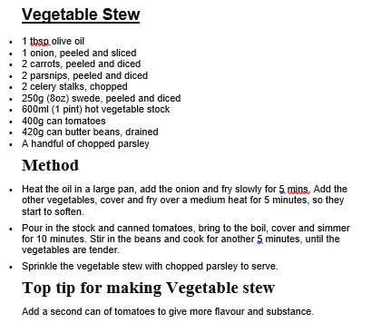  NB. We will be using slow cookers to cook the stews, ensure children understand how these work.
LO: To know how to prepare, cook and store a product safely and hygienically  I know how to prepare chosen ingredients  I know how to cook chosen ingredients  I know what happens to ingredients during the cooking process  I understand and can explain the importance of storing ingredients and the finished product correctly  I can identify the possible hygiene risks throughout the process  Challenge: To produce a risk assessment for making the product (Stew) | - Prepare ingredients by making sure hands are thoroughly washed and equipment and working surface is clean  - Wash all produce under slightly warm running water.  Peel and trim  Slice / chop / grate / julienne / dice / crush etc.  Cook by boiling, sauteeing, etc – time to discuss the use of slow cooker.  During the cooking process food breaks down some of its fibers and plant cell walls, making it easier for the body to digest and absorb the nutrients ( 17 ). Cooking also generally improves the taste and aroma of food, which makes it much more enjoyable to eat.  Some foods need to be kept in the fridge to help slow down germs' growth and keep food fresh and safe for longer.These are foods marked with a "use by" date and "keep refrigerated" on the label, such as milk, meat and ready meals.  Cool down leftovers as quickly as possible (within 2 hours), store them in the fridge and eat them within 2 days.  No food lasts forever, how ever well it is stored. Most pre-packed foods carry either a "use by" or a "best before" date.  "Use by" dates appear on foods that go off quite quickly. It can be dangerous to eat foods past this date.  "Best before" dates are for foods with a longer life. They show how long the food will be at its best.  Food can look and smell fine even after its "use by" date but that does not mean it's safe to eat. It could still contain bugs that could make you ill.  Eating food past its "best before" date is not dangerous, but the food may not be good quality.  You can freeze pretty much everything, Anything with a high water content like strawberries and tomatoes will go squishy but are still fine to cook with.  Place food in an airtight container or wrap it tightly in freezer bags or similar before placing in the freezer otherwise th cold air will dry it out.  - cool leftovers as quickly as possible, ideally within 2 hours  - divide leftovers into individual portions and refrigerate or freeze  - use refrigerated leftovers within 2 days  - when reheating food, make sure it is heated until it reaches a temperature of 70C for 2 minutes, so that it is steaming hot throughout  - always defrost leftovers completely, either in the fridge or in the microwave  - when defrosted, food should be reheated only once, because the more times you cool and reheat food, the higher the risk of food poisoning
LO: To prepare and cook a range of predominantly savoury dishes using a range of cooking techniques  I can select appropriate tools for the task of preparing ingredients  I can use tools safely  I can use a range of techniques: cutting, slicing, dicing, grating, peeling, crushing, boiling, sautéing, simmering etc  I am aware of the dangers involved with using a heat source and do so carefully  Challenge: To record the making process in an engaging way, using knowledge to produce detailed lists of ingredients / components / materials and tools | Tools:  Grater Knife Peeler Press Slow cooker  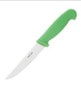  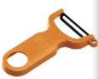  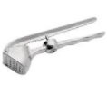  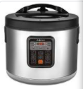    Camping stove  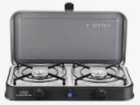  Techniques:  Slicing – cut something into slices  Chopped – cut, at most, into about ¼ inch chunks  Dicing – Dicing is a culinary knife cut in which the food item is cut into small blocks or dice. This may be done for aesthetic reasons or to create uniformly sized pieces to ensure even cooking. ... Dicing usually applies to vegetables prepared in this way  Julienne – the French name for a method of cutting vegetables into thin strips.  Grating – The process of transforming solid, firm food items into small pieces by rubbing the item against a grating instrument.  Crushing – Crushing refers to the pressing, grinding, or pounding of an item into smaller particles, a powder, or a paste.  Sautéing – To sauté is to cook food quickly in a minimal amount of fat over relatively high heat.  Simmering – (of water or food that is being heated) stay just below boiling point while bubbling gently.  Boiling – the cooking of food by immersion in water that has been heated to near its boiling point  Frying – the cooking of food in hot fats or oils, usually done with a shallow oil bath in a pan over a fire or as so-called deep fat frying, in which the food is completely immersed in a deeper vessel of hot oil.  Correct knife grip – thumb and forefinger at the back of the knife, rest of fingers wrapped around it.  Heat source hazards  Pot handles – towards the back so they can’t be knocked, not over a heat source.  Risk of burning on heat source  Risk of burning from cooked materials  Loose materials (clothing and tea towels) catching fire  Spitting – when frying or sauteing
LO: To evaluate ideas and products against original design specification
I can participate in a taste test
I can record my thoughts about taste, texture and appeal
I can critically assess if the design brief has been achieved
I can make realistic suggestions on how to improve the product, within the context given
Challenge: To consider how to produce a sweet course, with the same constraints

