Term: Spring
Subject: DT
Unit: Sewing – Gadget case
LO/SC | Knowledge organiser
LO: To apply understanding of seam allowances to create a case  I can make a case for a rubber.  I have included an appropriate seam allowance.  I can explain why a seam allowance is needed  I have used an appropriate stitching method.  Challenge: Record ideas step by step | 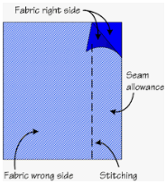  Seam allowance:  is the area between the fabric edge and the stitching line on two (or more) pieces of material being sewn together. This can be hidden if the sewn items are then turned inside out, making a hidden join. It means that the stitching will not be too close to the edge, which can sometimes lead to a breakage in the material.  Stitching methods (as with Year 5): higher expectation on accuracy and evenly sized stitching.  Running stitch –  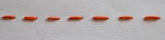  Back stitch –  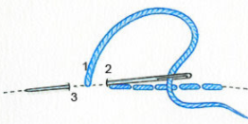  Blanket stitch –  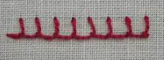  Overstitch –  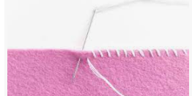  Cross Stitch – https://www.youtube.com/watch?v=wOK48Z7u0WA  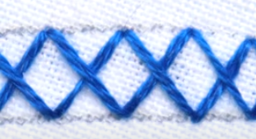
LO: To generate and develop ideas  I can consider the needs, wants and values of a target audience  I can collect ideas in a range of formats  I can present ideas clearly  Challenge: To design for a teenage spy | Values: things you believe are important to the way you live and work. They determine your priorities:  Target audience:  A particular group at which a product is aimed, e.g children, male teenagers, football fans…etc
LO: To investigate and analyse existing products  I can say how well products have been designed  I can say how well products have been made  I can suggest why materials have been chosen  I can identify which methods of construction have been used  I can comment on how well the products work and achieve their purpose  Challenge: Consider how sustainable the materials used are | Methods of construction: gluing, sewing, moulding, welding.  Welded = join together (metal parts) by heating the surfaces to the point of melting with a blowpipe, electric arc, or other means, and uniting them by pressing, hammering, etc.  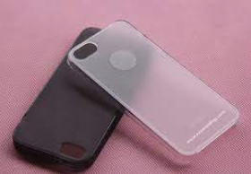  Moulded =  Sustainability:  Sustainability means meeting our own needs without compromising the ability of future generations to meet their own needs.  Sustainable materials:  materials used throughout our consumer and industrial economy that can be produced in required volumes without depleting non-renewable resources. For a product to be sustainable, it must be possible to produce and/or consume it in a way that doesn't result in harm or destruction. If the production of a product requires nonrenewable resources, damages the environment, or results in harm to individuals or society, it is unlikely to be considered sustainable.  e.g. bamboo; wood; hemp; wool; linen; straw; clay, stone, sand; beeswax; and coconut.
LO: To investigate and analyse fastening methods  I can evaluate a number of fastenings  I can comment on aesthetic and functional attributes of fastenings  I can sew a button and create a loop  I can attach smaller fastenings (such as a popper or hook and eye)  I can record my findings clearly  Challenge: To explain preference and justify choice | Fastenings: a device that closes or secures something.  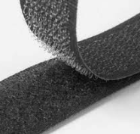  - Velcro – a fastener for clothes or other items, consisting of two strips of thin plastic sheet, one covered with tiny loops and the other with tiny flexible hooks, which adhere when pressed together and can be separated when pulled apart.  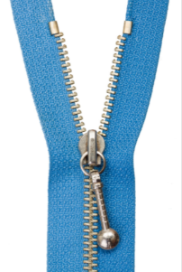  Zip - a device consisting of two flexible strips of metal or plastic with interlocking projections closed or opened by pulling a slide along them, used to fasten garments, bags, and other items.  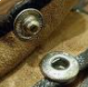  Snap fastener (popper) - a pair of interlocking discs, made out of a metal or plastic, commonly used in place of traditional buttons to fasten clothing and for similar purposes. A circular lip under one disc fits into a groove on the top of the other, holding them fast until a certain amount of force is applied.  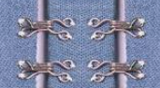  Hook and eye closure -  consists of a metal hook, commonly made of flattened wire bent to the required shape, and an eye (or "eyelet") of the same material into which the hook fits.  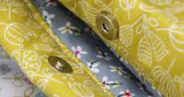  Magnetic clasps - They are easy to hook together because the magnets are attracted to each other but they won't come apart easily because the magnets are so strong. This could be done with magnetic strips too. As long as the North and South poles are facing each other they will snap / attract and close.  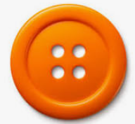  Button - a fastener that joins two pieces of fabric together by slipping through a loop or by sliding through a buttonhole.
LO: To generate, develop and communicate ideas through discussion, annotated sketches, cross-sectional and exploded diagrams.  I can create designs with a specific person in mind  I can explain design choices I have made  I can communicate my designs through sketches and/or diagrams  I can decide on a final design  I know the measures of my chosen gadget  I have taken in to account the measures of my chosen gadget and have shown the effect on my design  Challenge: Use maths skills to produce orthographic diagram | Orthographic diagram: is used to represent a three-dimensional object through multiple two-dimensional views. Usually three views of a drawing give enough information to make a three-dimensional object. These views are known as front view, top view and end view.  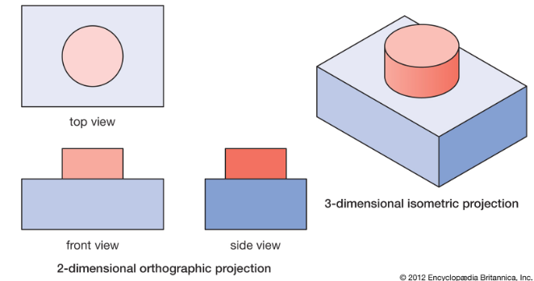
LO: To develop a prototype
I can measure accurately
I can problem solve when the need arises
I can use pins to show where joining will occur
I can model my idea through a successful prototype
Challenge: I can make adaptation to my design as the need arises
LO: To select from and use a wide range of materials according to their functional and aesthetic purposes.  I can accurately measure, mark, cut and shape materials and components  I can accurately assemble, join and combine materials and components (pin and tack pieces together)  I can use a range of joining and finishing techniques  I can demonstrate resourcefulness when tackling practical problems  Challenge: To clearly formulate step-by-step plans as a guide to making with detailed lists of ingredients / components / materials and tools | Components: parts or element of a whole  Pin and tack:  to sew quick, temporary stitches that will later be removed. Tacking is used for a variety of reasons, such as holding a seam in place until it is sewn properly, or transferring pattern markings onto the garment.  Stitches: (see above)  Glue Gun  Health & Safety -  Students must be taught:  - About the risk of burns from the glue gun itself and hot melted glue (including residual heat risk);  - The first aid actions to take in the event of a burn;  - The importance of placing the glue gun in a proprietary stand;  - Not to engage in horseplay when using glue guns.  Teaching staff must have completed a risk assessment prior to using the glue guns with children.  Attaching a button:  https://www.google.com/search?q=how+to+attach  +a+button+for+kids&rlz=1C1GCEV_en___GB870&oq=  how+to+attach+a+button+for+kids&aqs=chrome..  #69i57.5406j0j4&sourceid=chrome&ie=UTF-8&safe=active&ssui=on#kpvalbx=_DpGLYr7eBsbWg  QbhmI_gCg18  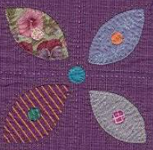  Applique:  ornamental needlework in which pieces or patches of fabric in different shapes and patterns are sewn or stuck onto a larger piece to form a picture or pattern. It is commonly used as decoration
LO: To evaluate the work of myself, and others, against design criteria.  I can critically evaluate the quality of my design  I can evaluate the manufacturing process that I went through  I can identify strengths and areas for development in the work of my peers  Challenge: Make suggestions for an alternative design criteria for next year’s cohort | Critically evaluate:  Provide your opinion or verdict on something. Relate back to design criteria or objectives.  Manufacturing process:  The production of goods

