Subject: Geography | Year: 3 |  |  | Term: Autumn 1 |  | Focus: Southampton |  | Time: Half a term
National curriculum objective |  |  |  | Knowledge outcomes:
- LO: I am learning to name and locate the county and city relevant to local area  SC – I can:  - Name the county, city and suburb I live in  - Identify these on a map  - Describe the location of these in relation to other counties and cities using 4 points of a compass  - Challenge: Give some features that make our suburb special |  |  |  | County: Hampshire  City: Southampton  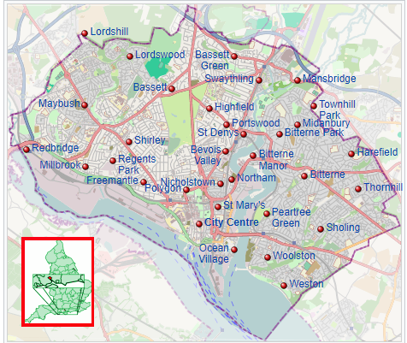  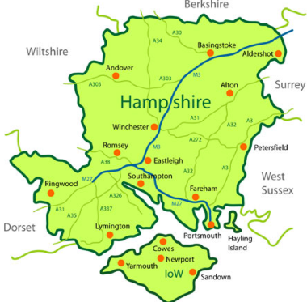  Suburb: Townhill Park  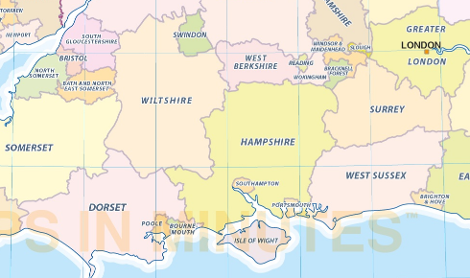  Sentence stems:  North of Hampshire is _________  South of Hampshire is ______________  Winchester is _____________ of Southampton.  Portsmouth is ________________ of Southampton
- LO: I am learning to identify and locate types of settlement in Hampshire  SC - I can:  - Identify which county I live in  - Identify which city I live in and other cities nearby  - Name towns, villages and hamlets in my local area  - Compare the types of settlements  - Challenge: consider why we split the country up in these ways |  |  |  | County: Hampshire  City: Southampton, Winchester, Portsmouth  Town: Eastleigh, Romsey, Fareham, Basingstoke (largest in Hampshire),  Village: Hedge End, Bitterne, Beaulieu, Hamble  Hamlet: Hardley, South Baddesley, Upton  Suburb: Townhill Park, Bitterne Park, Portswood  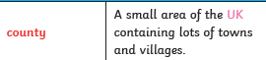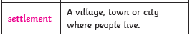  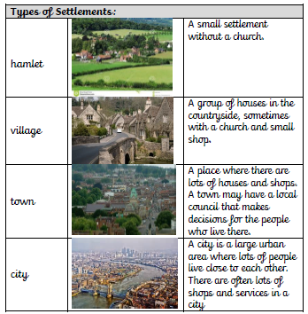
- LO: I am learning to use 4-figure grid references  SC – I can:  - Locate a feature/place using a four figure grid reference  - Describe the location of a place/feature using a four figure grid reference  - Challenge: consider how this could be made even more accurate |  |  |  | How to use four figure grid references  https://www.youtube.com/watch?v=c0du8v4EE_  https://www.youtube.com/watch?v=o8AsM5ajxrE  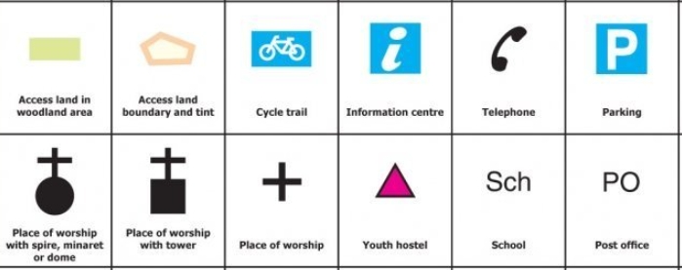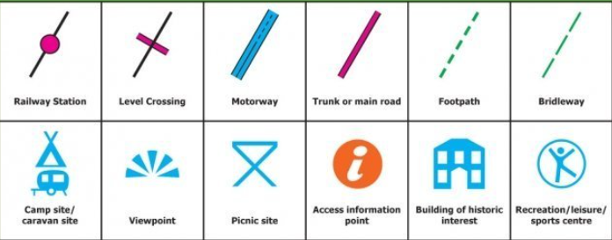  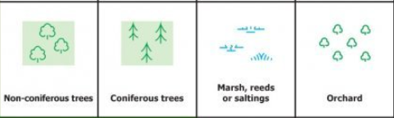  An Ordnance Survey map is a detailed map produced by the British or Irish government map-making organization  Example of how to record four figure grid references  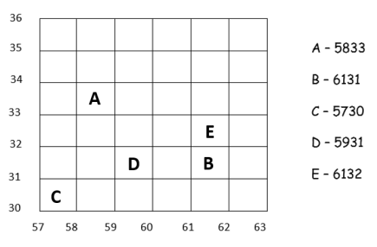
- LO: I am learning to identify key physical and human features of the local area.  SC – I can:  - Explain what is meant by physical and human in terms of geographical vocabulary  - Identify specific human features* in my area  - Identify specific physical features* in my area  - Challenge: compare these to another area that I have visited or know about |  |  |  | Human: something that has been made by humans: houses, shops, roads, bridges, factory, farm, port, harbour, office, city, town  Physical: something formed by nature: green spaces, pond, hill, river, sea, coast, forest  Human features of Southampton: Southampton train station, ferry port, city centre shops, airport  Physical features of Southampton: River Itchen, Itchen Valley country park, The Solent
- LO: I am learning to identify land use patterns and understand how some of these aspects have changed over time.  SC – I can:  - Compare maps from different historical periods in terms of the amount of roads, buildings and other use  - Compare the amount of rural (green) spaces  - Explain what is meant by urban  - Challenge: consider reasons why land use has changes |  |  |  | 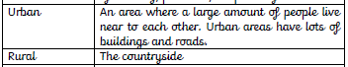  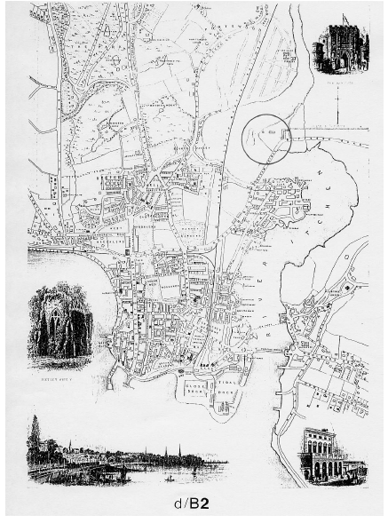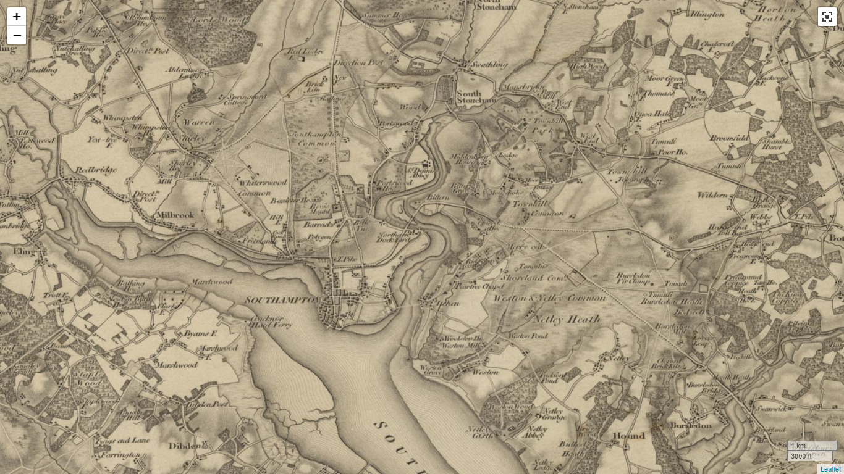  1850 1805  ARCHI UK Detailed Old Maps of England, Scotland and Wales | British Old Maps | British Archaeological Sites Data | Digital Map | Christopher Saxton | John Speed | John Rocque | Stonehenge | Archaeology | Metal Detecting Finds | Treasure Trove | Ancient History | Archaeological Treasures of the UK | Map | ARCHI UK | archiUK has lots of historic maps  Interactive Map (southampton.gov.uk) – you can put layers on the map to see historic maps to compare the same area
- LO: I am learning to use field word to observe, measure, record and present the human and physical features in the local area using a range of methods including sketch maps, plans and graphs and digital technologies  SC – I can:  - Locate three different locations in Townhill and compare them  - Sketch the location, including physical and human features*, and label these  - Carry out a traffic survey in different locations and compare my findings  - Colour code land use on a map  - Challenge: link this to historical uses of the land over time |  |  |  | Three locations: Riverside Park, Woodmill, Meggeson Avenue
Post assessment questions:
What city do we live in?
What county do we live in?
Where are these on a map?
Where do we live compared to other cities and counties?
Describe the different types of settlements.
What are physical features?
What are human features?
What human and physical features do we have in our local area?
What does rural mean?
What does urban mean?
How has rural and urban land use changed over time in our local area?

SEND: |  | AGT: |  |  | Links to other subjects |  | Trips/experiences:
Can they give an example of each type of settlement?  Can they identify where they live and what kind of settlement it is? |  | Do they know the 8 points of the compass?  Make predictions and analyse data to a deeper level.  Eg Do you think there would be more or less traffic at a different time? |  |  | History – change over time (use maps from Roman period) |  | Traffic survey  Walk around Townhill
Skills outcome: |  |  |  |  | Resources:
To use a map to find places in our local area  To use 4 points of a compass to describe the location of a place  To use four figure grid references to locate places and describe the location of places  To use keys and symbols on maps to understand more about the features of the local area  To sketch human and physical features in our area  To carry out a traffic survey to obtain information about the local area |  |  |  |  | Maps of the UK  OS maps  Maps of local area (digimaps are good for these)  Compasses for walk around local area  Maps of local area from the past
Subject: Geography | Year: 3 |  |  | Term: Spring 1 |  | Focus: UK |  | Time: Half a term
Learning Objective and Success criteria |  |  | Knowledge outcomes:
LO: I am learning to identify land use and types of settlement in the UK and locate these using four points of a compass  SC – I can:  - Recall previously learnt knowledge about settlements in Hampshire  - Sort the land use in Hampshire between urban and rural  - Identify North, South, East and West on a compass  - Describe the position of a location using this language  - Challenge: Compare to a different county. |  |  | Settlement: a place where people have settled, live and stay there  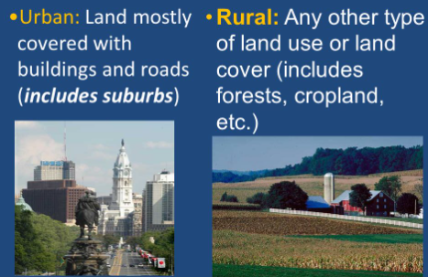  Urban- relating to, or characteristic of a town or city  Land use- buildings, housing, factories  Rural - relating to, or characteristic of the countryside rather than the town.  Land use- farms, parks, forestry  Approximately 75% of Hampshire is classified as rural and these areas are home to 300,000 people, which is 21.8% of the county's total population.  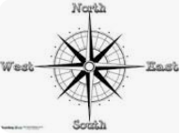  Towns and cities are urban, villages and hamlets are rural.  Urban land use: Southampton airport, city centre shops  Rural land use: New Forest, Beaulieu  Position- a place where someone or something is located.  Direction- a course along which someone or something moves  Sentence stems  North of Hampshire is _________  To the West of Hampshire is _________  To the East of Hampshire is _________  England is south of _________
LO: I am learning to identify and locate countries, capital cities of the UK and southern counties AND I am learning to use maps, atlases, and globes to locate countries and describe features studied  SC – I can:  - Label all of the countries of the UK  - Identify and label the capital cities of these countries  - Label the counties in Southern England that border Hampshire  - Explain the difference between cities, counties and countries  - Challenge: Consider why London is the capital city of the UK |  |  | Countries and capital cities of UK (Identify and label)  England: London  Scotland: Edinburgh  Wales: Cardiff  Northern Ireland: Belfast  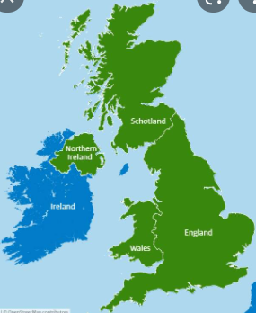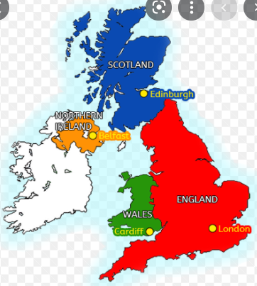  Counties of Southern England (label)  Dorset, Hampshire, Isle of Wight, West Sussex, East Sussex, Kent, Somerset, Wiltshire, Berkshire, Gloucestershire, Surrey, Greater London, Hertfordshire  Use compass knowledge to describe location of countries and counties (N,E,S,W)  City- A city is an area in which a large number of people live fairly close together. A city is basically a big town — the population is large in relation to the amount of land, since people often live in apartments or multi-family housing.  noun a large and densely populated urban area; may include several independent administrative districts  It's a common myth that a city must have a cathedral in order to be a city. In fact, “city status” is conferred by the queen. It has nothing to do with whether a city has a cathedral or not.  County- a territorial division of some countries, forming the chief unit of local administration  Country- a nation with its own government, occupying a particular territory
LO: I am learning to name and locate key topographical features including, hills, mountains, coasts and rivers* AND to use maps atlases, globes and digital/computer mapping to locate countries and describe features studied.  SC – I can locate on a map:  - Hilly and mountainous areas of significance  - The tallest mountain in each UK country  - Popular coastal areas  - The major rivers in the UK |  |  | Topographical- relating to the arrangement or accurate representation of the physical features of an area.  Locate and record physical features on a map:  Hilly and mountainous areas of significance  Pennines, Hebrides, Grampians, Lake District, Chiltern Hills  Mountains  Scotland: Ben Nevis, Wales: Snowdon, England: Scafell Pike, Northern Ireland: Slieve Donard  Popular coastal areas  Cornwall, Devon, Dorset, Hampshire, Essex, Isle of Wight, Sussex, Jurassic  Main rivers of the UK  Thames, Severn, Trent, Tay, Dee, Mersey, Shannon
LO: I am learning to locate and describe the most significant human and physical features of the UK  SC – I can:  - Key human landmarks*  - Famous physical landmarks*  - Challenge: Identify patterns and trends in the location of these features |  |  | https://www.bbc.co.uk/bitesize/topics/zqj3n9q/articles/zr8q7nb#:~:text=Human%20and%20physical%20features%20are,have%20been%20built%20by%20people. Human and physical features explained  Human  Big Ben, Angel of the North, Buckingham Palace, Houses of Parliament, Corfe Castle, Stonehenge, Hadrian’s Wall, Tower of London, Winchester Cathedral, Southwark Cathedral  Physical  Ben Nevis, Snowdon, Thames, White cliffs of Dover, Grampian Mountains, New Forest, Severn River (links to previous lesson)  Identify patterns/trends in location of these features.
Key questions:
What are the four points of a compass?
What are urban and rural areas of Hampshire?
What are the countries in the UK?
What are the capital cities in the UK?
Where are these on a map?
What is the difference between a city, county and country?
What is the tallest mountain in each country in the UK?
Where are hilly and mountainous areas in the UK?
Where are the major rivers of the UK?
Where are popular coastal areas in the UK?
What are the four points of a compass?
Describe the location of places in the UK using these compass points.
What are some key human landmarks in the UK?
What are some key physical landmarks in the UK?
SEND: |  | AGT: |  |  | Links to other subjects |  | Trips/experiences:
2 figure grid references |  | Use 6 figure grid references  Compare location of settlements to physical features |  |  | Maths – grid references
Skills outcome: |  |  |  |  | Resources:
To use four points of a compass to describe the location of places  To use a map to locate counties, capital cities, rivers, coasts and mountains in countries of the UK  To use keys and symbols on maps to be able to understand the features of the countries of the UK |  |  |  |  | Maps of the UK  iPads for Google Maps

Subject: Geography | Year: 3 |  | Term: Summer 1 |  | Focus: Circles on the Earth |  | Time: Half a term
Learning Objectives and Success Criteria |  |  | Knowledge outcomes:
LO: I am learning to identify how we describe positions on the Earth  SC – I can:  - Identify the equator  - Explain how lines of latitude and longitude are used  - Identify the Tropic of Cancer, Tropic of Capricorn, Arctic Circle and Antarctic Circle  - Challenge: Relate the areas to the climate and give reasons for this |  |  | 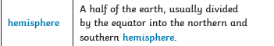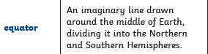  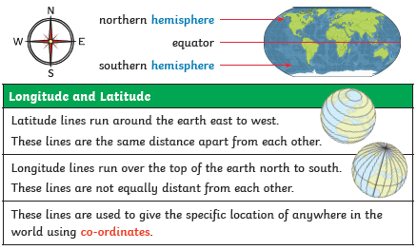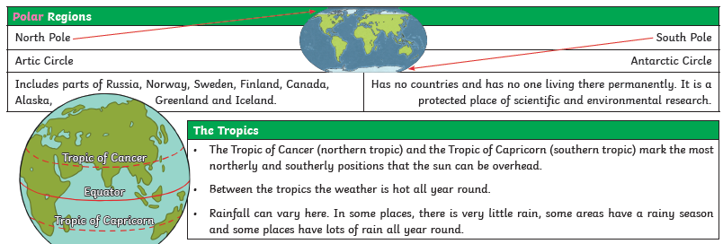  Latitude  vertical lines, measured in degrees (how far north or south of the equator something is)  Longitude  horizontal lines, measured in degrees (how far east or west something is from the Prime Meridian)  Equator:  0⁰ latitude – closer to the equator the hotter places are  Tropic of Cancer/ Tropic of Capricorn  Equator is In the middle – between the tropics it is hot (tropical climate) The Tropic of Cancer is the most northern latitude on the Earth where the sun can appear directly overhead. The Tropic of Capricorn is the most southern latitude on the Earth where the sun can appear directly overhead.  Arctic Circle/Antarctic Circle  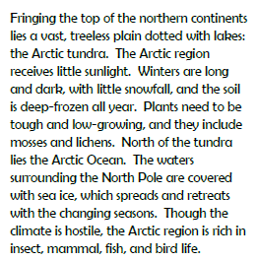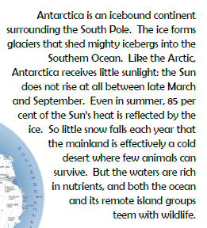  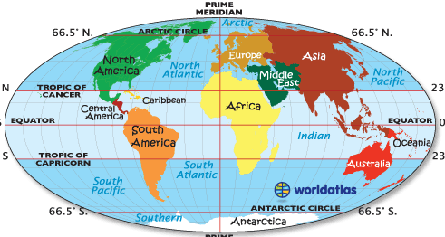
LO: I am learning to identify the location and patterns of climate zones  SC – I can:  - Define what a climate zone is  - Locate polar, tropical and temperate climate zones on a map  - Challenge: Consider how the poles and tropics are linked to climate zones |  |  | 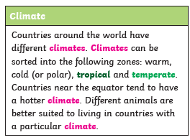  A climate zone is an area that has its own distinct climate. They also have their own type of vegetation and wildlife.  Climate: the weather conditions prevailing in an area in general or over a long period.  Polar  Very cold and dry all year  Found in areas around the North and South Poles.  Temperate  Cold winters and mild summers. Found in the UK.  Tropical  Hot and wet most of the year. Found around the equator, where rainforests grow.  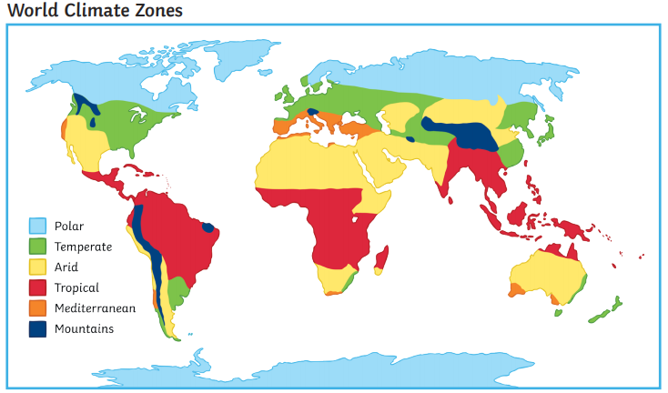
LO: I am learning to use maps, atlases, globes and digital/computer mapping to locate countries and describe features studied  SC – I can:  - Compare land use in different climate zones  - Compare the animals living in different climate zones  - Compare the plants found in the different climate zones  - Challenge: consider how different animals are adapted for its climate  N.B. Spend one lesson on each climate zone |  |  | Polar:  Land use – fishing, no one lives permanently in the Antarctic circle, but scientists stay there temporarily to find out about the land  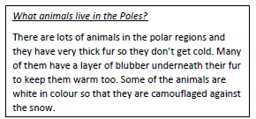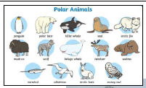  Plants - Polar plants are plants that grow and thrive in the freezing conditions of the Arctic and Antarctica. Over 1,000 Combinations of mosses, lichens, sedges, grasses, and dwarf woody shrubs dominate most Arctic tundra, and miniature flowering plants dominate the polar deserts.  Arctic willow: A dwarf shrub that is food for caribou, musk oxen, and arctic hares. The Inuit people call it the “tongue plant” because of the shape of its leaves.  Bearberry: A low-growing evergreen with leathery leaves and silky hairs protect from the cold and wind. The plant was named bearberry because bears like to eat its red berries  Arctic Poppy: A plant that is about 10-15 cm tall, with a single flower per stem. The flower heads follow the sun, and the cup-shaped petals help absorb solar energy.  Antarctic lichen: Approximately 150 species of lichens grow in the polar ecosystem. Lichens can tolerate very cold temperatures, and thus can live where true plants cannot. Lack of water, not cold temperatures, is the largest concern, and lichens deal with this problem by living in cracks between rocks.  Temperate:  The vast majority of the world's human population resides in temperate zones, especially in the northern hemisphere, due to its greater mass of land and lack of extreme temperatures Farming is a large-scale practice in the temperate regions due to the plentiful rainfall and warm summers, because most agricultural activity occurs in the spring and summer, cold winters have a small effect on agricultural production.  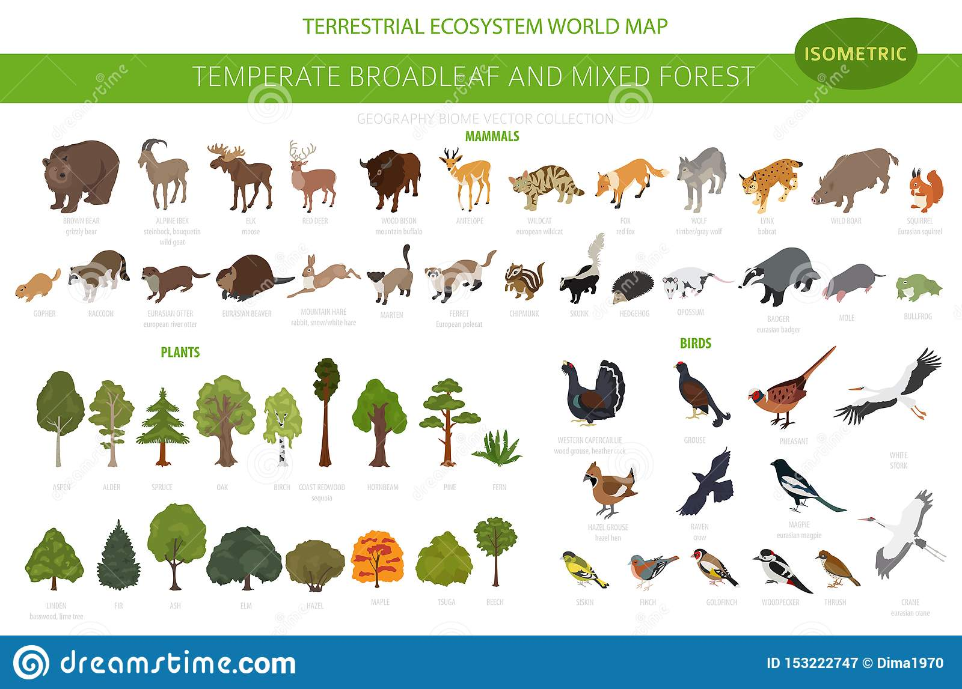  Temperate zone animals must utilize strategies like hibernation and migration to survive the sometimes harsh winters. Flyways, the migration paths of raptors, songbirds and waterfowl, crisscross temperate zones as birds make their way between summer and winter territories. Other animals store food, such as seeds and nuts, for the cold winter months.  Tropical  Animals Found in the Tropical Evergreen Forest (sciencing.com)
Post assessment questions:
Where is the equator?
What are lines of latitude and longitude?
How are they used?
Where is the Tropic of Cancer?
Where is the Tropic of Capricorn?
Where is the Arctic Circle?
Where is the Antarctic Circle?
What is a polar climate zone? Where are these on a map?
What is a tropical climate zone? Where are these on a map?
What are temperate climate zones? Where are these on a map?
What plants and animals found in these climate zones?
SEND: |  | AGT: |  | Links to other subjects: |  | Trips/experiences:
Can they identify that the climate will be warmer nearer the equator? |  | Can they compare and explain the difference in climate?  Could they think about what animals/plants may live there? |  | Science – plants (GD could think about how plants living in different places will need different things to grow)  Science – light (how the sun moves across the sky links to tropics)
Skills outcome: |  |  |  | Resources:
To use maps and atlases to locate areas of the world

