Subject: Geography | Year: 4 |  |  | Term: Autumn |  | Focus: Europe & Mountains |  |  | Time: A term
Learning Objective and Success Criteria: |  | Knowledge Outcomes
LO: I am learning to use the 8 points of a compass, 4- and 6-figure grid references, symbols and key to build my knowledge of the United Kingdom and the wider world  SC – I can:  - Use 8 points of a compass: N.E,S,W,NE,NW,SE,SW and relate these to positions on maps, atlases and globes (with particular reference to Europe)  - Use 4-figure grid references to locate places and landmarks  - Identify the symbols that are used to represent different land uses on atlases e.g. how are mountains represented?  - Challenge: consider what other information I can find in an atlas |  | 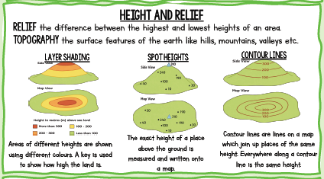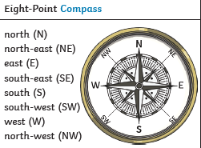  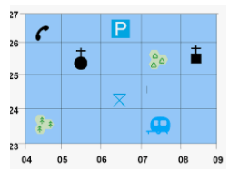
LO: I am learning to locate the world’s countries, using maps to focus on Europe (including the location of Russia) concentrating on their environmental regions, key physical and human characteristics, countries, and major cities  SC – I can:  - Identify the continents of the world  - Identify which are in Northern or Southern Hemisphere  - Locate and describe the position of Europe using compass points  - Identify countries within Europe and their position in relation to each other  - Locate significant human and physical features (See MTP)  - Challenge: link these features to tourism e.g. why do people choose to visit particular countries? |  | Continents of the world:  North America, South America, Europe, Asia, Africa, Oceania, Antarctica  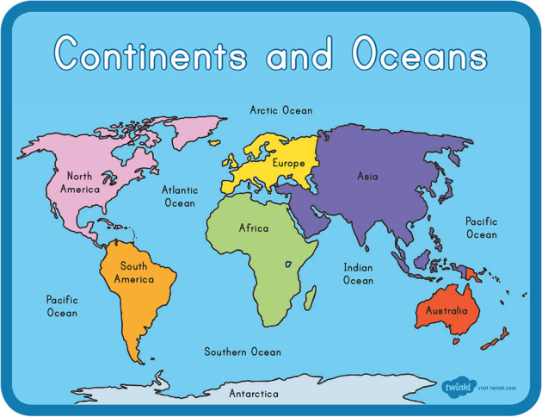  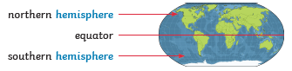  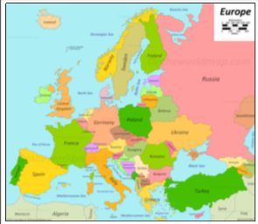  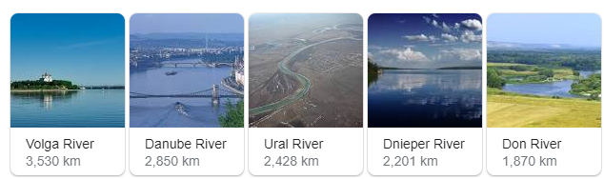  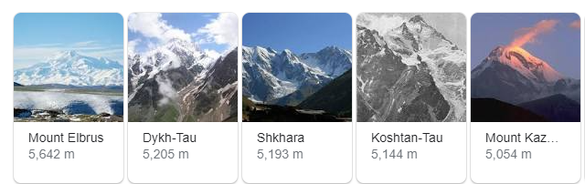  Europe's boundaries are primarily maritime. The continent is bound by the Atlantic, the Arctic Ocean, the Black Sea and the Mediterranean.  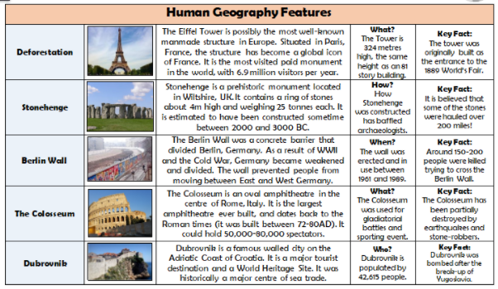  Eifel Tower  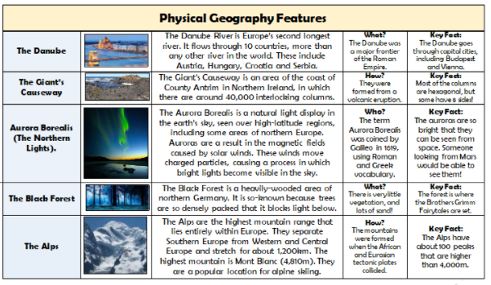
LO: I am learning to understand geographical similarities and differences through the study of human and physical geography in a region of Europe  SC – I can research a given area (Iberian Peninsula, Scandinavia or Eastern Edge)  - Identify countries which make up area and describe positioning  - Identify the climate and biomes  - Identify physical features: rivers, mountains, coastlines, weather  - Identify human features: capital cities, significant cities, monuments, importing and exporting opportunities  - Consider how the land is mainly used  - Challenge: answer questions set by another group on my area of expertise |  | Research given area : Iberian Peninsula, Scandinavia or Eastern Edge  Identify countries which make up area and describe positioning  Identify the climates of the country
 |  | Polar  Very cold and dry all year  Found in areas around the North and South Poles.  Temperate  Cold winters and mild summers. Found in the UK.  Arid  Dry. More than a third of the Earth is covered in Arid climate. This climate is mainly found 30 degrees north and south of the Equator. |  |  |  |  | Tropical  Hot and wet most of the year. Found around the equator, where rainforests grow.  Mediterranean  Mild winters and dry, hot summers. Found mainly around the Mediterranean Sea.  Mountains  Varies depending on what altitude (how high) you are.  At the foothills (near the bottom) there may be a tropical climate, whilst the peaks (the very top of mountains) may be covered in ice. The uppermost level of mountains is often bare rock and snow.
Identify biomes.
An area which has similar plants, animals and climate.

Deciduous Forest (in context of Iberian Peninsula and Eastern Edge)
Climate: temperate
Plants: broad leaved trees that lose their leaves in winter
Animals: Deer, fox, porcupines, squirrels, mice owls, deer, doves, moths

Tundra (in context of Scandinavia)
Climate: polar – cold and dry all year
Plants: as the ground is frozen for most of the year, nothing much can grow. When surface melts, small plants can grow.
Animals: polar bears, seals, reindeer, Arctic foxes.

Alpine (in context of Scandinavia) – focus for more able as this is a ‘new’ climate (others were covered in Year 3)
Climate: Alpine climate – cold, windy and snowy all year.
Plants: mostly tough shrubs that can handle the cold and wind.
Animals: malls with thick fur to keep them warm, birds (including golden eagles and vultures) and a few insect species.

Physical features: rivers, mountains, coastlines, weather (link to Y3 topography work)

Human features: capital cities, significant cities, monuments, importing and exporting opportunities,
Notable land uses
Make comparisons between three areas studied. Note similarities and differences
Suggest reasons for these.
LO: To describe and understand key aspects of mountains  Sub Objective: Explain how and why mountains are formed  SC – I can:  • Explain what a tectonic plate is  • Name the different types of mountains  • Describe how the different types of mountains are formed  • Challenge: consider what kinds of habitats may form on the different mountain types  Sub Objective – Identify locations of mountains  SC – I can:  • Locate mountain ranges of Europe on different map types  • Notice patterns in the locations of mountain ranges  • Describe the impact of tourism in mountain ranges  • Challenge: Consider negative and positive impacts of humans on this particular environment  Sub Objective – Research Mountain Biomes  SC – I can:  • Identify features of Alpine biomes  • Explain how they differ to other biomes studied  • Challenge: Give reasons why Alpine biomes vary |  | Explain how and why mountains are formed  Mountains are formed when huge areas of land hit each other or when magma comes from the centre of the earth (Do not focus on Volcanoes in depth – Y6 topic).  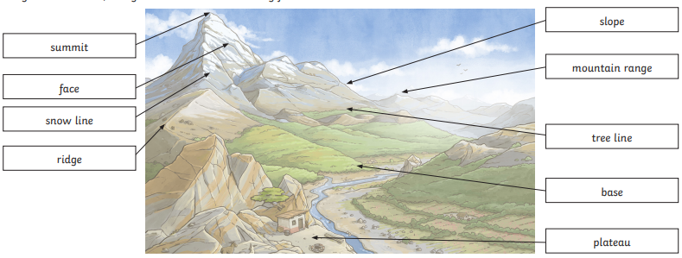  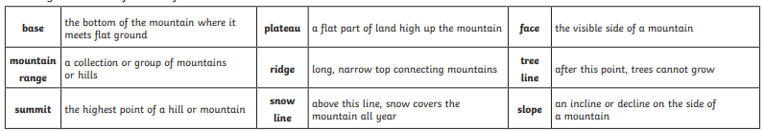  Know that the Earth is formed from tectonic plates  Name the different types of mountain:  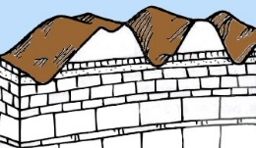  Fold: The most common type of mountain. The world’s largest mountain ranges are fold mountains. These ranges were formed over millions of years. Fold mountains are formed when two plates collide head on, and their edges crumbled, much the same way as a piece of paper folds when pushed together.  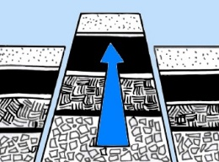  Fault-block: These mountains form when faults or cracks in the earth's crust force some materials or blocks of rock up and others down. Instead of the earth folding over, the earth's crust fractures (pulls apart). It breaks up into blocks or chunks. Sometimes these blocks of rock move up and down, as they move apart and blocks of rock end up being stacked on one another.  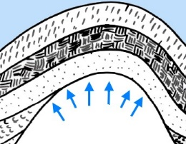  Dome: Dome mountains are the result of a great amount of melted rock (magma) pushing its way up under the earth crust. Without actually erupting onto the surface, the magma pushes up overlaying rock layers. At some point, the magma cools and forms hardened rock. The uplifted area created by rising magma is called a dome because of looking like the top half of a sphere (ball). The rock layers over the hardened magma are warped upward to form the dome. But the rock layers of the surrounding area remain flat.  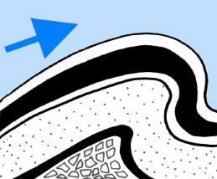  Volcanic: As the name suggests, volcanic mountains are formed by volcanoes. Volcanic Mountains are formed when molten rock (magma) deep within the earth, erupts, and piles upon the surface. Magna is called lava when it breaks through the earth's crust. When the ash and lava cools, it builds a cone of rock. Rock and lava pile up, layer on top of layer.  Plateau: Not formed by internal activity. Instead, these mountains are formed by erosion. Plateaus are large flat areas that have been pushed above sea level by forces within the Earth, or have been formed by layers of lava. The dictionary describes these as large areas of ‘high levels’ of flat land, over 600 meters above sea level. Plateau mountains are often found near folded mountains. As years pass, streams and rivers erode valleys through the plateau, leaving mountains standing between the valleys.  Locate mountainous areas in Europe  Alps, Carpathian, Pyrenees, Apennine, Ural, Caucasus, Dolomites  Notice patterns in the locations of mountain ranges  Describe the impact of tourism in mountain ranges.  Alpine biome  The climate is cold, windy and snowy all year. Plants are mostly tough shrubs that can handle the cold and wind. Mammals with thick fur to keep them warm, birds (including golden eagles).  Explain how they differ to other biomes studied
Post-Assessment Questions
What are the eight points of the compass?
How do six figure grid references work?
How are mountains represented on maps?
What are the seven continents?
Which hemisphere is Europe in?
Can you locate Portugal, Spain, the UK, Belarus, Bulgaria, the Czech Republic, Denmark, Norway, Sweden, Finland and Iceland on a map?
Can you describe their location, using compass points and grid references?
Choose one country in Europe and tell me all that you know about it e.g. climate, biomes, hum.an and physical features
How and why are different types of mountains formed?
Can you locate the Scandinavian Mountains, the Urals and the Pyrenees on a map?

SEND: |  |  | AGT: |  | Links to other subjects |  |  | Trips/experiences
2 figure grid references  Less information to find for their research  Use four compass points  Teacher supported for research  Simpler texts (eg Poland from Twinkl is quite simple) |  |  | Can they identify the names of the 7 oceans?  Can they use one map to help them with the information on another map (e.g. page 28 and 29 in the atlases) |  | Computing: Websites and research  Maths: grid references
Skills outcomes |  |  |  |  | Resources
Use maps, atlases, globes and digital/computer mapping to locate countries and  describe features studied  Use the eight points of a compass, four and six-figure grid references, symbols and key  (including the use of Ordnance Survey maps) to build their knowledge of the United  Kingdom and the wider world |  |  |  |  | Atlases  Fact sheets and information books on the countries and biomes covered  Play-dough (for modelling mountain formation)

Subject: Geography | Year: 4 |  |  | Term: Summer 1 |  | Focus: Fieldwork study |  | Time: Half a term
Learning Objective and Success Criteria: |  |  | Knowledge outcomes:
I am learning to make a prediction  SC – I can:  - Describe the optimal conditions for a mindful space  - Use 4-digit grid references to locate areas on a map  - Use 8 compass points to describe the location of an area  - Make a prediction as to which area will be the best/worst for a mindful space |  |  | What is a mindful space?  Space which has been created resonating with your own idea of calm.  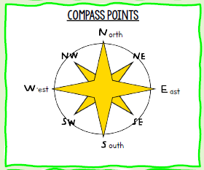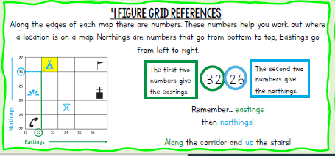
I am learning to explain how to conduct fieldwork necessary to answer an investigative question  SC – I can:  - Explain what information I need to decide which is the best/worst location  - Decide which equipment will be most useful  - Justify why I am using each piece of equipment |  |  | Different types of equipment – photometer (light) noise level meter (app on phone) thermometer, wind speed
I am learning to collect relevant data  SC – I can:  - Use a variety of techniques to collect data  - Use equipment to find measures, make observations, give scaled scores  - Record my findings |  |  | 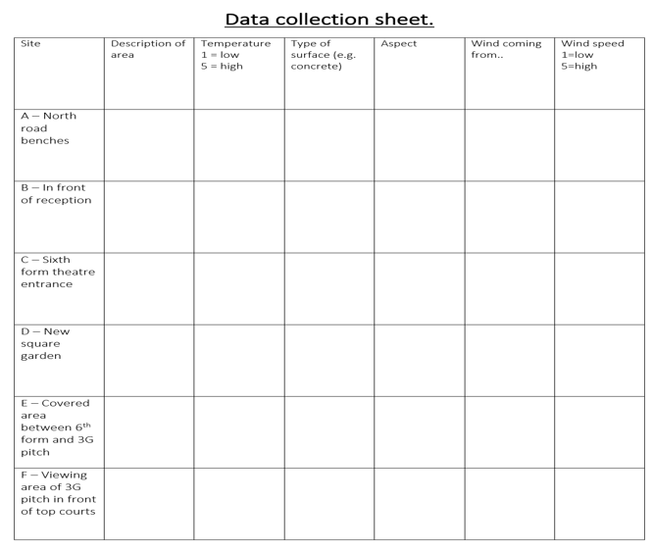
I am learning to present relevant data  SC – I can:  - Discuss different ways to present my data  - Accurately present my findings using a range of graphs  - Select appropriate scales and keys |  |  | 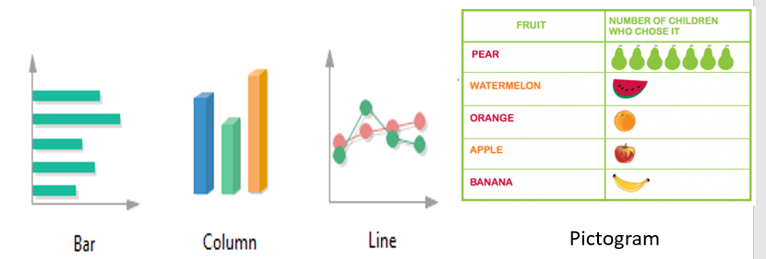
I am learning to analyse my data  SC – I can:  - Explain what my data shows  - Begin to think about why these results occurred.  - Explain how these would help to identify the best/worst locations for a mindful area. |  |  | 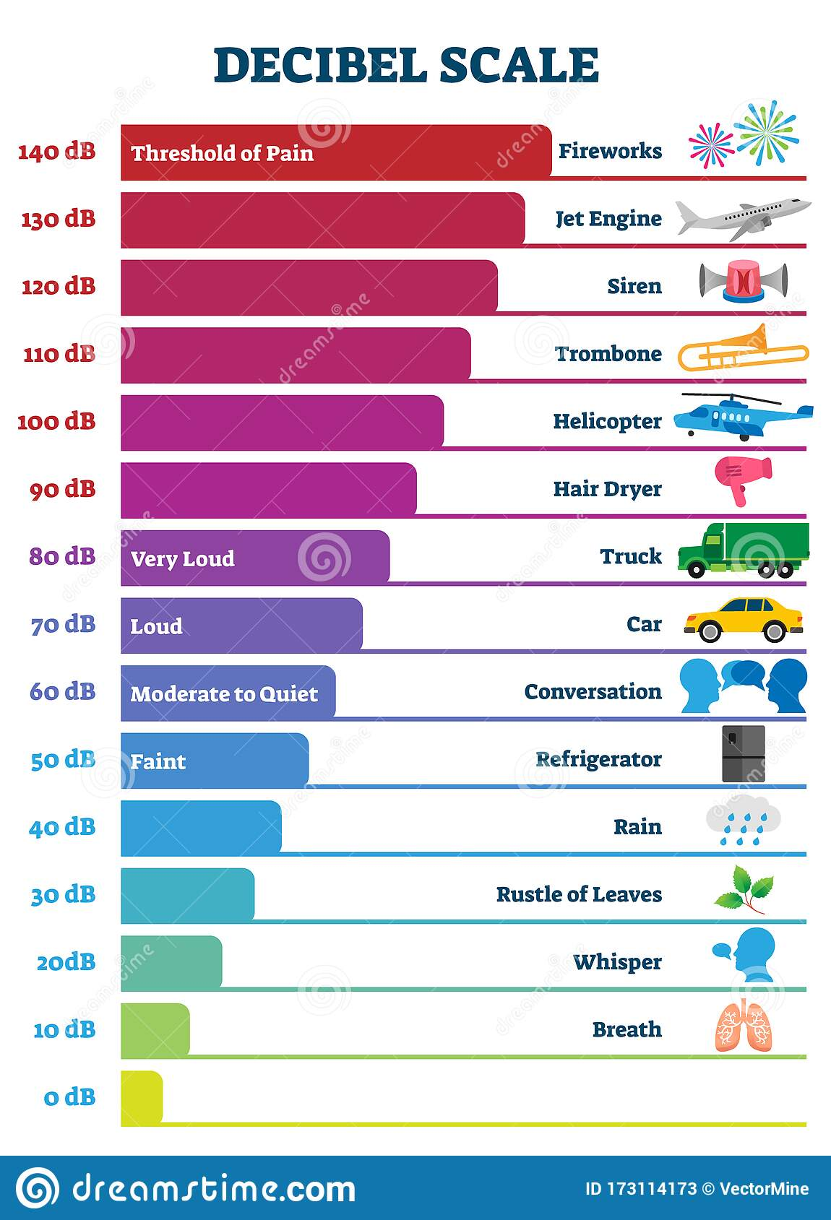Mindful space – probably between 40-60dB  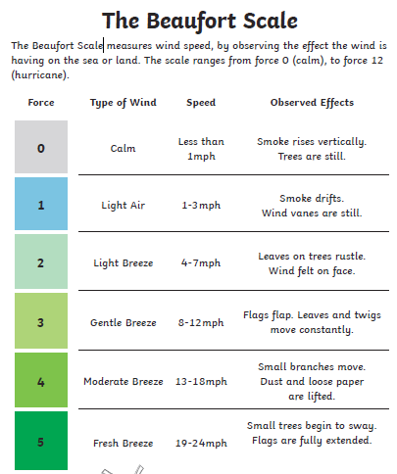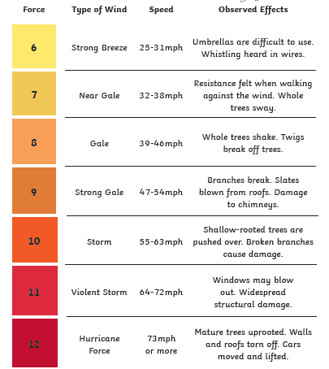  The most optimum number of Lumens you will need to read is at least 450 Lumens.  - Dim Lighting can cause serious strain in your eyes. poor lighting will lead your eyes to overwork resulting in weak vision. Too much strain on your eyes can further lead to headaches, blurred vision, and an increase in the sensitivity to light.  - Spending long hours reading in dim light is proven to affect your memory performance and learning abilities.  - Dim Lights normally tend to calm the brain which will eventually lead to difficulty in focusing on things.
I am learning to make a conclusion  SC – I can:  - Use my results to identify the best/worst location for a mindful area.  - Sketch the best and the worst location  - Annotate my sketches |  |  | KS2 geography sketch example:  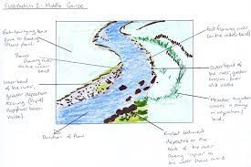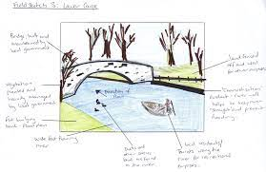
I am learning to evaluate my fieldwork study project
SC – I can:
- Give my opinion on how well my project went
- Identify reliability of my data
- Suggest ways to make my data more reliable
- Create a question for further investigation
Post-Assessment Questions
- What would be the best/worst place to create a mindful space?
- What would a mindful space be like? What would happen there?
- How do you use grid references? How do I use compass points? How would I describe the location of a place using these?
- How are we going to find out which place is the best/worst?
- What information will we need?
- How will we collect the data?
- How are we going to present this information?
- What does our information tell us?
- Why is this the best/worst place?
- How did the project go? If we did it again, what would you change?
- What could you look at next?
SEND: |  | AGT: |  |  | Links to other subjects |  | Trips/experiences:
- Take pictures of the areas as you go round and add to map  - Stem sentences  - More scaffolded from I do  - Selected data collection and presentation options |  | - Justify predictions with detailed reasoning  - Look at more aspects to compare  - Explain why they chose the graph |  |  | Maths – graphs  Science – light, sound, investigative skills  PSHE – mindful spaces |  | Possibly visit a mindful space  Experience yoga or doing mindful tasks
Skills |  |  |  |  | Resources
- use the eight points of a compass, four and six-figure grid references, symbols and key (including the use of Ordnance Survey maps) to build their knowledge of the United Kingdom and the wider world  - use fieldwork to observe, measure, record and present the human and physical features in the local area using a range of methods, including sketch maps, plans and graphs, and digital technologies. |  |  |  |  | Map of the school  Compass  Data logging equipment

