Subject: Geography | Year: 5 |  | Term: Spring 1 |  | Focus: North America |  | Time: Half term
National Curriculum Objectives/LO and SC |  |  | Need to know |  |  |  | Suggested activities
KS2 - locate the world’s countries, using maps to focus on Europe (including the location of Russia) and North and South America, concentrating on their environmental regions, key physical and human characteristics, countries, and major cities  KS2 - use maps, atlases, globes and digital/computer mapping to locate countries and describe features studied  L1 - LO: I am learning to identify the countries of  North America.  SC: I can –  - locate the continent of North America on a world map  - name the countries of North America  - locate North American countries on a map  L4 - LO: I am learning to explore the capital cities of North America.  SC: I can –  - say what a capital city is  - identify North American capital cities and match them to their countries  - explore features of different capital cities, such as language and population  L7 – LO: I am learning to research the human and physical geography of a particular North American country.  SC: I can –  - use a variety of sources of information to find out about a specific North American country  - select appropriate facts, figures and images to include in my work  - present geographical information in a variety  - of ways |  |  | 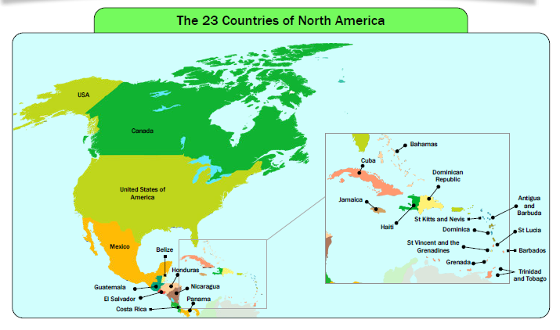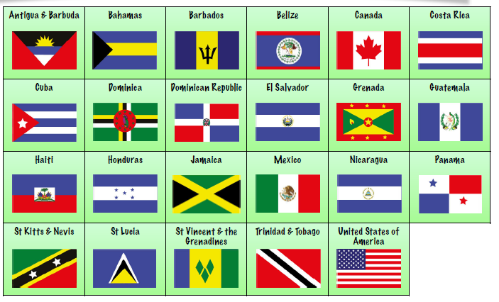  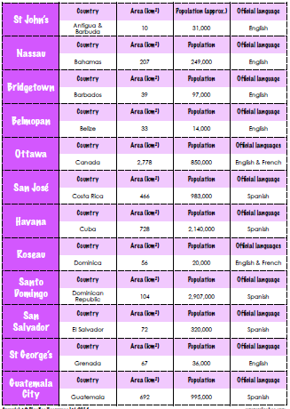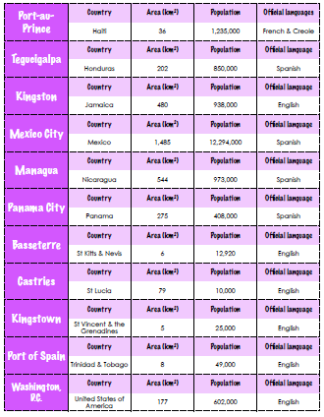  Pupils need to know some of the capital cities and how they compare to each other in terms of language and population  The children need to know the following about one North American country  - how big it is  - the population  - what language people speak  - the currency  - what the climate is like  - what mountains, rivers, lakes and other physical geographical features are there  - What the capital city is like  - Whether it is rich or poor  - What the culture is like  - What tourists can see and do there  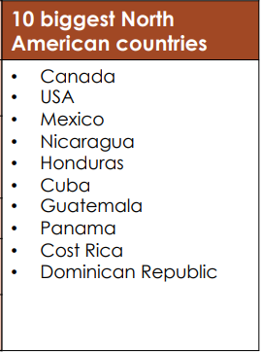 |  |  |  | L1: Children will identify the continent of North America on a map and learn how it is organised into areas, such as the Caribbean and Central America. They will identify the 23 countries that comprise North America and locate them on a map.  L4: Children will define what a capital city is before finding out the names of some North American capital cities. They will think about questions they could ask to find out information about a particular city, as well as matching capitals to their countries.  L7: Children will recap everything they have learnt about North America. They will then move on to researching a particular North American country, generating questions they want to find the answer to and using a variety of sources of information to find the answers. They will present what they have found out in a variety of ways.
KS2 - describe and understand key aspects of physical geography, including: climate zones, biomes and vegetation belts, rivers, mountains, volcanoes and earthquakes, and the water cycle  L2 - LO: I am learning to investigate and compare climates in North America.  SC: I can –  - identify some different climate zones in  - North America  - investigate the climate of a particular area  - compare climates in North America  L3 - LO: I am learning to explore the geographical features of North America.  SC: I can –  - describe the difference between human and physical geographical features?  - identify and describe some geographical features of North America  - describe how certain geographical features are formed |  |  | 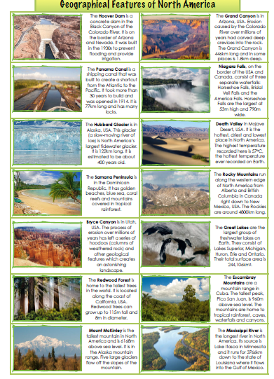  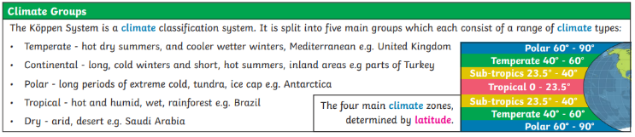  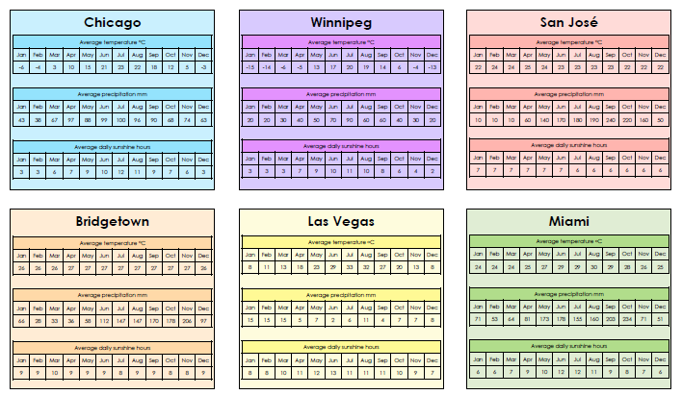 |  |  |  | L2: Children will look at a global climate zone map to identify climate patterns around the world. They will then explore some of the different climate zones in North America, using graphs and charts to examine and compare the climate in different locations around the continent.  L3: Children will identify some of the famous features of North America, including natural features such as the Grand Canyon and Niagara Falls, finding out how they were formed. They will also explore some human features and landmarks, such as the Panama Canal and the Hoover Dam.
KS2 - identify the position and significance of latitude, longitude, Equator, Northern Hemisphere, Southern Hemisphere, the Tropics of Cancer and Capricorn, Arctic and Antarctic Circle, the Prime/Greenwich Meridian and time zones (including day and night)  L5 - LO: I am learning to explore the various time zones of North America and how these compare to other time zones around the world.  SC: I can –  - explain why different parts of the world have different time zones  - calculate the time at different locations in North America based on GMT  - calculate corresponding times within different locations in North America |  |  | 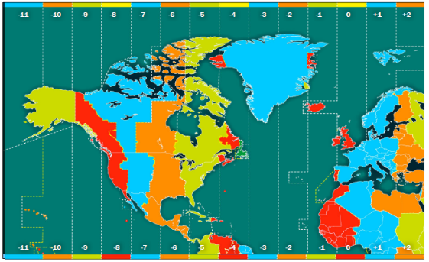  What are time zones?  Time zones are divided by imaginary lines called meridians which run from the North Pole to the South Pole.  There is an imaginary line running through the UK called the Prime Meridian. It runs through a place in London called Greenwich.  The Prime Meridian splits the world into eastern and western hemispheres.  Time in countries to the east of the Prime Meridian is always in front of that in the UK.  Time in countries to the west of the Prime Meridian is always behind that of the UK.  Time in different parts of the world  As the Earth rotates on its axis, the Sun only shines on the side of the Earth that it is facing. This means:  it is daytime for the parts of the Earth that have the Sun shining on them  it is night-time for places that are on the opposite side of the Earth and are in the shade  As it is night in some parts of the world while it is day in other parts, different places in the world have different times. This is why the world is divided into 24 different time zones. One for each hour in a day.  Very large countries that are spread out across many time zones, such as Russia or the USA, are divided into separate time zones. Most smaller countries keep to the same time zone even if part of them falls outside a meridian line. |  |  |  | L5: Children will identify why different parts of the world have different time zones. They will use time zone maps to work out time differences between various locations in North America, as well as locations in North America and the rest of the world.
KS2 - understand geographical similarities and differences through the study of human and physical geography of a region of the United Kingdom, a region in a European country, and a region within North or South America  L6 - LO: I am learning to compare a region in the UK with a region in North America.  SC: I can –  - compare the physical geography of a region in the UK and a region in North America  - compare the human geography of a region in the UK and a region in North America  - use a variety of appropriate sources to find out about the human and physical geography of a region |  |  | The children need to know the following about one North American country  - how big it is  - the population  - what language people speak  - the currency  - what the climate is like  - what mountains, rivers, lakes and other physical geographical features are there  - What is the capital city like?  - Is it a rich or a poor country?  - What is the culture like?  - What can tourists see and do there?  Southampton  - how big it is: 57.41km²  - the population: 254,361  - what language people speak: The main language spoken in Southampton is English. The top five languages spoken in Southampton's schools (apart from English) are Polish (8.3%), Panjabi (2.0%), Urdu (1.5%), Pashto/Pakhto (1.2%) and Bengali (1.1%).  - the currency  - what the climate is like  - what mountains, rivers, lakes and other physical geographical features are there: the River Itchen, the Solent  - What the city is like: commercial, port city, tourism hub  - Is it a rich or a poor city?: Very mixed  - What is the culture like?: modern, multicultural  - What can tourists see and do there?: Art gallery, West Quay, Sea City museum |  |  |  | L6: Children will describe their local area in detail, using appropriate geographical vocabulary. They will then compare their local area with specific areas in North America, considering how both physical and human features and similar and different.
Post assessment:
- Where is North America? (Compare this to the UK)
- What countries make up North America?
- How does North America compare to other continents, in terms of physical and human features?
- Why do we have time zones?
- What different time zones are there in America?
- What is the climate like and what different climate zones are present?
SEND: |  | AGT: |  | Links to other subjects |  | Trips/experiences:
See differentiated tasks within lessons  Consider where language and skills need to be pre-taught in small groups |  | Focus on comparison between North America and other continents studied.  Use Geographical Information Systems (GIS) to view, analyse and interpret places and data  In L6, compare to a different geographical location in the UK, not Southampton |  | North American text in English  Linked cookery in DT |  | New Forest Wildlife Park (focus on North American animals, particularly the wolves depending on text in English)
Field Work Skills |  |  |  | Resources
- Use maps, atlases, globes and digital/computer mapping to locate countries and describe features studied
- Use the eight points of a compass, four and six-figure grid references, symbols and key (including the use of Ordnance Survey maps) to build their knowledge of the United Kingdom and the wider world

Subject: Geography | Year: 5 |  |  | Term: Spring 2 |  | Focus: Amazon Rain Forest |  | Time: Half a term
Learning Objective and Success Criteria |  |  | Knowledge Outcomes:
LO: I am learning to use maps, atlases and digital/computer mapping to locate the Amazon Rainforest and describe its location.  SC – I can:  - Locate Brazil and identify surrounding countries  - Locate and name oceans that Brazil sits between  - Locate tropical and temperate rainforests across the world  - Sort rainforests by whether they are temperate or tropical  - Challenge: make links between rainforests and other physical features of the environment |  |  | 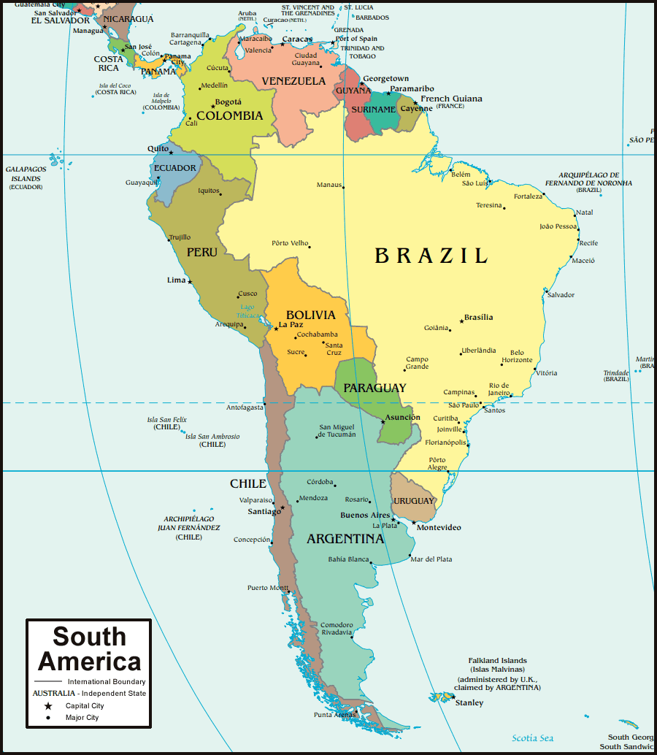  Prior knowledge: Equator, tropics, South America (continent)  Locate Brazil and identify surrounding countries – Argentina, Bolivia, Chile, Colombia, Ecuador, Falkland Islands (United Kingdom), French Guinea (France), Guyana, Paraguay, Peru, Suriname, Uruguay and Venezuela.  Locate and name oceans: Pacific and Atlantic  Locate Tropical and Temperate rainforest across the world:  Tropical: Amazon, Congo, Southeast Asia, smaller rainforests are located in Central America, Madagascar, Australia. Located near the equator between the Tropics of Cancer and Capricorn. Hotter  Temperate: New Zealand, N. America, Chile, UK, Norway, Japan and Australia. Located to the north of the Tropic of Cancer and to the south of the Tropic of Capricorn neither really hot or cold but vary in temperature  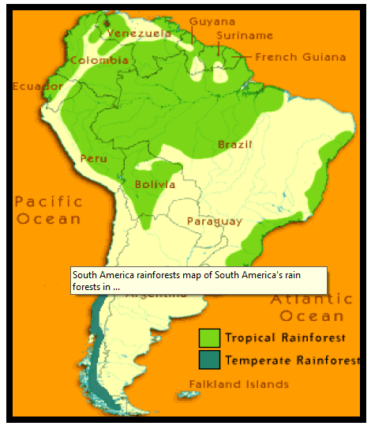
LO: I am learning to describe and understand key elements of a tropical rainforest biome:  SC – I can:  - Name the different layers  - Give some features of each  - Explain what the function of each layer is  - Explore the biodiversity within them  - Challenge: Consider why these need preserving |  |  | 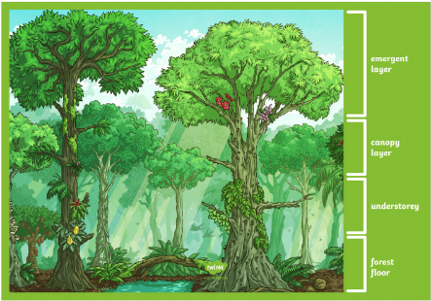  Layers:  Emergent / Top layer: few animals, hot wet and windy,  Canopy: below the emergent lots of animals lots of food and shelter  Understory: beneath the canopy, dark and humid, large animals hunt, lots of insects and snakes  Forest floor: dark, humid, hot, only 5% of sunlight makes it to the ground, ground litter  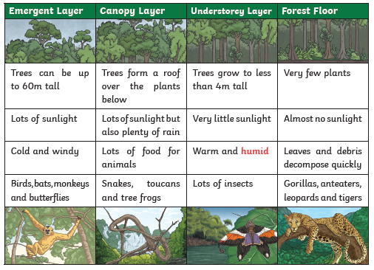  What is their function?  Biodiversity within them (range of flora and fauna)  https://www.dkfindout.com/uk/animals-and-nature/habitats-and-ecosystems/rainforest-layers/
LO: I am learning to describe and understand key aspects of the Amazon Rainforest climate.  SC – I can:  - Research temperature, humidity, wind, precipitation and weather patterns including using maps that show these features  - Record these in tables and/or graphs  - Consider why the weather is like this  - Challenge: Consider how weather in this region has impacted on land use |  |  | Temperature: How hot or cold something feels  Humidity: The amount of water vapour in the air  Wind: The movement of air near the Earth’s surface  Precipitation: Water that falls to the earth as hail, mist, rain, sleet, or snow  Weather patterns: A weather pattern occurs when the weather stays the same for days or weeks at a time  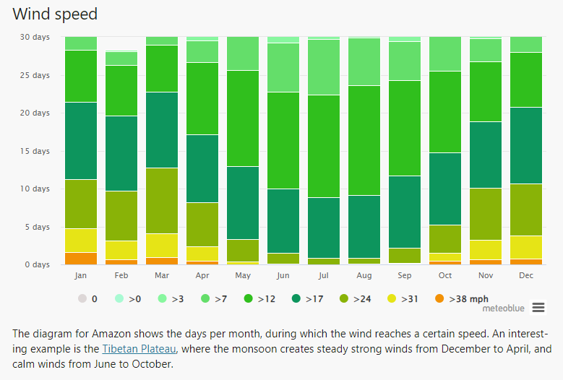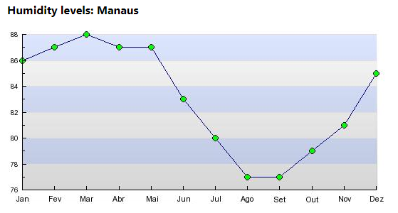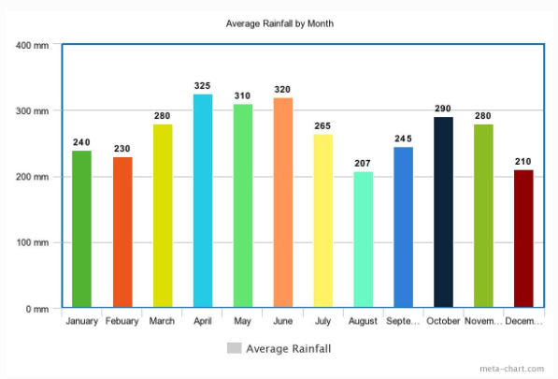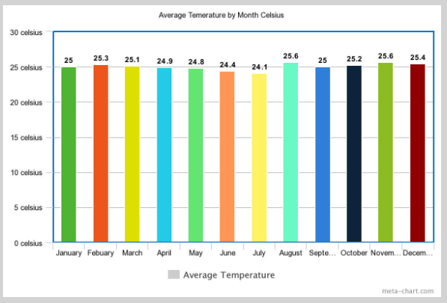  The Wet Seasons: The most precipitation falls in the Amazon Basin of Ecuador in March, April, May, and June. These are the same months as the world’s rainy season. The rain in the Andes spills into Ecuador’s Amazon Basin, raising the Napo River and its tributaries, leading into Peru and overflowing into the Amazon River.  The rain showers are, on average, 200 days in the jungle, which is a must for a good rain jacket! In this climate, the Amazon rainforest tour is an experience that makes jungles more open to canoes on high rivers. Flora and fauna are full of colorful rainfall during the year, allowing the canopy and the animals under its umbrella to thrive.  The Dry Seasons: From July to December, there is a decrease in the amount of rain that falls every month. The average temperature in the jungle retains about 25°C (77°F) throughout the year, but during the dry season, daytime temperatures can exceed 40°C (104°F). It is during this period that the waters recede-and carry the species that usually shy away from well-traveled areas out of hiding and into the water’s edge-including nesting birds on the beaches.
I am learning to understand and compare the human and physical aspects of the Amazon with the UK.  SC – I can:  - Look at and compare the life of a tribal child with my own life.  - Link to human and physical features*  - Make general statements about my findings  - Challenge: Explain where I would prefer to live and why |  |  | Amazonian child: Although they generally don’t watch TV, use the Internet, or play video games, kids in the rainforest do many of the same things you probably do. They play with friends, help their families with chores, and go to school.  Since “rainforest kids” live closer to nature than the average American child, they learn things that are helpful in the environment around them. From an early age many children learn how to fish, hunt, and collect materials and food from the forest. Instead of going to a playground or a shopping mall for fun, children in places like the Amazon spend most of their time outdoors playing in the forest and in rivers and streams.  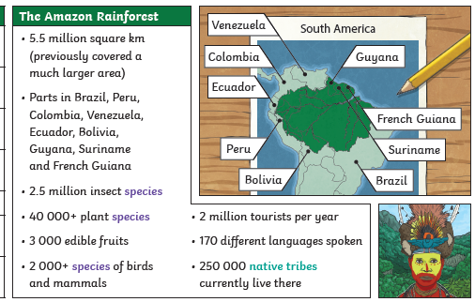  Human: land use, cutting down trees, farming, self-sufficiency, amenities, homes, infrastructure  Physical: using the river, using the trees, how to live from the natural environment, how they live amongst the animals, food is eaten as found i.e. don’t add non-natural products  UK – human more important  Amazon - physical more important
I am learning to understand and describe the human and physical features of California (N. America) and make comparisons of that to the Amazon  SC – I can:  - Compare the climates across the region  - Research how land is used*  - Research and record how many people live within the regions (population) and where the population is most dense  - Challenge: Compare this to other locations studied |  |  | Climate: sub-tropical Mediterranean climate  North America: temperate climate, colder winters, snow in mountains, summers are warm but not as hot, humid  South America: tropical climate, long, hot, dry, summers, mild winters, day time temperate stay warm most of the year.  Land use:  North America: mostly – rural, natural, vineyards, mountains, agricultural regions  South America: mostly – urban, well-developed, major cities  Both: costal on the west side
I am learning to explain the effect of the human impact on the physical features of the amazon rainforest.  SC – I can:  - Describe what is meant by deforestation, palm oil farming and fair trade  - Consider the impact on animals  - Consider the impact on humans  - Challenge: Consider how we can help reduce negative human impact on rainforests |  |  | 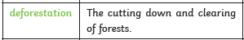  Effect on animals – loss of homes,  Effect on humans – income, different use of the land,  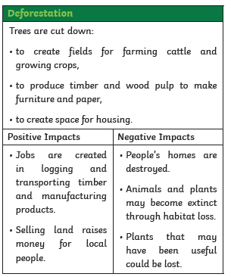  Food, shelter, clothes and medicine come from the rainforest.  Palm oil: What is Palm Oil? Facts About the Palm Oil Industry (worldwildlife.org)  Fair trade: What is Fairtrade? - Fairtrade Foundation
I am learning to describe the journey and features of the Amazon River  SC – I can:  - Research the key features.  - Map the river’s journey  - Investigate some of its tributaries  - Challenge: Compare this to other rivers I have studied or know about. |  |  | Largest river, second longest after the Nile  Largest drainage basin and water flow  Also known as River Sea  1/5 of the fresh water entering the Ocean comes from the Amazon  Countries it runs through: brazil, Ecuador, Bolivia, Venezuela and Peru  Source: Andes (Peru)  Mouth: Brazil into the Atlantic  4,000 miles long  Over 1,000 tributaries (Rio Negro is the largest)  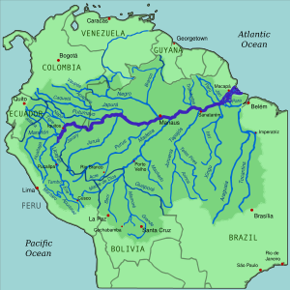
Post assessment questions:
Where is Brazil on a map?
What countries surround Brazil?
What oceans are around Brazil?
Where are tropical and temperate rainforests around the world?
What are the features and function of the layers of a rainforest?
What is the climate in Brazil like? Consider the temperature, humidity, wind speed and precipitation.
How are the human and physical aspects of the Amazon rainforest different to the UK?
How are the human and physical aspects of the Amazon rainforest different to a place in North America?
What is the impact of deforestation?
What are the key features of the Amazon river?
Where are some of its tributaries? Map the journey of the river.
SEND: |  | AGT: |  |  | Links to other subjects |  | Trips/experiences:
Make the river from salt dough |  | Identify river features of different looking rivers – differently presented rivers eg on a map, pictures.  Draw and label their own river  Pros and cons for the deforestation  Look at where other tropical and temperate rainforests are
Skills outcomes: |  |  |  |  | Resources:
- Use maps, atlases, globes and computer mapping to locate Brazil and places within  - Use keys to identify rivers in Brazil |  |  |  |  | Maps of Brazil and South America

Subject: Geography | Year: 5 |  | Term: Summer |  | Focus: Rivers |  |  |  | Time: Term
Learning Objectives and Success Criteria |  |  | Knowledge Outcomes:
LO: I am learning to identify features of a river.  SC – I can:  - Identify features of a river  - Explain the features and their function  - Challenge: I can identify features on a map |  |  | 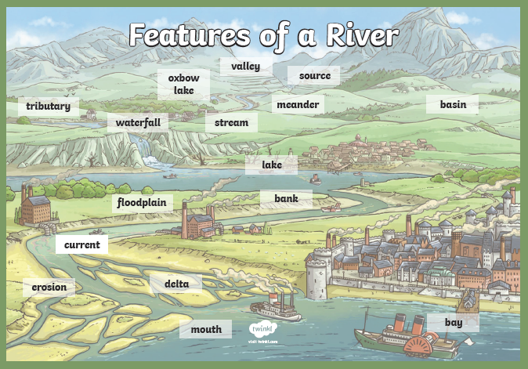  Upper/middle/lower course: 3 stages of the river  Mouth: where the river meets the sea/ocean  Source: where it starts  Tributary: small rivers that join  Confluence: point at which 2 rivers join  Meander: bend in the river  Water fall: where the river goes off the edge of a cliff  Ox bow lake: when the river changes its course and the meander gets cut off  Delta: sediment that is deposited at the mouth  Valley: low area between hills/mountains  Current: speed of the flow  Estuary: wide part of the river where it joins the sea.  Flood plain: an area of low-lying ground adjacent to a river, formed mainly of river sediments and subject to flooding  Levee: an embankment built to prevent the overflow of a river  Main Channel: the outline of a path of relatively shallow and narrow body of fluid
LO: I am learning to describe and understand key aspects of the water cycle.  SC – I can:  - Explain the process of the water cycle  - Explain the function of rivers in the water cycle  - Challenge: understand how the water cycle links to weather  . |  |  | Surface run off: When the rain hits the ground it runs over the ground into rivers and streams.  Underground water: present beneath Earth's surface in soil pore spaces and in the fractures of rock formations  Rivers/lakes/streams/sea – body  Precipitation: different ways water falls from the sky when too heavy – rain, hail, snow, sleet etc  Evaporation: when water is heated and turns into water vapour  Condensation: When water is cooled and returns to a liquid state  Wind  Heat source: sun  Transfer of water  Flood plains: area that floods due ot heavy rain fall  Infiltration: when water enters the soil  Transpiration: plants soak up water from under the ground, then give out water vapour from their leaves.  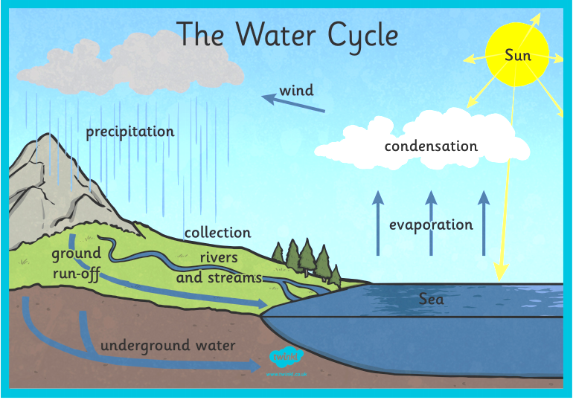  Water is part of a never-ending cycle and is always being recycled.
LO: I am learning to use grid references to identify features on a map.  SC – I can:  - Use 6-figure grid references  - Use 8 points of a compass to compare  - Use map symbols to identify features near a river  - Identify part of a river from a map  - Challenge: compare rivers |  |  | 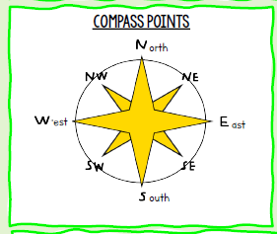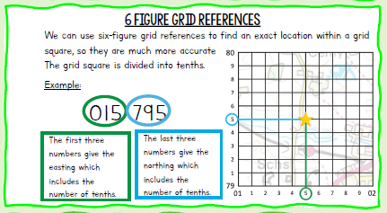  River map skills - River map skills - CCEA - GCSE Geography Revision - CCEA - BBC Bitesize
LO: I am learning to use an OS map to plan a route.  SC – I can:  - Use symbols to know what is on the route  - Draw my route  - Provide instructions for my route.  - Challenge: use scale to work out the distance of my route |  |  | Symbols for:
 |  |  | 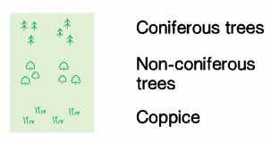  woodland |  |  | 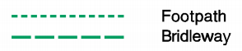  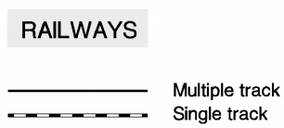  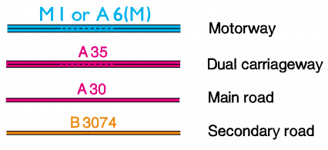  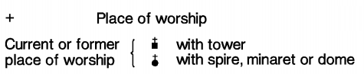  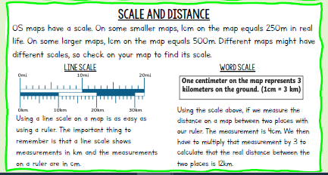
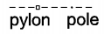
electricity pylons

public house


bridge

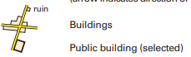
buildings
 |  |  | 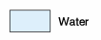

telephone box
LO: I am learning to use field work to observe, measure and record the physical features of sketch maps, plans and graphs including digital technologies.  SC – I can:  - Identify features from observations  - Identify physical features from observations  - Use pictures to explain the route I took  - Use pictures to explain the features found |  |  | Observing the changes and human and physical along the journey of the river.  Photograph the different features  Draw the route they took and label features of a river on the map
LO: I am learning to compare the physical and human features of the Amazon and River Itchen.  SC – I can:  - Identify physical features of the Itchen  - Identify human features of the Itchen  - Compare human and physical features  - Challenge: compare threats to the Itchen and Amazon |  |  | Amazon |  |  |  | Itchen
 |  |  | Human
 |  |  | Deforestation: chopping down large areas of the rainforest to make paper and timber.  Farming: controlling how much happens  National parks: where deforestation is illegal |  |  |  | Marinas  Boat yards  Pollution  Bridges  Weir (or low head dam): A barrier across the width of a river that alters the flow of water and usually results in a change in the height of the river level.
 |  |  | Physical
 |  |  | White water: contains a lot of sediment, so the water looks milky.  Clearwater: doesn’t have much sediments, so the water looks clear.  Blackwater: contains a mixture of sediment and dead plants that makes the water look black. |  |  |  | Chalk water
Post assessment:
- What are the features and functions of a river?
- What is the process of the water cycle?
- How could we use a map to find features of a river?
- How can we use an OS map to plan a route?

SEND: |  | AGT: |  | Links to other subjects |  |  |  | Trips/experiences:
Have the river journey already drawn, features to be added using photos taken from the day |  | Compare features of different rivers |  | Science – water cycle
Skills outcomes: |  |  |  | Resources:

