A non—European society that provides contrast with British History: Maya civilisation c.AD 900 Y6 Summer Term
LO/SC | Knowledge organiser
LO: I am learning where and when the Mayas lived  SC- I can  Place Maya period onto a timeline in relation to other time-periods studied  Locate Maya civilisation on a map (geog focus)  Compare Maya civilisation to what was happening in Britain at this time.  Challenge:  Discuss what could have been the causes of some of the differences between these civilisations? | 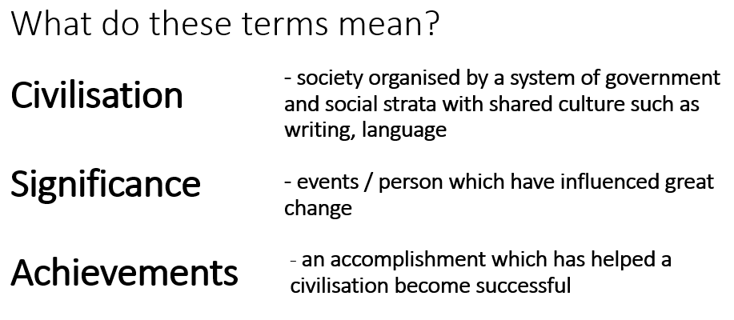  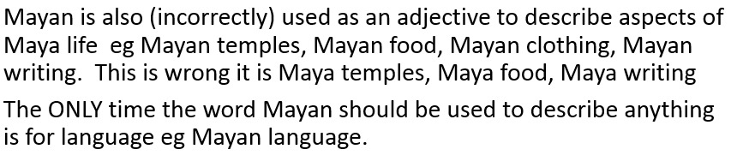  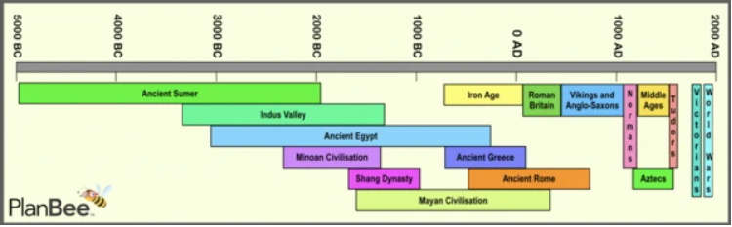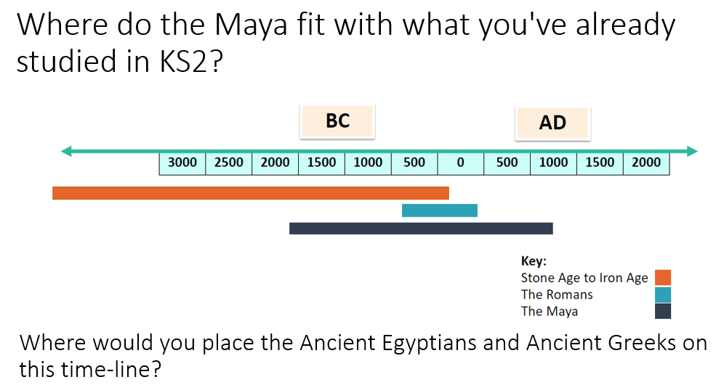  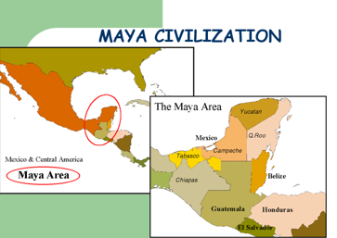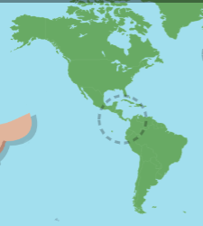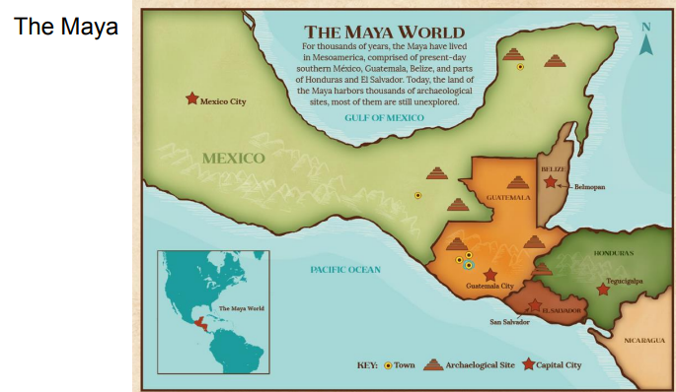
LO: I am learning about childhood in Maya civilisations  SC- I can:  Link sources and draw conclusions about Maya childhood/education  Communicate my understanding about the life of a child in Maya times  Compare the life of a child in Maya times a to another time period studied (Vikings/Anglo-Saxons)  Present my research in a cohesive way using historical terms  Chal  Consider which civilisation they would prefer to live in and why? | 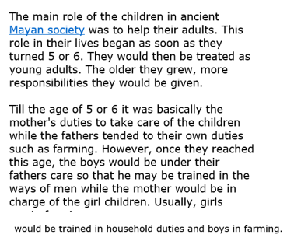  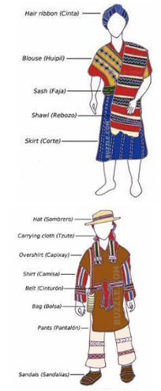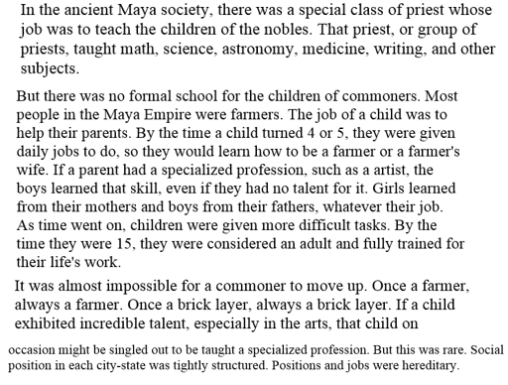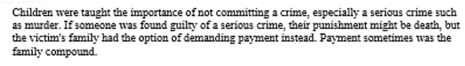  Some sources  https://historicalmx.org/items/show/111 children of Maya  https://mayas.mrdonn.org/school.html- education  https://www.bbc.co.uk/bitesize/topics/zq6svcw- games
LO: I am learning about houses in the Maya civilisation  Gather information from variety of sources  Evaluate the different evidence available  Describe and compare homes in Maya civilisation to homes in Britain at the same time  Present my research in a cohesive way using historical terms  Show an awareness that different evidence will lead to different conclusions  Chal  How do Maya homes compare to other historical periods studied | 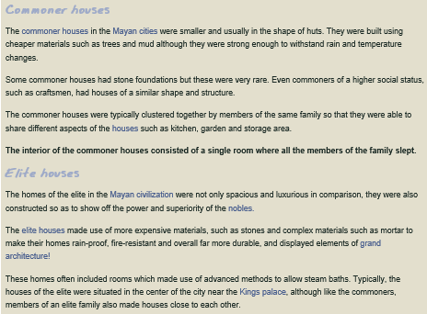  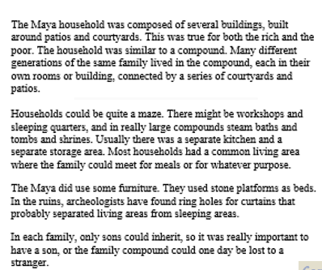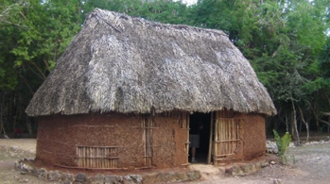  Some sources  https://everythingplayadelcarmen.com/mayan-houses/- how houses were constructed  https://mayas.mrdonn.org/homes.html  https://mayansandtikal.com/mayan-society/mayan-homes/  Check knowledge organisers from previous year groups for homes in Britain at same time
LO: I am learning about the social hierarchy during the Maya period  SC I can  Link sources and work out how conclusions about meanings were made.  Consider ways of checking the accuracy of a certain interpretation (fact/opinion) How do we know this is what these represented?  Challenge- How does this compare to other Ancient civilisations that you have studied? | 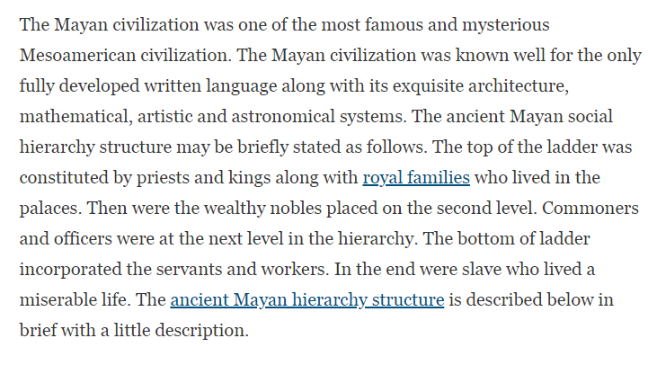  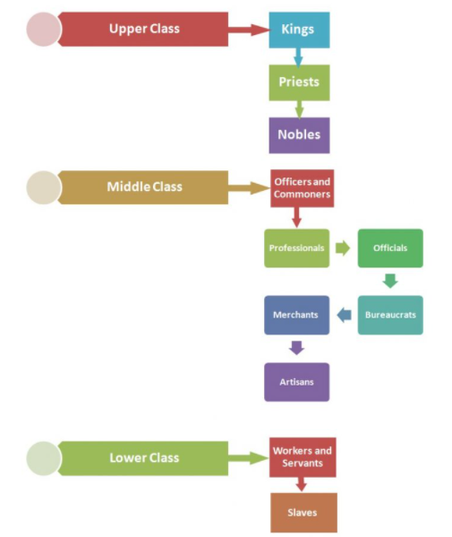  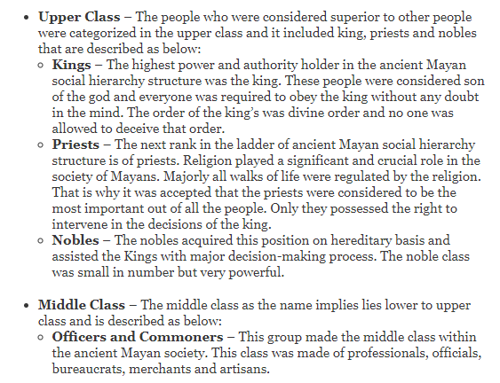  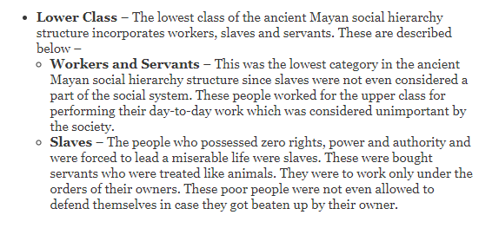  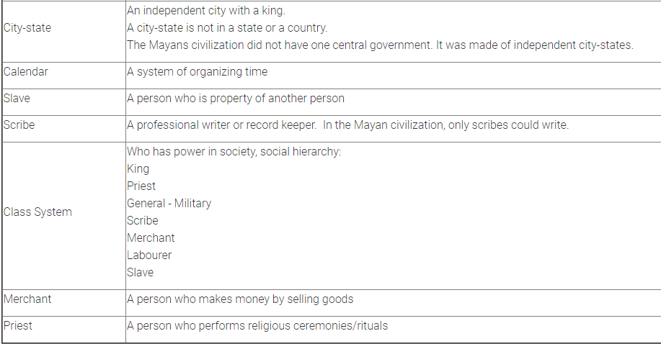  Some sources  https://www.hierarchystructure.com/ancient-mayan-social-hierarchy/ Maya Hierarchy  https://mayas.mrdonn.org/socialstructure.html Maya social structure  https://www.historyforkids.net/egyptian-hierarchy.html Ancient Egyptian hierarchy  https://study.com/academy/lesson/ancient-roman-social-structure-lesson-for-kids.html  Ancient Rome hierarchy
LO: I am learning about the religious beliefs of the Ancient Maya  I can discuss the Maya creation story  I can identify the importance of the different gods and goddesses  I can explain the purpose of religious rituals  Challenge: Create a Maya God explaining their role within the civilisation (or link to Science to explain a phenomenon) | 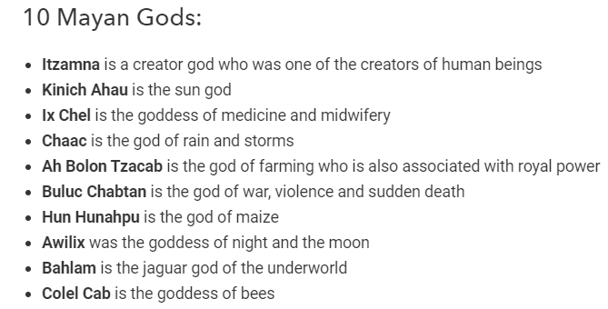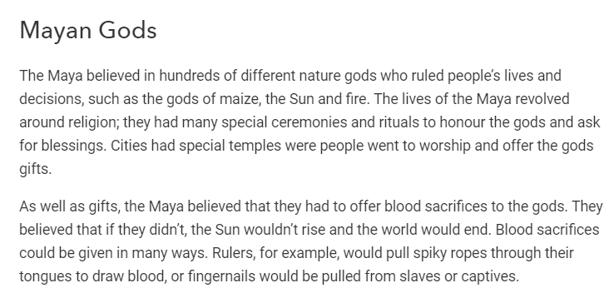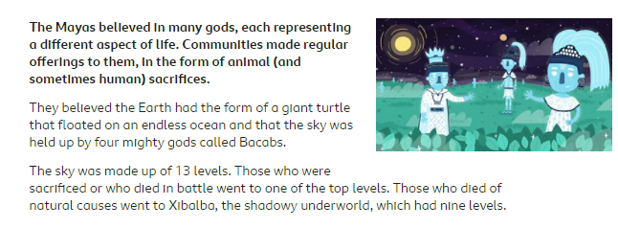  https://www.mayaarchaeologist.co.uk/school-resources/maya-world/maya-gods-and-goddesses/  plenty of information  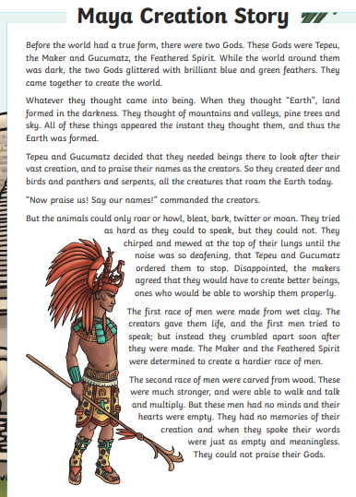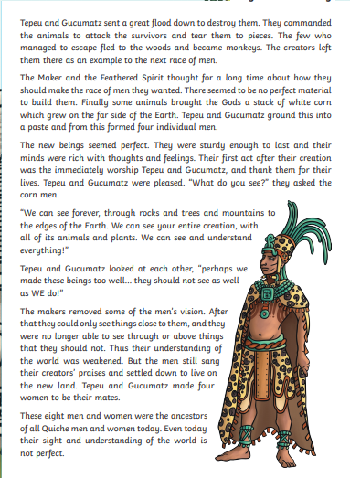  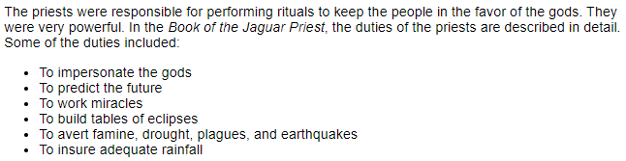  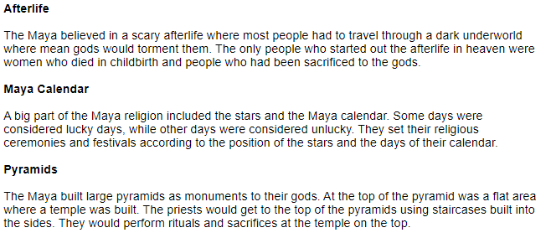  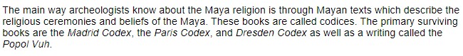  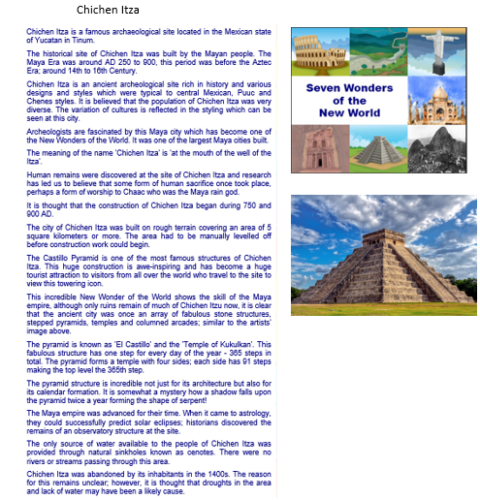
LO: I can compare two ancient civilisations  I can clarify what a civilisation is  I identify similarities within Ancient Egypt and Maya civilisations (childhood/education/homes/religion/social hierarchy)  I can identify differences between Ancient Egypt and Maya civilisations  Challenge: which civilisation would you prefer to live in and why? | information can be found on both Knowledge organisers

