Year 3 overview
Suggested experiences and trips
- Hillier gardens (Plant unit)
- Frogs copse (Animals including humans)
- Southampton Mineral and Fossil society (Rocks and fossils)

Suggested stretch and challenges
- Explanations of diagrams – how things work etc.
- Independent questions and independent research of that subject
- Independently research based

Scaffolds for SEND and EAL
- Word banks and pictures
- Definitions of key words
- Labelling of diagrams using key word.
- Observational skills – pattern seeking and classifying.
- Given research with glossary of key words.
- Specific research – Small paragraphs for each heading (easy read).

Year: 3: plants (Local area – topic link)
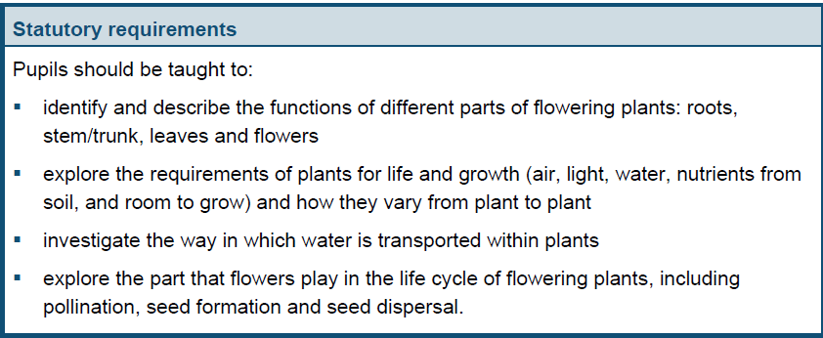
Curriculum objectives
Lesson Objectives
LO: I can identify and describe the functions of different parts of a flowering plant (the list can be used as a success criteria) (1 hour and 30 mins) (Working scientifically skill: Recording data – see progression of skills doc.)
LO: I am exploring what plants need for life and growth and how they are different from plant to plant. (the list here can be the success criteria) (2 hours) (Working scientifically skill: Questioning – see progression of skills doc. E.g. what if…)
LO: I am investigating how water is transported in plants. (2 hours) (Working scientifically skill: Approach and testing – see progression of skills doc.)
LO: I am exploring the life cycle of a plant.
(Working scientifically skill: Recording data – see progression of skills doc.) (1 hour)

Suggested activities:
- Dissecting plants – sticky back plastic (Label)
- Why does a plant have many roots? (P4C / PHSE) – experiment why (drink through lots of straws etc.)
Key Websites
Hamilton trust (use on chrome)
STEM website
- Plant experiment (using dye to see it travel around the stem (celery, daffodils etc.) – investigation – colours etc.
- Helicopter seed dispersal (Hamilton Trust investigation)

Key Vocab children should be using
Structure (flowering plants, roots, stem, trunk, leaves, flowers) function (nutrition, support, reproduction, makes own food), requirements for life and growth (air, light, water, nutrients from soil, room to grow, fertilizer), life cycle (flowers, pollination, seed formation, seed dispersal).

Resources
- Plants.
- Food colouring.
- Celery/carnations.
- Jugs of water.
- Bunch of different flowers per class (to be pulled apart).
- Sunflower, daffodil (showing male and female parts).
- Helicopter seeds.

Key questions
- What if I took the leaves off my flower? What would happen?
- Would a plant survive in a dark room?
- What is the purpose of each part of a plant?
Prior learning
- What does deciduous and evergreen mean?
- How might a tree/plant change through the year?
- Can the children label parts of a plant (root, stem, petal, leaf and a sun)
- How do
Year 3: Animals including humans – (Local area comparison)
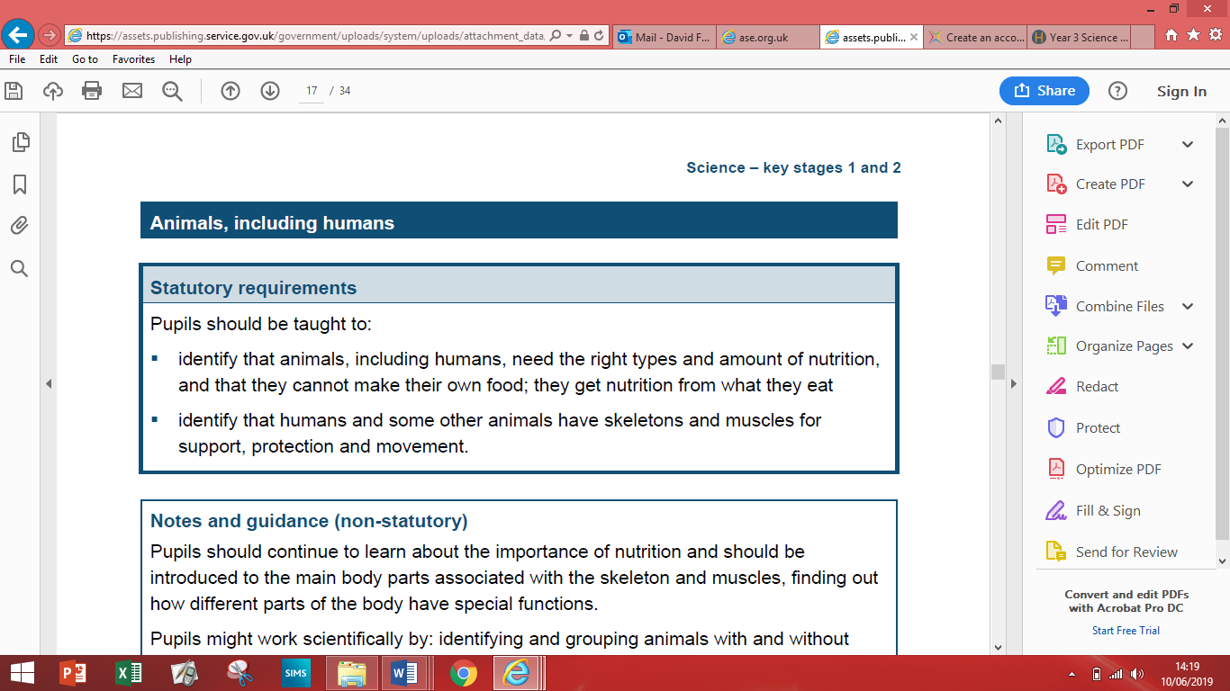
Curriculum objectives:
Lesson objectives
LO: I can identify that animals, including humans, need different types of nutrition to survive. (1 hour and 30mins)
(Working scientifically skill: Observe and measure– see progression of skills doc.)
LO: I can identify where animals, including humans, get their nutrients. (2 hour)
LO: I can identify and understand why humans and some animals have a skeleton (1 hour) (Use support, protection and movement for success criteria)
LO: I am exploring why muscles are important for humans and animals. (2 hour) (Working scientifically skill: Recording data – see progression of skills doc.)

Suggested activities:
- Comparing X-rays of animal skeletons.
- Muscles and movement investigations (Hamilton Trust)
- Maths focus and data analysis – looking at packages food and nutrients – calorie counts) – then create their own balanced diet.
- Comparison between elite athlete’s diet v normal people. GDS – looking at
Athletes and how many calories they lose.
- Comparing an animals diet with a humans diet – why is it different?
Resources
- Picture of animal skeletons.
- Research of different nutrition for animals. (food packaging)
- Card, split pin and string (making a muscle).
- X-rays of animals
- Research of athlete’s diets.
Prior learning
- Can the children understand what people need to survive – food oxygen etc?
- Show a baby animal and a baby human – what changes over time?
- What is a healthy diet and what types of food should you eat?
- Fossils and how they have changed.
Key questions
- How do we look after our bones?
- Why it important to have a balanced diet?
- Can they compare different types of animal skeletons – why are they different (giraffe and kangaroo).
Key Vocab children should be using
Nutrition, vitamins, minerals, fat, protein, carbohydrates, fibre, water, skeletons (support, protection) Skull (brain), ribs (heart and lungs) joints, muscles (movement, pull, contract) relax, diet.

Year 3: Rocks and fossils
Curriculum objectives:
Lesson Objectives
LO: I can compare and group different types of rocks. (1 hour 30 mins) (Working scientifically skill: Observe and measure– see progression of skills doc.)
LO: I can explain and describe how fossils are formed. (3 hours) (Working scientifically skill: Recording data – see progression of skills doc.)
LO: I am investigating what the soil is made from. (2 hours) (Working scientifically skill: Observe and measure– see progression of skills doc.)
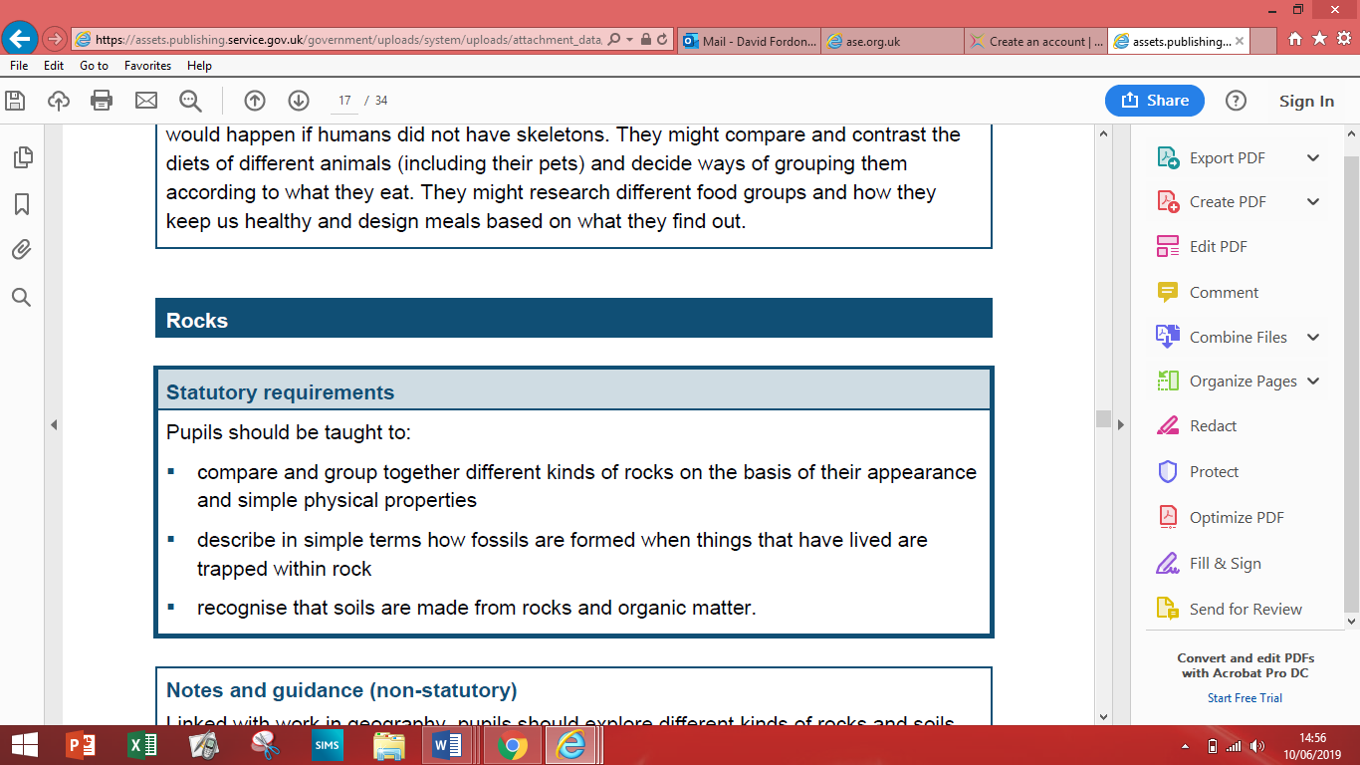
Suggested activities:
- Soil samples
- Observational drawings and labels
Key Vocab children should be using
Rock, stone, pebble, boulder, soil, fossil, grains, crystals, hard/soft, texture, absorb water, marble, chalk, granite, sun stone, slate, sandy soil, clay soil, chalky soil, peat.
- Rock detective investigations (acid test, hardness test and water test (Hamilton Trust) – create their own test.
- Investigation – linking fossils to their animal
- Make your own fossil (Hamilton Trust).
- Difference in rocks and fossils – water and weighing.

Key questions
- What do fossils tell us about the past?
- Show them a statue made of chalk and marble – which better and why?
- Why is a school roof made out of slate?
- Why do we use bricks?
- Why are the stones in your garden to different from those on the beach?

Resources
- Soil sample.
- Rocks.
- Fossils.
- Plaster Paris (child friendly).
- Water.
- Pipettes

Prior learning
- Bone structure – year 2 – what the skeleton does etc.
- What is a fossil?
- What are the differences between rocks and fossils?
- Where fossils come from?
- Rock formation – year 2 materials.

Year 3: Light (Victorian link – light sources)
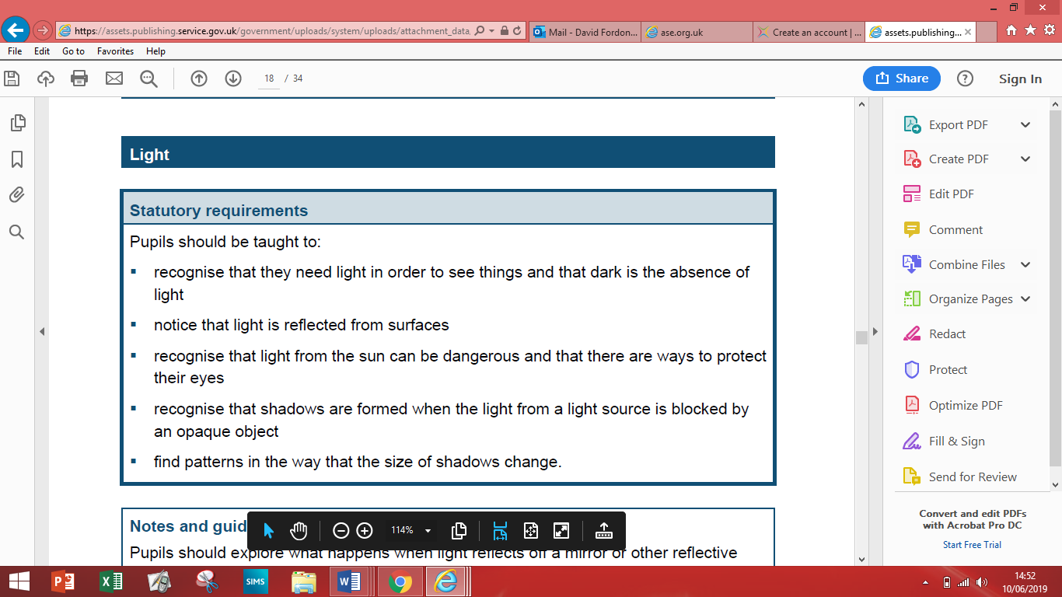
Curriculum objectives:
Lesson Objectives
LO: I can recognise that light is needed to see things. (30 mins) (Answer questions using scientific evidence) (Working scientifically skill: Recording data & Evaluating – see progression of skills doc.)
LO: I am investigating how shadows are formed when the light source is blocked by an opaque object. (Day) (Observe and measure) (Working scientifically skill: Approach and testing – see progression of skills doc.)
LO: I am investigating what surfaces are reflective. (1 hour and 30 mins) (Practical enquiries, comparative and fair test) (Working scientifically skill: Recording data & Evaluating – see progression of skills doc.)
LO: I can understand how the sun can be dangerous and how I can protect my eyes. (1 lesson)
LO: I can investigate why the sizes of shadows change. (1 lesson – investigation) Working scientifically skill: Observe & measure – unit of measure and evaluating skills.

Suggested activities:
- Drawing their shadows in the morning and then comparing that to other times of the day.
- Children to have a range of materials – they have to use the light to try to hit the target behind them – they need to use the materials to direct the light behind (torch fixed and cannot be moved) – questions based on what materials can be used. (Mirrors, glass, tin foil, shiny surfaces).
Key Vocab children should be using
Light, dark, reflect, reflective, surface, natural, artificial, star, sun. moon, torch, candle, lamp, translucent and transparent.
- Creating puppets or hand puppets (using materials to change the shadow on the wall.
- Looking at why if they move their hand the size changes etc. (challenge: layers of the shadows and the density of the shadows).
Resources
- Lights
- Torches
- Better unit to do in the summer (shadows).
- Mirrors
- Tin foil
Key questions
- What is a light source?
- What do you notice when I shine a torch?
- What is a shadow and why is it formed?
- How can I make light go round in a circle?
Prior learning
- What are the light sources?
Misconception: May say the moon is a light source – it is not.

Year 3: Forces and magnets – (Roman inventions)
Lesson Objectives
LO: I can investigate how different objects move on different surfaces. (2 hours) Working scientifically skill: Approach and testing and Observe and measure and (Newton’s) and Evaluating – see progression doc.)
LO: I can understand how magnets work and observe how they attract and repeal to each other and different materials.
Working scientifically skill: Recording data – see progression of skills doc.
LO: I can investigate what everyday materials are magnetic and compare these objects. Working scientifically skill: Observe and measure (classifying).
LO: I can label the different parts of a magnet (SC can be the two poles)
(Final NCLO is in success criteria – see separate doc)
Working scientifically skill: Recording data and Approach and testing

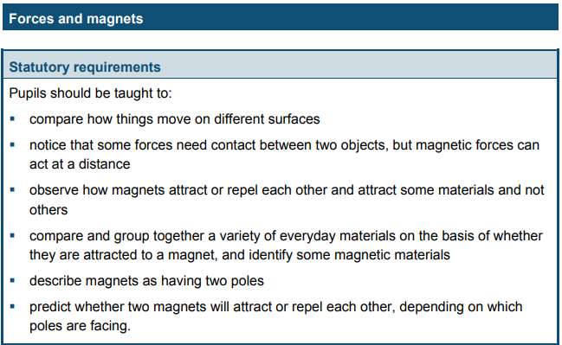
Suggest activities
- Open led investigation of objects being pushed on different materials (tables and carpets) – Why is there a difference in distance? Easier to push on different surfaces?
- Applying force to a variety of objects (door, opening a draw, kicking a ball, throwing a ball – all linking to that a force has been applied) looking at how the objects have moved (don’t worry about fair testing and explain why – children may apply more force than others) + (tug of war – pulling force) – different surfaces for pushing/kicking the object (ball) – collecting data.
- Blind fold children and guide them through a maze – forces.
- Magnetic attraction (Hamilton Trust).
- Show children (try to trick) using magnets – showing them that objects can move without a force been applied (magnets).
- Which objects around the room are magnetic and which aren’t.
- Hamilton Trust website.
- Exploring what magnets can and cannot do – make a generalisation with magnets then allow the children to do a child led investigation based on statements.
Resources
- Different types of magnets – horseshoe, pole magnets, disc magnets, wand magnets.
- Magnetic materials (metal discs).
- Different surface types.
Key Vocab
Force, push, pull, open, surface, magnet, magnetic, attract, repel, magnetic poles, north, south, metal, iron, steel.

Prior learning
- How does a seesaw work?
- How does a swing work? (You can use this for all playground objects)

Key questions
- Where and why margents used?
- Where might you find margents used?

Year 4 overview
Suggested experiences and trips
- Steve Dorney (Soton uni) (Sound)
- Marwell zoo (Living things and their habitats)
- Experiments
- Town hill walk (Living things and their habitat).
Suggested stretch and challenges
- Make comparisons when doing a fair test.
- Explanations of diagrams – how things work etc.
- Independent questions and independent research of that subject
- Independently research based.
- Open ended questions.

Scaffolds for SEND and EAL
- Word banks and pictures
- Definitions of key words
- Labelling of diagrams using key word.
- Observational skills – pattern seeking and classifying.
- Given research with glossary of key words.
- Specific research – Small paragraphs for each heading (easy read).
- Given the variables for testing.
- Closed questions.

Year 4: Living things and their habitats (Comparison between different European cities)
Lesson Objectives
LO: I can identify and compare living things and group them by their characteristics (1 hour and 30 mins) Working scientifically skill: Recording data – classifying – see progression of skills doc.
LO: I can use a classification key and identify and name a variety of living things in my local and wider environment. (1 hour and 30 mins) (Identify differences, similarities or changes classify) Working scientifically skill: Recording data – classifying – see progression of skills doc.
LO: I can understand that the environment can change and that can sometimes be dangerous to living things (2 hours)

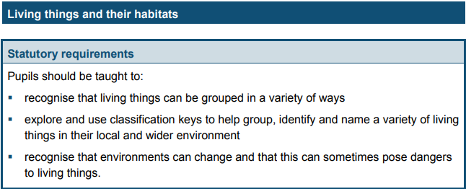
Suggested activities
- CT to take photos of school grounds (nature area) at the beginning/middle and end of the year – so children can then see the difference throughout the year.
- Comparison of animals living on the field (not a lot) and then comparing living things living in the nature garden – why is there a difference (draw key etc.)
- Organisation of animals that you have found and then put them in a classification key.
- Classification of living things that do not live here (spiders) – compare the differences between classifications of a different country.
- Man made changes in the environment – looking at housing blocks that have been made recently – what changes etc.
- Impact on local area and wildlife based on manmade environment – compare this to natural (flooding etc.)

Resources
- Tablets for photos
- Use of school field.

Key Vocab
Environment, flowering, non-flowering, plants, animals, vertebrate, danger, invertebrate, amphibians, reptiles, birds, mammals, fish, insects, population, development, deforestation.

Prior learning
- Can they draw and label a plant (stigma, carpel etc.)
- What key things does a plant need to survive?
- Can they describe the life cycle of a plant.

Key questions
- What would happen if the North and South Pole melted?
- What is the same and what is different between a flamingo and penguin?
- What is the difference between a snake and a worm?

Year 4: Animals including humans
Lesson Objectives
LO: I can identify parts of the digestive system and describe their function. (2 hours) Working scientifically skill: Recording data - see progression of skills doc.
LO: I can identify and compare different types of teeth in humans and describe their function. (2 hours and 30 mins) Working scientifically skill: Recording data - see progression of skills doc.
LO: I can construct and interpret a variety of food chains and identify the different roles within it. (1 hour and 30 mins) Working scientifically skill: Recording data - see progression of skills doc.

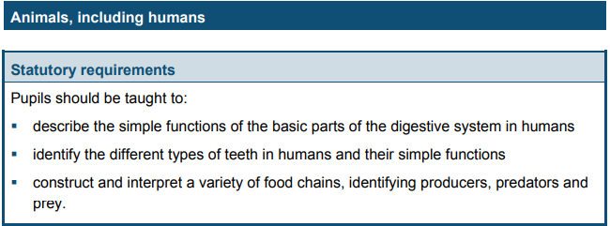
Suggested activities
- https://www.stem.org.uk/resources/elibrary/resource/35396/digestive-system-experiment (teacher led experiment)
- Eat sweetcorn and then children to observe poo – looking at how long it takes to be digested – children to look at how long it takes and record – looking at difference between adult and child)
- Eggshell and coke experiment – eggshell in different liquids – to see how it erodes – child led investigation.
- Look at their own teeth – dentist mirrors?
- Eat in class – which teeth are you using and why? Compare this to different animal’s teeth. Looking at their teeth and seeing if they can identify their diet.
- Hamilton Trust website.
- Excuse me – are these your teeth? Hamilton trust website. (Dental student UNI?)
- What happens to my food? – Hamilton Trust - Measure out intestine length.

Resources
- Skeleton model
- Teeth of different animals (Vet?)
- Eggs, coke, vinegar, orange etc.
Key Vocab
Prey, producers, predators, digestive system, tongue, moistens, saliva, oesophagus, transports stomach, acid, enzyme, small/large intestine, carnivore, omnivore, herbivore, food chain,

TEETH: incisors, canines, molars

Key questions
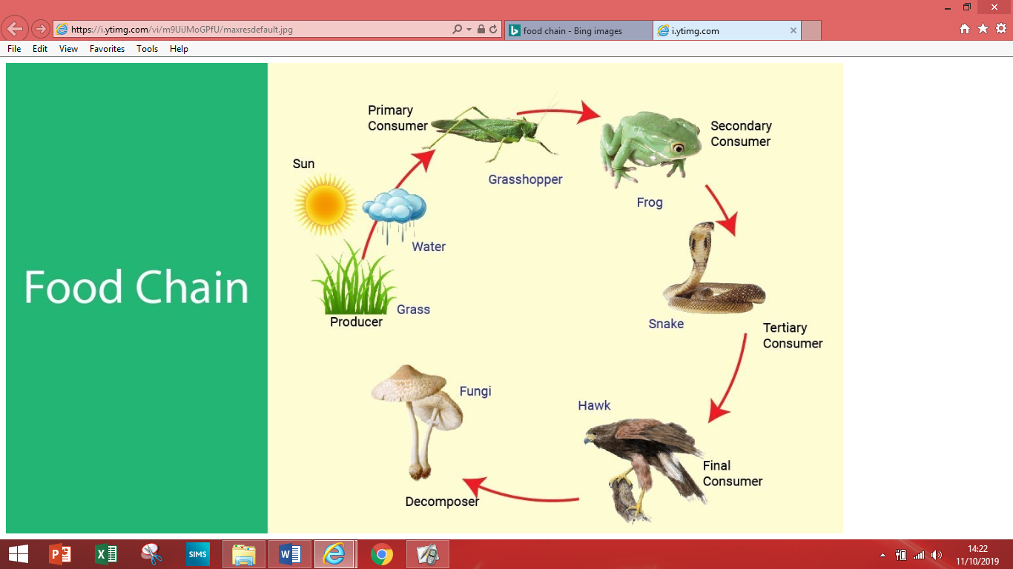What would happen if all the hawks died in that area?

Prior learning
See year 3 prior learning plus:
- What types of food would humans/animals need?
- What types of food would an athlete need compared to us?
- Which bones protect key organs?
- What can you tell me about muscles in the body?

Year 4: States of matter (Cooking – change of state – DT)
Lesson Objectives
LO: I can compare and group different materials according to whether they are solids, liquids of gases. (1 hour and 30 mins) Working scientifically skill: Observe and measure - see progression of skills doc.
LO: I am investigating how some materials change state when there is a change in temperature and record this appropriately. (3 hours) Working scientifically skill: Questioning & recording data - see progression of skills doc.
LO: I can understand how evaporation and condensation in the water cycle is important. (1 hour and 30 mins) (Answer questions using scientific evidence) Working scientifically skill: Recording data - see progression of skills doc.

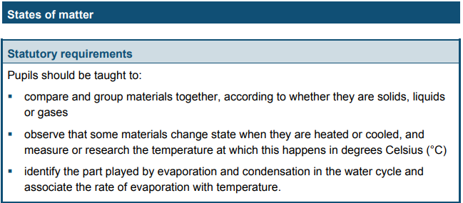
Suggested activities
- Glupe science investigation – making the glupe (year 4 planning morning)
- Changing states of different states of matter and explore what happens in the change (heated – why does it happen?) Recording temperatures of things.
- Create a water puddle on the tarmac – look at the difference throughout the day – what happens to it and why? Maybe keep a thermometer near and in the puddle and look at how hot it is when the matter changes state.
- Is chocolate spread a liquid? – Explore why and how it is or is not. Investigate whether it is or not – then think of different spreads to find out.
- Welcome to the science fair! (Hamilton Trust website)
- Water cycle: Heating ice/freezing water – changing state. Apply this knowledge to the water cycle. (Rain etc.)
Resources
- Solids, liquids and gases
- Corn flower (glupe)
- Ice cubes.
- Hair dryer
- Thermometer
Key Vocab
Evaporate, evaporation, condense, condensation, change of state, state, solid, liquid, gas, melt, freeze, condition, solidify, freezing, melting.

Prior learning
- What forces do they know about already?
- Mr Fordon wants to use a different material for his roof for his conservatory. What material should he use and why? (Glass, metal, thatch – multiple choice)

Key questions
- Do all objects change shape because they are heated in the same way?

Lesson Objectives
LO: I can identify how sounds are made, though vibrations (1 hour and 30 min) Working scientifically skill: Recording data - see progression of skills doc.
LO: I am investigating how sound travels through different materials (1 hour and 30 mins) Working scientifically skill: Approach & testing and Evaluating - see progression of skills doc.
LO: I am investigating how to vary the pitch of a sound e,g, the length of the instrument, the width of the string etc. (1 hour and 30 mins) Working scientifically skill: Recording data (classify) and Evaluating - see progression of skills doc.
LO: I am investigating how to change the volume of a sound and how this is linked to vibrations Working scientifically skill: Observe and measure & Evaluating - see progression of skills doc.
LO: I am investigating the relationship between sound and distance. (2 hours) (Working scientifically skill: Approach & testing and Evaluating - see progression of skills doc.)

Year 4: Sound
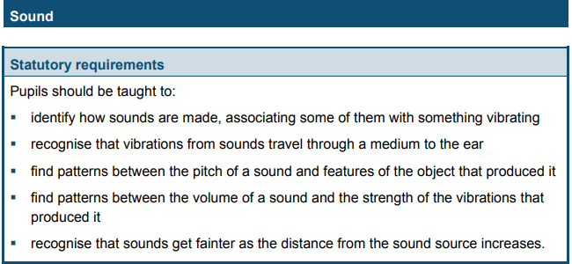
Suggested activities
- Rice on drums etc. – seeing sound vibrates.
- Explore how different objects make sound.
- Hamilton Trust website.
- Bowl of water and tuning fork (vibrations in water) – stations of all the above and then children can investigate and conclude.
- Investigation around how sound travels – sound in space and underwater. Telephone cup experiment.
- Saucepan lid experiment – how does size and shape effect sound?
- Have a general statement – then children investigate it – then design their own instrument making a specific sound.
- How can sound be stopped?
- What materials can be good at insulating sound? Investigation. (data logger?)
Resources
- Instruments
- Rice
- Slinky (sound waves)
- Headphones (muffling sounds)
- Tuning fork
- Phone app (pitch and volume of things)
Key Vocab
Sounds, pitch, loudness, vibrate, vibration, muffle, tuning, quiet, soft, noise, sound, low, vibrating.

Prior learning
- How does different instruments work, and how does it make that noise?
- If I stood outside the classroom and shouted compared to shouting with the door open – what would be the same and what would be different? (Volume)
- If you were in a cave - what would you notice?

Year 4: Electricity
Lesson Objectives
LO: I can identify what appliances need electricity. (1 hour lesson) Working scientifically skill: Recording data - see progression of skills doc.
LO: I can construct a simple electrical circuit. (1 hour and 30 mins) Working scientifically skill: Recording data - see progression of skills doc.
LO: I can identify whether or not a lamp will light in a simple series circuit, based on whether or not the lamp is part of a complete loop with a battery. (1 hour) Working scientifically skill: Questioning- see progression of skills doc. (don’t go into year 6 progression).
LO: I am investigating what materials make a good conductor and which act as insulators (2 hours) Working scientifically skill: Approach & testing and Evaluating & observe and measure - see progression of skills doc.

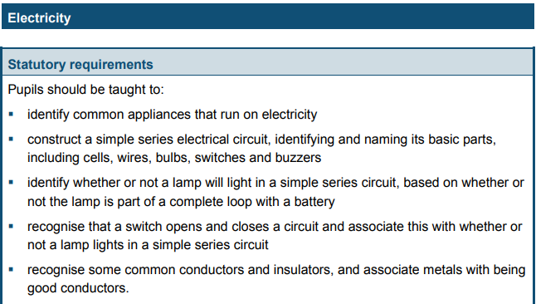
Suggested activities
- Electrical fun (Hamilton website).
Key Vocab
Circuit, complete circuit, conductor, insulator, symbol, circuit diagram, electricity, component, voltage
Resources
- Wires, bulbs, switches, buzzers, motors, batteries, battery cases.
- Insulator and conductor materials.
- Building a circuit (Hamilton website).

Prior learning (They would not have done this before)
- What electricity is and what it is used for.
- They can identify what objects need electricity and which are powered by a battery.
- Look at properties of materials (conductor, magnetic etc.)
Key questions
What is electricity?
How do we know if something I electrical?
What is a simple circuit?
How do electrical currents work?
How do we know what materials make a good conductor?

Year 5 overview
Scaffolds for SEND and EAL
- Word banks and pictures
- Definitions of key words
- Labelling of diagrams using key word.
- Observational skills – pattern seeking and classifying.
- Given research with glossary of key words.
- Specific research – Small paragraphs for each heading (easy read).
- Given the variables for testing.
- Closed questions.
- Concrete objects (earth and space).
Suggested stretch and challenges
- Make comparisons when doing a fair test.
- Explanations of diagrams – how things work etc.
- Independent questions and independent research of that subject
- Independently research based.
- Open ended questions.
- Create own hypothesis and investigate in independently.
- Explanation of subject knowledge – written (leaflet) or pupil teaching.

Suggested experiences and trips
- Buy in the butterfly kit – see the life cycle (Living things and their habitat).
- Winchester Science centre and planetarium (Earth and Space)

Year 5: Living things and their habitat (Rainforest topic)
Lesson Objectives
LO: I can identify and compare life cycles of different animals. (2 hours) Working scientifically skill: Observe and measure see progression of skills doc.
LO: I can observe the life cycle of an animal (1 hour) Working scientifically skill: Recording data see progression of skills doc.
LO: I can describe the life process of a plant. (2 hours) Working scientifically skill: Recording data see progression of skills doc.

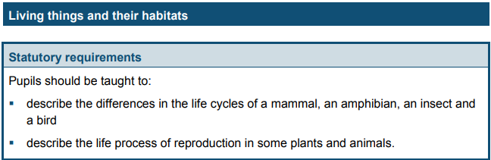
Suggested activities
- Butterflies and lava (to buy) – observe the life cycle a butterfly and describe and compare to other animals’ life cycles.
Key Vocab
Life process of reproduction (plants, animals, vegetable garden, flower border, reproduction. Plants (sexual & asexual). Animals (sexual). Life cycles (mammal, amphibian, insect & bird). Lifecycles around the world (rainforest, oceans, desert), prehistoric, similarities, differences, germination, pollination, stamen, stigma.
- Seed dispersal – dandelions – look at the similarities and differences between plants (plants abroad).
- Hand pollination.
- Sigmascience (very worksheet based) – comparing the life cycle of plants.
- Happy Chick Company – to buy eggs that hatch.
- Tadpols – amphibian life cycle.
- Amphibians – research based.

Key questions
What is a life cycle?
How do we know how a life cycle works?
Can you describe how an animals life cycle works?
What are the similarities and differences between an animal life cycle and a plant life cycle?
Resources
- Plants
- Sexual and asexual plants – potatoes, spider plants etc.
- Butterfly kit – life cycle.

Prior learning
- Can they classify animals into different groups?
- Pictures of different animals – how have they adapted to their environment? (compare frogs, birds from Britain to the rainforest) – how and why are they different?

Year 5: Animals, including humans (PSHE)
Lesson Objectives
LO: I can investigate whether the size of animal relates to the gestation period. (2 hours) Working scientifically skill: Recording data see progression of skills doc.
LO: I can describe the changes of the human life cycle. (3 hours) Working scientifically skill: Observe and measure see progression of skills doc.
LO: I can investigate whether the size of the animal relates to the gestation period. Working scientifically skill: Questioning &Recording data see progression of skills doc.
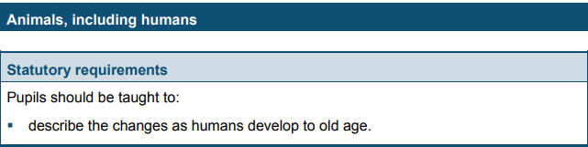
Suggested activities
- Links to puberty (PSHE + Sex education)
Key Vocab
Gestation, pregnant, life cycle, life expectancy, puberty, hormones, testosterone, physical changes.
- Gestation cycles – investigations (bigger they are, the longer they’re pregnant) – investigating between size of baby, length of life etc. – link to maths (mass of baby, lengths averages).
- Life cycles etc.
Key questions
How do we know we have changed as we have older?
Can you describe what a gestation period is?

Resources
- Sex ed video

Prior learning – year 5 Aut 1.
- Can you match offspring to adults?
- Describe the life of an animal.
- Can they compare different types of animals.

Year5: Properties and changes of materials (DT food – baking)
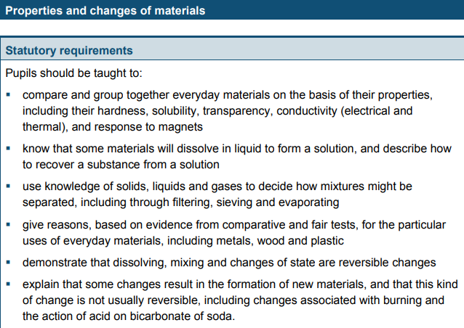
Lesson Objectives
LO: I can compare different materials based in their properties. (1 hour and 30 mins) Working scientifically skill: Observe and measure & Evaluating see progression of skills doc.
LO: I can identify which materials will change state (2 hours) (Ensure different to year 4) Working scientifically skill: Approach and testing and questioning see progression of skills doc.
LO: I can create a fair test to investigate reversible and irreversible states. (2hours) Working scientifically skill: Approach and testing & Evaluating & Recording data see progression of skills doc.
LO: I can investigate which solids dissolve. (1 hour and 30 mins) Working scientifically skill: Questioning and Approach and testing see progression of skills doc.
LO: I am investigating the separation of different materials. (1 hour and 30 mins) Working scientifically skill: Recording data and evaluating see progression of skills doc.

Key Vocab
Properties, hardness, solubility, transparency, conductive, response to magnets, dissolve, liquid, solution, solute, separate, separating, solids, liquids, gases, filtering, sieving, evaporating, reversible changes, mixing, melting, irreversible, insulation, conductivity, chemical, opaque, translucent, rusting, residue condensing.

Suggested activities
(Many little investigations)
- Give a range of materials – compare and investigating.
- Separating a variety of materials – oil/water, sand/stone, water/salt (dissolve)
- Hamilton Trust website.
- Investigations based from year 3 (see year 3 for ideas).
- Variety of materials – then come up with their own statements – transparency, solidness etc. (Self-led).
- Investigate reversible and irreversible states – why are some not? Explain etc.
- MUG cake – reversible and irreversible – HOW IS A MUG CAKE DIFFERENT TO A MUD CAKE? Investigation lesson.
- Research Spencer Silver.
Resources
- Materials with different properties including magnet.
- Dissolvable materials.
- Ice cubes.
- Sieve
- Magnets
- Beakers, filter paper
Key questions
What are the properties of different materials?
How do we know different materials change state?
Can you describe the differences in a reversible and irreversible state?

Prior learning
- What is the purpose of the plastic coating on the cables?
- Can they group objects found in the classroom.
- What is the difference between a candle and an ice cube?

Year 5: Earth and Space
Lesson Objectives
LO: I can describe the movement of the Earth and other planets to relation to the sun and the solar system. (1 hour and 30 mins) Working scientifically skill: Recording data see progression of skills doc.
LO: I can describe the movement of the moon relative to the Earth. (1 hour and 30 mins) Working scientifically skill: Recording data see progression of skills doc.
LO: I can investigate the Earth’s rotation and explain what is happening. (2 hours) Working scientifically skill: Evaluating see progression of skills doc.
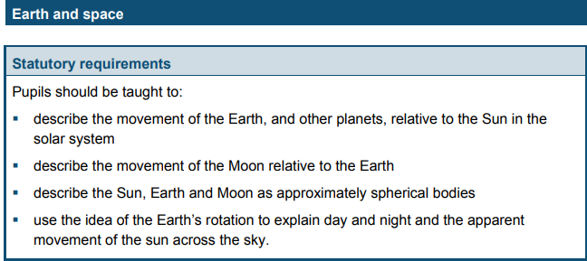
Suggested activities
- Link to DT – create the Solar system in groups with appropriate measurements.
Resources
- Concrete objects: fruits, balls etc.
- Video clips
- Hamilton Trust website
- Plenty of different YouTube videos to help.
- Link to art – draw the solar system with approximate distances.

Prior learning
- What if there was no sun?
- What if there was no moon?
- What if we swapped places with Mars or Mercury in the Solar system?

Key Vocab
Earth planets, sun, solar system, moon, celestial body, sphere/spherical, rotate/rotation, spin, night & day, Mercury, Venus, Mars, Jupiter, Saturn, Uranus, Neptune, Pluto, ‘dwarf’ planets, orbit, revolve, geocentric model, heliocentric models, shadow clocks, sundials, astronomical clocks.
Key questions
How does the moon move in relation to the sun?
Why does the earth rotate as it moves?
What does the earth move around?
How do other planets in our solar system move?

Year 5: Forces (DT – moving toy)
Lesson Objectives
LO: I can explain how gravity works.(1 hour) Working scientifically skill: Recording data see progression of skills doc.
LO: I can compare different types of resistances between moving surfaces. (3 hours) Working scientifically skill: Observe and measure & Approach and testing see progression of skills doc. (Do over 3 lessons
LO: I am investigating how force is used and how it effects different objects. (2 hours) Working scientifically skill: Questioning & Approach and testing data see progression of skills doc.
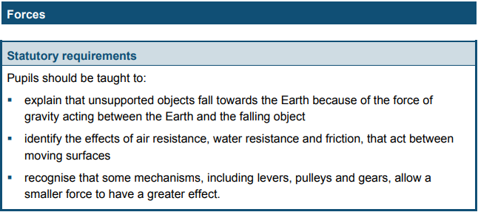
Suggested activities
- Carpet ramp – investigation of materials being released down the ramp, investigate why objects go down faster/slower.
- SIGMASCIENCE – investigate ‘when diving for rubber bricks in a swimming pool, Andy says that the bricks get heavier when lifting them out of the water?’ (newton measure – using water tanks)
Key Vocab
Fall, gravity, force, air resistance, water resistance, friction, moving surfaces, mechanisms, levers, pulleys, gears, magnetic force, magnet and attract.
- Air resistance – can use DT – look at how you can drop different objects – create ‘parachutes’ and drop objects.
- Catapults – adding force against air resistance.
- https://www.hamilton-trust.org.uk/science/year-5-science/forces-may-forces-be-you/
Key questions
What is gravity? How do we know what it is?
Who first identified gravity?
What is a resistance? How does this work?
How does force effect an object?
Resources
- Material boards (friction)
- Magnets etc.
- Water – basins for this.
- Plastercine
- Levers, pulleys and gears (toys that have this)

Prior learning
- Can they label the different parts of a magnet?
- Mr Fordon lost his needle in a haystack – what is the best way to help him find it?
- What would be different if I jumped on the moon compared to on earth?

Year 6 overview
Suggested stretch and challenges
- Make comparisons when doing a fair test.
- Explanations of diagrams – how things work etc.
- Independent questions and independent research of that subject
- Independently research based.
- Open ended questions.
- Create own hypothesis and investigate in independently.
- Explanation of subject knowledge – written (leaflet) or pupil teaching.
- Opportunities to explain to lower year groups (electricity and animals including humans
Scaffolds for SEND and EAL
- Word banks and pictures
- Definitions of key words
- Labelling of diagrams using key word.
- Observational skills – pattern seeking and classifying.
- Given research with glossary of key words.
- Specific research – Small paragraphs for each heading (easy read).
- Given the variables for testing.
- Closed questions.
- Concrete objects

Suggested experiences and trips
- Stubbington and non Stubbington week (Living things)
- Southampton Uni (Light and electricity)
- Dissection at Secondary school. (Animals including humans)

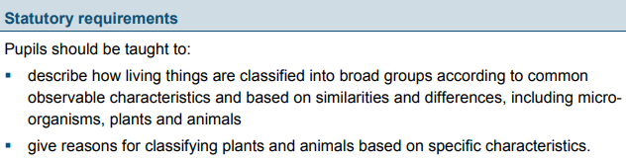
Year 6: Living things and their habitats (Topic mountains)
Lesson Objectives
LO: I can describe how living things are classified. (2 hours) Working scientifically skill: Recording data see progression of skills doc.
LO: I can classify living things accordingly. (1 hour and 30 mins) Working scientifically skill: Recording data see progression of skills doc.
LO: I can explain how different animals and plants are different. (1 hour and 30 mins)

Suggested activities
- Sweets, classify the sweets (texture, hard, shape, soft) etc. then link this to animals. (classification) – link this to plants and animals.
- Mouldy bread investigation.
Key Vocab
Organism, micro-organism, fungus classification keys, environment, fish, amphibians, reptiles, birds, mammals, vertebrates, invertebrates.
- Lots of scientists to research and explore.
- Classification tree of Townhill surroundings.
Resources
- Bread, fridge and freezer
- Research on scientists.

Prior learning
- How can they classify and group different types of animals?
- Can they describe the difference between two different plants? (Asexual and sexual reproduction)
- Comparing a baby to an adult – similarities and differences.
- Compare the life cycle of a plant to an animal.

Key questions
What is classification?
How do we classify living things? Why do we?
How are plants and animals different?

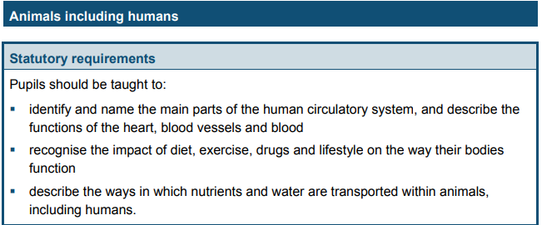
Year 6: Animals including humans (English – heart piece)
Lesson Objectives
LO: I can identify and name the main parts of the human circulatory system. (1 hour and 30 mins) Working scientifically skill: Recording data see progression of skills doc.
LO: I can describe the functions of the heart and what different parts do (2hours) Working scientifically skill: Questioning Observe and measure and recording data see progression of skills doc.
LO: I can recognise the impact of diet, exercise and drugs on your lifestyle. (1 hour and 30 mins) Working scientifically skill: Questioning see progression of skills doc.
LO: I can explore how nutrients and water are transported within animals (1 hour and 30 mins) Working scientifically skill: Observe and measure & Approach and testing and Evaluating see progression of skills doc.

Suggested activities
- Circuits in PE – recording scores and creating graphs.
- Dissection of heart.
- Heart circulatory system rap.
- 3D puzzle heart (to buy).
- How different food effects – calorie intake to year 3.
- What we need the different food groups for? Link to maths for proportions.

Key questions
How does our circulatory system work?
What are the main parts of our circulatory system?
How does our diet and exercise effect our circulatory system?
How is water transported?
Resources
- Heart
- Heart research
Prior learning
- Can they label and explain the functions of different teeth?
- Can they explain how the digestive system?
- How would the diet of an athlete be different to a non-athletic person.
- How would the diet of a child be different to an adult?

Key Vocab
Circulatory system, heart, blood, blood vessels, pumps, oxygen, carbon dioxide, lungs, nutrients, water, diet, exercise, drugs, lifestyle.

Year 6: Evolution and inheritance (PSHE)
Lesson objectives
LO: I can recognise that living things change over time. (1 hour 30 mins) Working scientifically skill: Observe and measure see progression of skills doc.
LO: I am exploring how fossils are formed (1 hour 30 mins) Working scientifically skill: Observe and measure see progression of skills doc.
LO: LO: I am exploring what parts of an offspring are similar their parents and why this is the case (1 hour 30 mins) Working scientifically skill: Observe and measure see progression of skills
doc.LO: I am investigating how animals and plants have adapted to their environment. (2 hours)

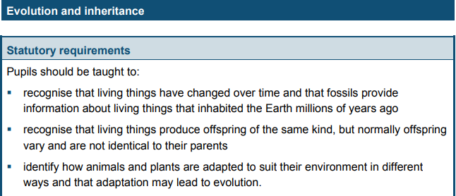
Suggested activities
- The flanamals – match habitats to the animals. (explanations)
- Genetics – Mr Men activities
- How animals have changed over time – our evolutions.
- Bird beak investigation.
- Crossbreeding of animals – selective breeding.
- Adaptation of environment – plants – cactus, lily pads, ivy etc.
- Harsh environment – specific plants.
- Fossils – drawing – cross curricular.

Key Vocab
Evolution, suited/suitable, adapted/adaptation, offspring, characteristics, vary/variation, inherit/ inheritance, fossils.
Resources
- Bird beak investigation stuff
- Bones
- Genetic equipment.

Prior learning (Year 3 – rocks and fossils)
- How animals have adapted over time to suit their habitat.
- Looking at bone structure and how this has adapted over time.
- Looking at how and why fossils have changed over time.
- We know we have adapted due to the research in the fossils and bone structure.
- How teeth have changed – year 4.

Key questions
How and why do living things change?
How are fossils formed and why/how are they formed?
How and why are we similar to our parents?

Year 6: Light (Topic – Blitz)
Lesson Objectives
LO: I am investigating how light travels. (2 hours) Working scientifically skill: Recording data & Observe and measure see progression of skills doc.
LO: I am investigating how and why objects reflect and how that impacts sight. ( 1hour and 30 mins) Working scientifically skill: Questioning & Evaluating see progression of skills doc.
LO: I can explain how light travels in straight lines and why shadows form. (2 hours) Working scientifically skill: Observe and measure & Evaluating see progression of skills doc.

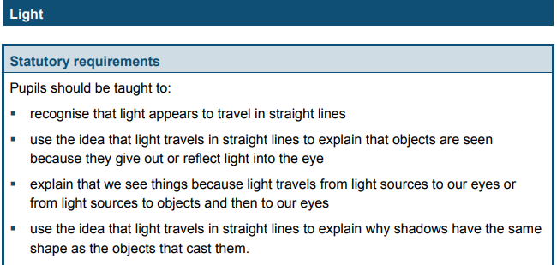

Suggested activities
- Torch experiment
- Science university trip.
Key Vocab
Light, travels, straight, reflect, reflection, light source, object, shadows, mirrors, periscope, rainbow, filters.
- Looking at different materials – investigations.
- Make your own periscope
- Shadow giants (Hamilton trust)
- Investigation – rainbows and the light.

Key questions
How does light travel?
How and why are shadows formed?
How does reflection work?
What is a light source?
Why is the moon not a light source?
Resources
- Lights
- Torches
- Better unit to do in the summer (shadows).
- Mirrors
- Tin foil

Prior learning (Year 3)
- What is a shadow and why is it formed?
- Recap shadows and reflective surfaces.

Year 6: Electricity (DT fairground)
Lesson objectives
LO: LO: I am investigating how to make a light brighter in a circuit (where there is only one bulb) or a buzzer louder Working scientifically skills: Approach and testing and evaluating.
LO: I can compare and explain how different components function. (2 hours) Working scientifically skills: Questioning & Approach and testing & Evaluating
LO: I can recognise different symbols and use them in my own circuit. (1 hour) Working scientifically skills: Recording data.
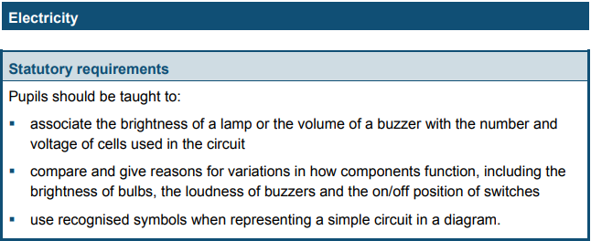
Suggested activities
- Investigating electrical circuits
- Create complex circuits and then reflect why they do/don’t work. Create circuits to create a dimmer/brighter light – how does this work?
- Entering the dragon’s den work
- Electrical festive challenge
Key Vocab
Appliances, electrical circuit, complete circuit, circuit diagram, circuit symbol, components, cell, battery, positive/negative, terminal, connection, loose connection short circuit, wire, crocodile clip, bulb, brightness, switch, buzzer, volume, conductor, insulator, voltage, current, resistance, danger, series circuits.

Prior learning
- Can they label components in simple circuits?
- Can they explain how simple circuits work/if not why not?
- How is electricity used within the world?
- If some circuits work/do not work based on different materials being conductors etc.
Key questions
What do the different symbols mean in an electrical circuit?
What makes an electrical circuit?
Can you explain the different functions of components within an electrical circuit?
Resources
- Wires, bulbs, switches, buzzers, motors, batteries, battery cases.
- Insulator and conductor materials.
- Voltage gauge.

