LO and SC | Knowledge organiser
Unit: Animals including humans  LO: I can identify that animals, including humans, need different types of nutrition to survive.  Success criteria:  - I can name the different food groups  3  - I can give examples of foods that go into the different food groups.  - I can explain how each food group benefits us.  - Challenge: I can explain why a balanced and healthy lifestyle is needed. | 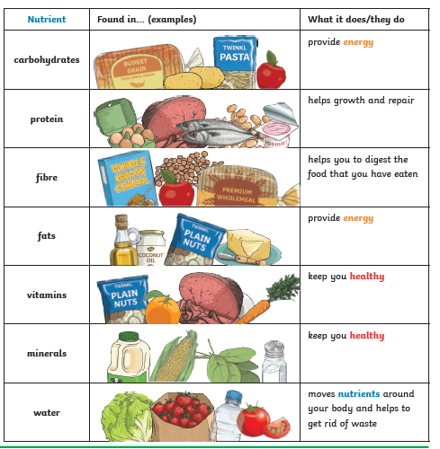
LO: I can identify where animals, including humans, get their nutrients.
Success criteria:
4
- I can name where animals get their nutrients from
- I can give examples of foods and explain why it is beneficial.
- Challenge: I can explain the difference between an animals diet compared to our own.

LO: I can identify and understand why humans and some animals have a skeleton  Success criteria:  1a  - I can demonstrate how bones provide support and shape to an animal’s body  - I can explain how bones protect organs (e.g. the skull protects the brain)  - Challenge: Consider what may happen if we did not have a particular bone | 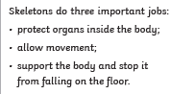  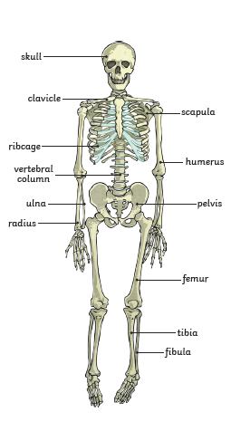
LO: I can explain how skeletons move
I can describe how a hinge joint works
I can describe how a ball and socket joint works
I can locate different types of joint on a human skeleton
Challenge: Annotate an animal skeleton, identifying where the two types of joint may be, and why.

LO: I am exploring why muscles are important for humans and animals.  Success criteria:  - I can explain what joints re and how they allow movement  - I can demonstrate how muscles contract and relax and the effect this has  2  - I can show how muscles work together and in opposition to allow my body to move.  - I can explain how muscles are connected to bones  - Challenge: Consider what would happen if you do not have a particular muscle | 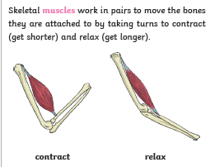

PLEASE SEE KNOWLEDGE ORGANISER FOR ALL KEY VOCAB AND DEFINITIONS

