LO and SC | Knowledge organiser
Forces and magnets  LO: I can investigate how different objects move on different surfaces.  Success criteria:  - I can observe how forces act in opposite directions to each other.  - I can explain how when an object moves across a surface, friction acts as an opposite force.  - I can investigate how some surfaces create more friction than others  - I can show that on a ramp, the force that causes the object to move downwards is gravity  Challenge: I can consider how friction affects the speed at which an object moves over a surface | 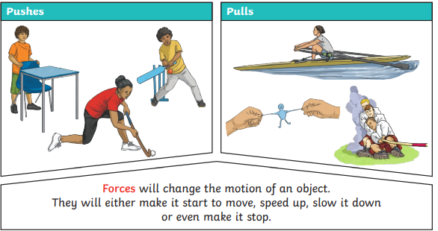  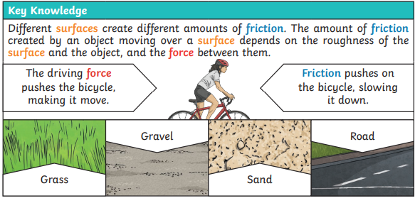
LO: I can investigate which everyday materials are magnetic  Success criteria:  2 & 3 Test metals first, then everyday objects. Can they link what they learnt  - I can plan an investigation  - I can test which metals are magnetic  - I can test which metals are not magnetic  - I can test other types of materials  - Challenge: I can give examples from everyday life where magnetic forces are used | 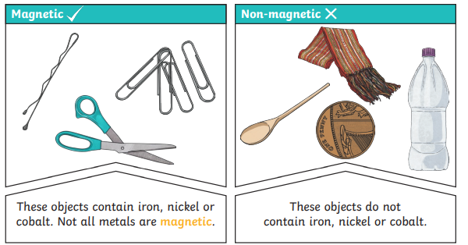
LO: I can identify the different parts of a magnet  Success criteria:  - I can label the north and south poles of the magnet  1  - I can test which poles attract and which poles repel  - I can use my knowledge of magnets to predict what will happen  - I can explain what attract and repel mean  - Challenge: I can write a conclusion on what I discovered | 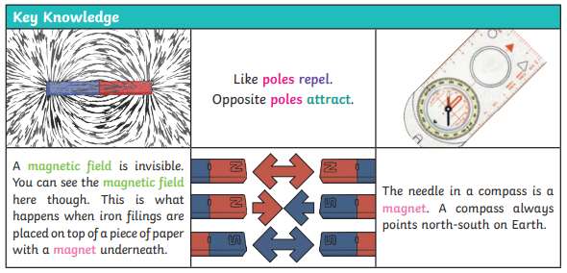

PLEASE SEE KNOWLEDGE ORGANISER FOR ALL KEY VOCAB AND DEFINITIONS

