LO and SC | Knowledge organiser
LO: I can recognise that light is needed to see things.  Success criteria:  - I can describe why if there is light I can see.  - I can explain what will happen if there is no light  - I can prove that if there is more light I can see better  - Challenge: Give examples of how lights are used to keep us safe | 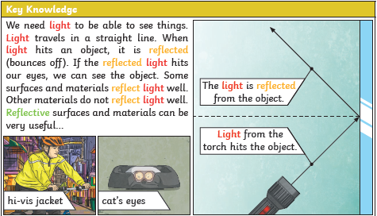
LO: I am investigating how shadows are formed when the light source is blocked by an opaque object.  Success criteria:  - I can demonstrate how a shadow is formed by an object blocking the light source.  - I can investigate opaque materials that cause a shadow.  - Challenge: Can translucent objects cause a shadow? | 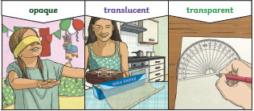  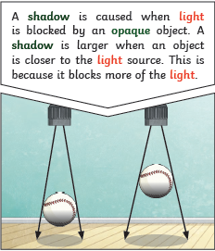
LO: I am investigating what surfaces are reflective.  Success criteria:  - I can give examples of objects can reflect and those that can’t.  - I can give reasons why smooth, shiny and flat surfaces reflect the best.  - I can use a diagram to show how a mirror works.  - Challenge: When you look in the mirror and raise your right hand, why does it look like you are raising your left in the reflection? | 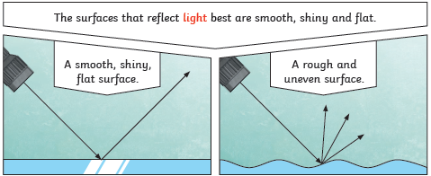  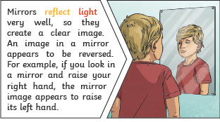
LO: I can understand how the sun can be dangerous and how I can protect my eyes.  Success criteria:  - I know that the sun is a ball of fire  - I can explain what will happen to my eyes if I look at the sun  - I can consider ways to protect my eyes  - Challenge: I can consider other sources of light that could be dangerous | 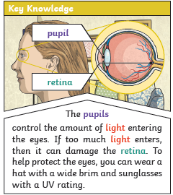
LO: I can investigate why the sizes of shadows change.  Success criteria:  - I know that a shadow is caused when light is blocked by an opaque object.  - I can investigate how the distance the object is from the light source changes the size of the shadow  - I can explain why when the light source is directly above the object, the shadow will be directly underneath  - Challenge: I can consider real life situations where the position of the light and the shadow are important | 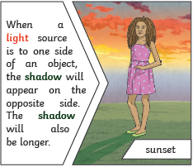  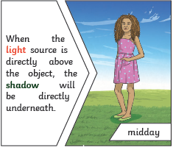

PLEASE SEE KNOWLEDGE ORGANISER FOR ALL KEY VOCAB AND DEFINITIONS

