LO and SC | Knowledge organiser
Rocks and fossils  LO: I can compare and group different types of rocks.  Success criteria:  • I can identify what an ingenious rock type is.  • I can identify what a sedimentary rock is.  • I can identify what a metamorphic rock is.  • Challenge: I can compare the structure of different types of the rocks. | 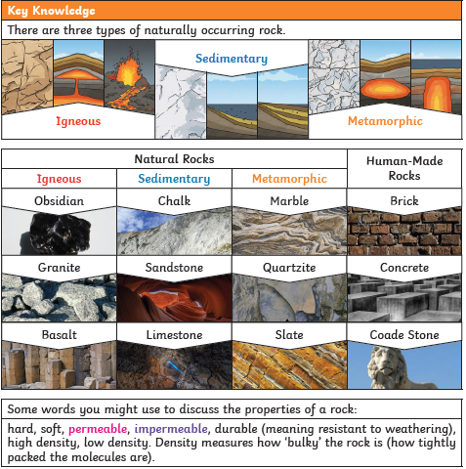
LO: I can explain and describe how fossils are formed.  Success criteria:  • I can explain what fossils are  • I can explain how fossils are usually formed  • Challenge: I can consider why fossils are useful to helping us understand the world | 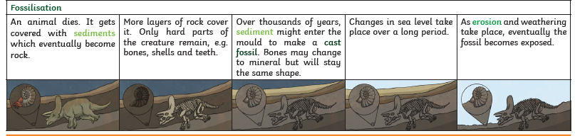
LO: I am investigating what the soil is made from.  Success criteria:  • I can describe the different ‘ingredients’ in soil  • I can observe the different layers in soil  • I can draw and label the different layers in soil  • Challenge: I can identify what lives in soil and how it survives | 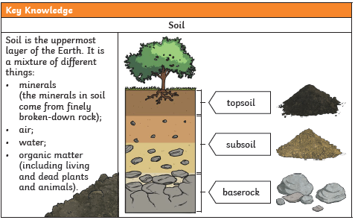

PLEASE SEE KNOWLEDGE ORGANISER FOR ALL KEY VOCAB AND DEFINITIONS

