LO and SC | Knowledge organiser
LO: I can identify and describe the functions of different parts of a flowering plant  Success criteria:  - I can identify where the roots are and what they do.  - I can identify the stem/trunk and what it does.  - I can identify the leaves and flowers and what they do.  - Challenge: I can consider what would happen to the plant if one of these parts was missing | 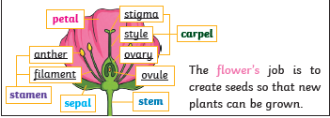  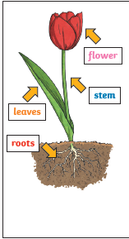
LO: I am exploring what plants need for life and growth and how they are different from plant to plant.  Success criteria:  - I can explain why a plant needs air, light, water and nutrients  - I can describe how a plant gets these.  - I can explain why a plant needs room to grow.  - Challenge: I can investigate what happens if a plant is deprived of one of these | 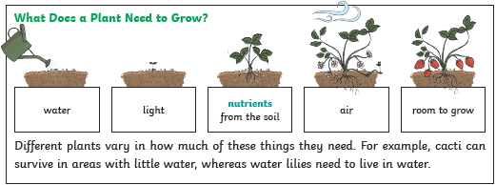
LO: I am investigating how water is transported in plants.  Success criteria:  - I can explain that water is absorbed from the soil by the roots.  - I can show how it is transported from the roots to the stem and then to the rest of the plant  - Challenge: I can consider why it is this important to the plant and what would the effect be if the water couldn’t be absorbed. | 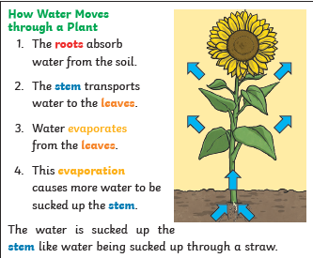
LO: I am exploring the life cycle of a plant  Success criteria:  - I can say why a plant needs to produce seeds  - I can explain how insects pollinate plants  - I can explain how the pollen travels to the ovule  - I can describe the fertilisation process  - I can describe why seeds need to be dispersed  - Challenge: How climate change affect this? | 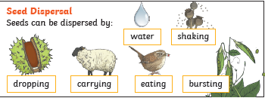  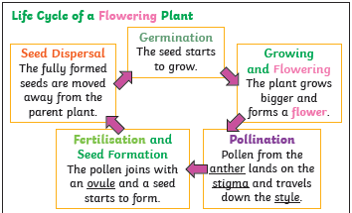

PLEASE SEE KNOWLEDGE ORGANISER FOR ALL KEY VOCAB AND DEFINITIONS

