LO and SC | Knowledge organiser
Animals including humans  LO: I can identify parts of the digestive system and describe their function.  SC: I can:  - Identify the oesophagus, stomach, small intestine, large intestine and rectum  - Explain the function of these organs  - Challenge: consider how these organs differ in different animals | 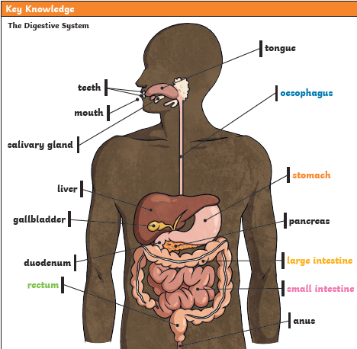
LO: I can identify and compare different types of teeth in humans and describe their function.  SC: I can:  - Demonstrate how teeth are used for cutting and chewing food.  - Show how teeth start the digestive process which gives us the energy we need to live.  - Explain why and how humans need to look after their teeth  - State the risks of not looking after my teeth  - Explain the appearance and purpose of canines, incisors, premolars and molars.  - Challenge: Identify differences, similarities or changes) | 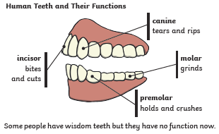
LO: I can construct and interpret a variety of food chains and identify the different roles within it.  SC: I can:  - Use a food chain to show the flow of energy  - Identify producer, predator and prey  - Identify herbivores, carnivores and omnivores  - Label primary, secondary and tertiary consumers  - Challenge: consider what would happen if one part of the food chain was removed from the habitat | 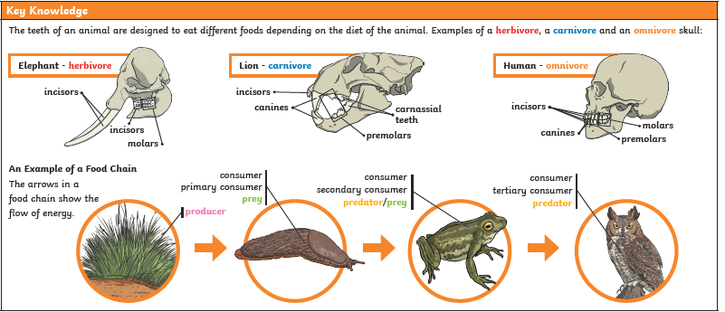

PLEASE SEE KNOWLEDGE ORGANISER FOR ALL KEY VOCAB AND DEFINITIONS

