LO and SC | Knowledge organiser
LO: I can identify what appliances need electricity.  SC – I can:  - Say how electricity generated using fuel sources  - Give examples of appliances that are powered by batteries and mains electricity  - Explain why different types of batteries are needed  - Challenge: consider different ways of powering appliances | 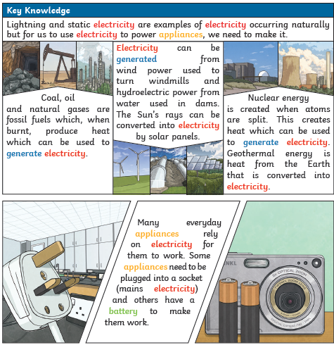
LO: I can construct a simple electrical circuit.  SC – I can:  - Demonstrate a simple complete circuit with wires, an energy source and an output  - Demonstrate how to break and reconnect a circuit and describe the effect of this  - Explain the purpose of a switch and how it works within the circuit  - Challenge: Identify circuits that are complete and incomplete | 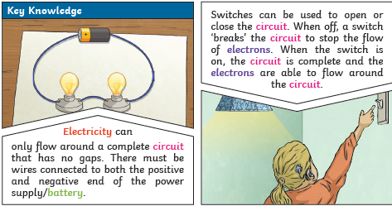
LO: I can identify whether or not a lamp will light in a simple series circuit, based on whether or not the lamp is part of a complete loop with a battery.
SC – I can:
- Hypothesise about whether a circuit will work or not
- Describe how I will test my hypothesis
- Test my hypothesis
- Challenge: consider different ways to power a circuit

LO: I am investigating what materials make a good conductor and which act as insulators  SC – I can:  - Predict which materials will allow electricity to pass through (conductor) and which will not (insulator)  - Plan a test to find out which materials are conductors and which are insulators  - Compare the materials that act as conductors  - Challenge: I can discuss where insulators might be used in every day life | 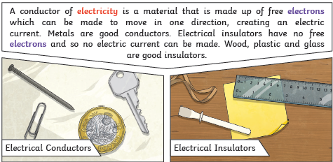

PLEASE SEE KNOWLEDGE ORGANISER FOR ALL KEY VOCAB AND DEFINITIONS

