LO and SC | Knowledge organiser
LO: I can identify how sounds are made, though vibrations  Success criteria: I can  - Say what a sound is and identify sources of sound  - Demonstrate how a sound is made, by an object vibrating  - Describe how a sound travels between the object, through the air, to the ear and then from the ear drum to the brain  - Challenge: consider why different objects make different sounds | 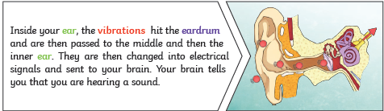  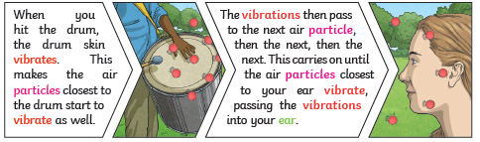
LO: I am learning how sound travels through different mediums  Success criteria: I can  - Explain how sound travels through a solid, gas and liquid  - Investigate which solids it travels through most easily  - Challenge: I can compare how sound travels in different ways  - WSS: you do- predicting, fair testing and recording results (we do conclusion) | 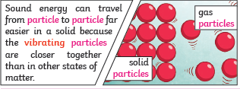  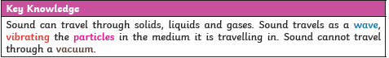
LO: I am investigating how to vary the pitch of a sound e.g. the length of the instrument, the width of the string etc.  Success criteria: I can  - Give examples of sounds that have a high or low pitch  - Compare the pitch made by different instruments  - Investigate how the differences in instruments create different pitches  - Challenge: identify patterns | 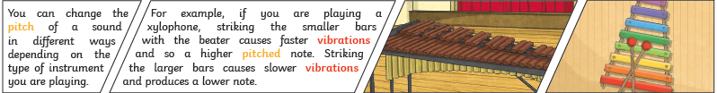  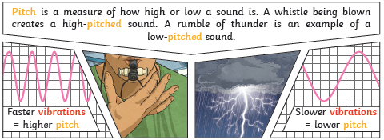
LO: I am investigating how to change the volume of a sound and how this is linked to vibrations  Success criteria: I can  - Give example of loud and quiet sounds  - Investigate how the energy used to produce the vibration changes the volume of the sound  - Challenge: Consider practical uses for this information e.g. noise reduction and management | 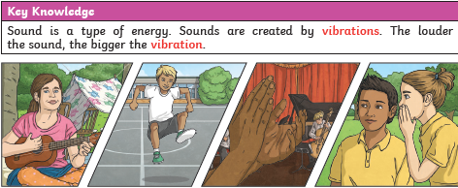  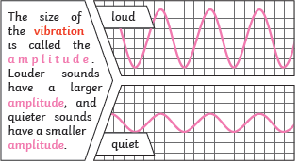
LO: I am investigating the relationship between sound and distance:  Success criteria: I can  - Demonstrate how the distance I am from the source affects ,the volume at which I hear the sound  - Describe this in terms of decibels and amplitude  - Challenge: consider other factors that affects volume | 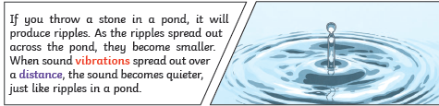

PLEASE SEE KNOWLEDGE ORGANISER FOR ALL KEY VOCAB AND DEFINITIONS

