LO and SC | Knowledge organiser
LO: I can compare and group different materials according to whether they are solids, liquids of gases.  SC: I can:  - Demonstrate how the particles in solids, liquids and gases are arranged differently  - Explain and name the different states of water  - Give examples of different solids, liquids and gases  - Challenge: I can prove and explain why sand is a solid and syrup is a liquid (or similar) | 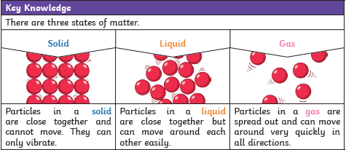
LO: I am investigating how some materials change state when there is a change in temperature and record this appropriately and the temperature at which these happen for water (0dgrees/100degrees)  SC: I can:  - Investigate what happens when a material is heated  - Investigate what happens when a material is cooled  - Use the terms freezing, evaporation, condensation and melting to describe these changes  - Challenge: consider how I could reverse this change | 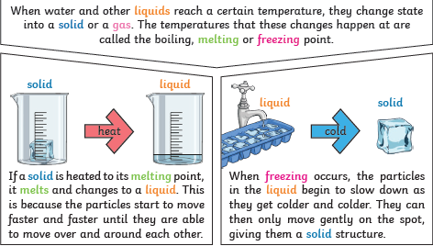
LO: I can understand how evaporation and condensation in the water cycle is important.  SC: I can:  - Label the different stages of the water cycle  - Link this to weather  - Challenge: consider factors that may affect the water cycle | 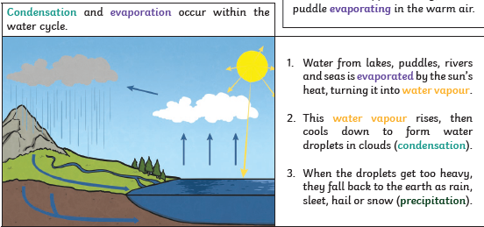  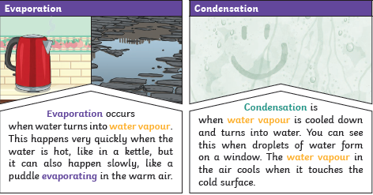

PLEASE SEE KNOWLEDGE ORGANISER FOR ALL KEY VOCAB AND DEFINITIONS

