LO and SC | Knowledge organiser
LO: I can identify and compare living things and group them by their characteristics  SC: I can:  - Explain that all living things, which can also be called organisms, have to do certain things to stay alive.  - Identify the life processes: • movement • respiration • sensitivity • growth • reproduction • excretion • nutrition  - Give examples of how living things can be grouped according to different criteria (where they live, what type of organism they are, what features they have)  - Challenge: Compare life processes in different organisms | 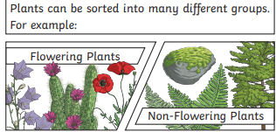  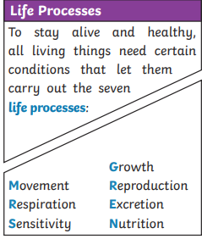
LO: I can use a classification key and identify and name a variety of living things in my local and wider environment.  SC: I can:  - Explain how a classification key is a tool that is used to group living things to help us identify them.  - Use a classification key  - Challenge: create my own classification key | 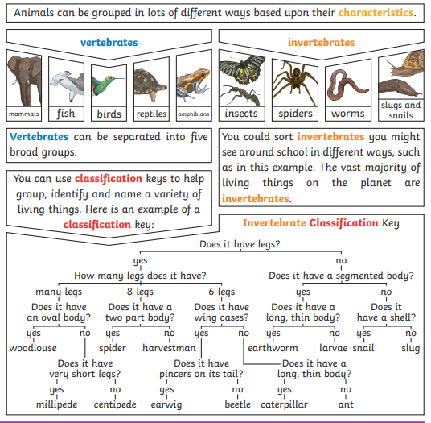
LO: I can understand that the environment can change and that can sometimes be dangerous to living things  SC: I can:  - Explain how habitats can change throughout the year and how this can have an effect on the plants and animals that live there.  - Give examples of how humans can have positive and negative effects on the environment e.g. positive effects: nature reserves, ecological parks / negative effects: litter, urban development  - Challenge: I can consider how an environment would be affected by humans leaving it | 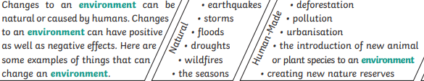  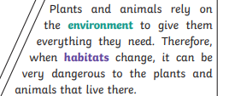

PLEASE SEE KNOWLEDGE ORGANISER FOR ALL KEY VOCAB AND DEFINITIONS

