LO and SC | Knowledge organiser
Unit: Animals inc. humans  LO: I can describe the changes of the human life cycle:  SC – I can:  - Describe the different stages within a human’s life cycle  - Identify the reproductive organs in humans  - Describe how humans change during puberty to allow them to reproduce  - Explain how fertilisation takes place in order for a baby to be reproduced  - Compare life cycles of mammals, amphibians, insects and birds  - Challenge: contrast the reproductive processes of animals and plants | 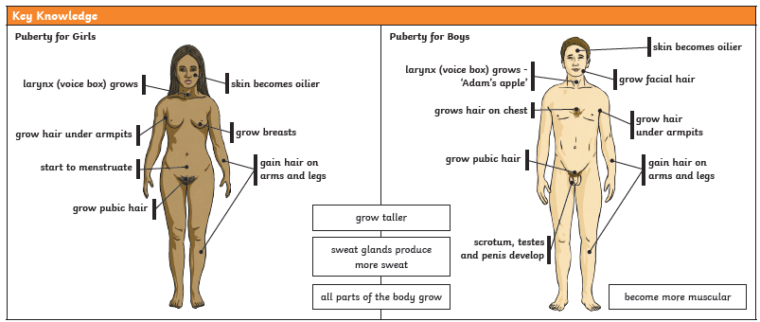  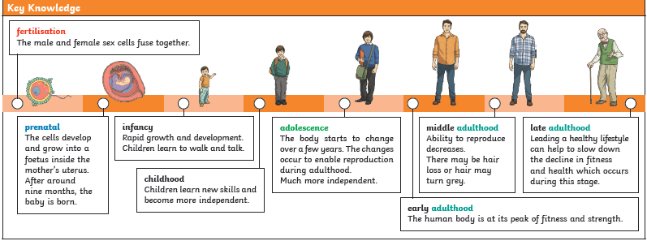
Extension - LO: I can investigate whether the size of animal relates to the gestation period
SC – I can:
- Research gestation periods of different animals
- Research the size of different animals
- Record findings in a table
- Use Excel to create a line graph of my results (Computing link)
- Describe the pattern of the results

PLEASE SEE KNOWLEDGE ORGANISER FOR ALL KEY VOCAB AND DEFINITIONS

