LO and SC | Knowledge organiser
LO: I can describe the shape of the Earth, Sun and Moon, using scientific vocabulary  SC – I can:  - Identify the three dimensional shape of celestial bodies  - Compare this to other planets in our solar system  - Consider how this affects how the celestial bodies can move  - Name the planets in the solar system  - Compare other physical features of planets that make them similar and different | 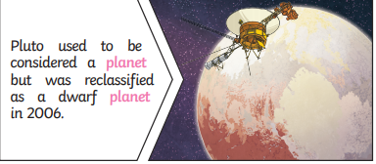  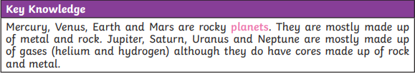  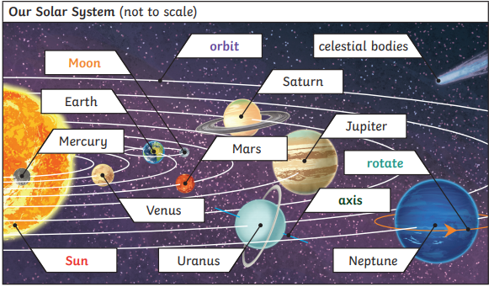
LO: I can describe the movement of the Earth and other planets in relation to the sun and the solar system.  SC – I can:  - Demonstrate what is meant by orbit  - Demonstrate what is meant by rotate  - Use these terms to describe how the solar system moves  - Challenge: compare and contrast the time it take for each planet to complete a full rotation and a full orbit. Can you spot any patterns? | 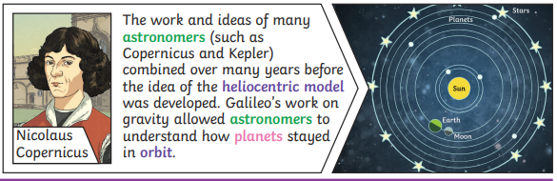  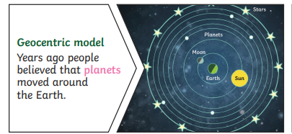
LO: I can investigate the Earth’s rotation and explain how this leads to day and night.  SC – I can:  - Identify the Earth’s axis  - Show how the Earth moves in relation to the sun  - Investigate (using concrete objects and light sources) how different parts of the Earth receive different amounts of light throughout the day  - Challenge: link this to time zones | 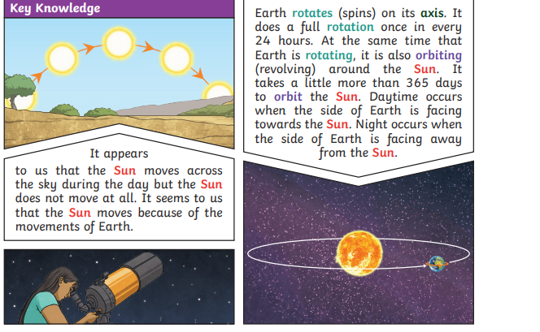
LO: I can describe the movement of the moon relative to the Earth.  - Show how the moon moves around the Earth  - State how long a complete orbit takes  - Investigate (using concrete objects and light sources) why the moons appearance seems to change as it orbits the Earth  - Challenge: consider how a lunar or solar eclipse may occur | 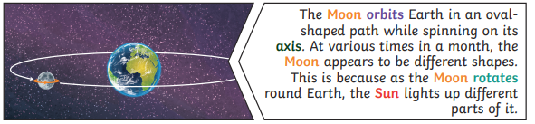

PLEASE SEE KNOWLEDGE ORGANISER FOR ALL KEY VOCAB AND DEFINITIONS

