LO and SC | Knowledge organiser
LO: I can explain the effect of gravity  SC - I can:  - Show gravity in action  - Relate this to the Earth’s gravitational pull  - Describe the difference between mass and weight  - Challenge: compare gravity to existing knowledge on magnets | 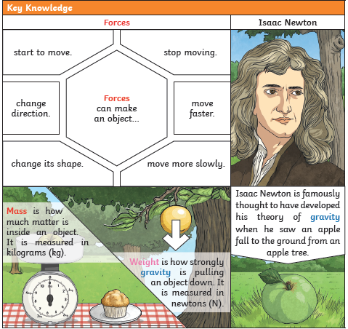
LO: I can compare different types of resistances between moving surfaces.  SC - I can:  - Describe how forces can change an object  - Demonstrate the direction in which air resistance, friction, buoyancy and water resistance act on an object  - Plan and carry out a fair test to find ways to reduce the impact of any one of these resistances on the movement of an object  - Write a scientific conclusion to summarise my findings  - Challenge: compare and contrast different resistances e.g. does reducing the air resistance on an object also affect the water resistance? | 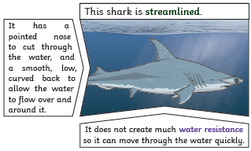  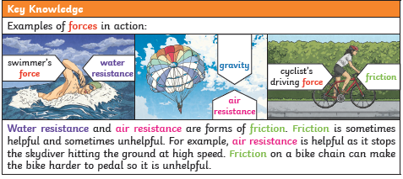
LO: I am investigating how force is used to create mechanisms  SC - I can:  - Identify pulleys, gears/cogs and levers  - Hypothesise how these affect the amount of force needed to move an object  - Carry out tests to prove these hypotheses  - Challenge: find examples of these mechanisms being used within and beyond the school | 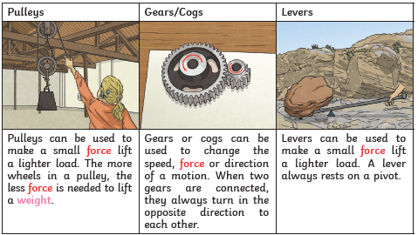

PLEASE SEE KNOWLEDGE ORGANISER FOR ALL KEY VOCAB AND DEFINITIONS

