LO and SC | Knowledge organiser
Unit: Living things and their habitat  LO: I can identify mammals, amphibians, insects and birds  SC – I can:  - Classify animals by their features  - Say what makes each group similar or different  - Challenge: Identify animals that are difficult to place in one group and explain my reasoning. | 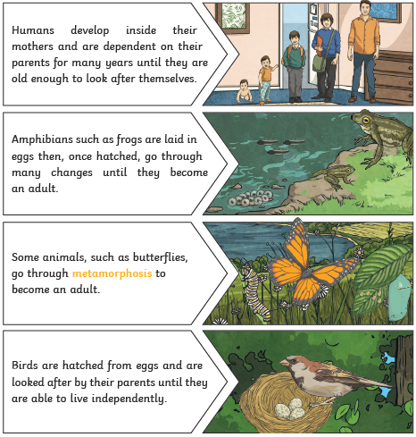
LO: I can describe the life process of reproduction of animals  SC – I can:  - Describe the life cycles of an insect, a bird, a mammal and an insect  - Compare and contrast these life cycles  - Give an example of an animal that goes through metamorphosis  - Challenge: How might the environment affect an animal’s life cycle? | 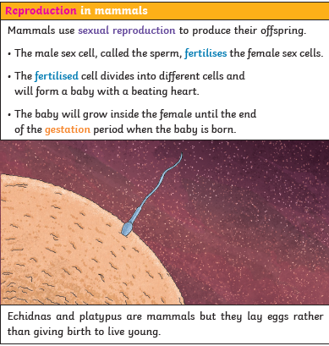
LO: I can describe the life process of reproduction of a plant.  SC – I can:  - Explain what reproduction means  - Identify the reproductive organs on a plant, through dissection  - Describe the difference between how sexual and asexual production works in plants  - Produce a step by step guide to how plants reproduce  - Challenge: investigate different ways that seeds are dispersed | 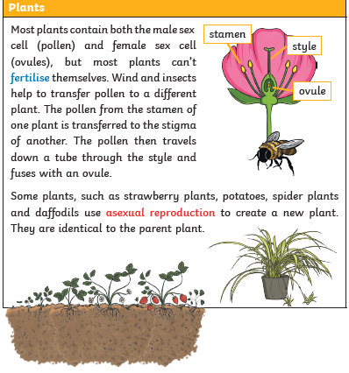

PLEASE SEE KNOWLEDGE ORGANISER FOR ALL KEY VOCAB AND DEFINITIONS

