LO and SC | Knowledge organiser
LO: I can compare different materials based in their properties.  SC – I can:  - Explain whether an object is hard, soluble, transparent, conductive to electricity or magnetic  - Give ways to test these properties  - Use these properties to group objects (including within Venn diagrams)  - Use these properties to explain how wood, metal and plastic are used in every-day life  - Challenge: I can consider other ways that I can classify materials | 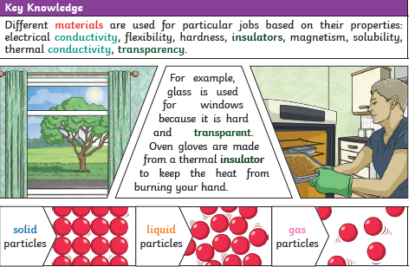
LO: I can identify which materials will change state  SC – I can:  - Describe the particle structure of solids, liquids and gases  - Identify processes that will change the state of an object e.g. changes in heat  - Carry out observations to describe what happens when a material is heated or cooled  - Challenge: identify some materials that need extreme conditions to change state | 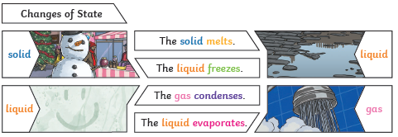
LO: I can create a fair test to investigate reversible and irreversible states  SC – I can:  - Describe the difference between a reversible and irreversible change  - Explain how to carry out a fair test  - Plan a fair test in order to identify some reversible and some irreversible changes  - Record my findings  - Challenge: make links about my findings e.g. identify possible patterns | 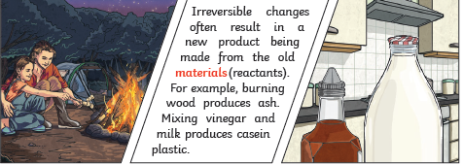  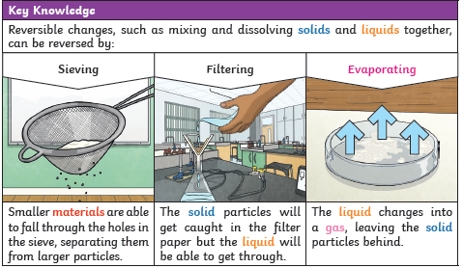
LO: I can investigate which solids dissolve  SC: I can:  - Describe how a solution is a particular sort of mixture  - Test which objects dissolve and which do not  - Recover a solid from a solution (practical)  - Challenge: consider how I could also recover the liquid | 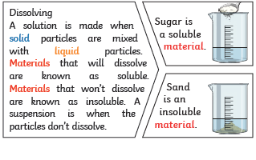
LO: I am investigating the separation of different materials
SC: I can:
- Research different ways of separating material
- Identify what equipment I will need to separate a mixture
- Consider whether the state of the two ‘ingredients’ effects my method of separation
- Challenge: consider other factors that limit the methods that I can use

PLEASE SEE KNOWLEDGE ORGANISER FOR ALL KEY VOCAB AND DEFINITIONS

