Year 6 Science – Animals including humans
LO and SC | Knowledge organiser
LO: I can identify and name the main parts of the human circulatory system  SC – I can:  - Identify the heart, lungs and the blood vessels within the circulatory system  - Describe the different roles of the arteries and veins  - Explain how nutrients, oxygen and carbon dioxide are exchanged | 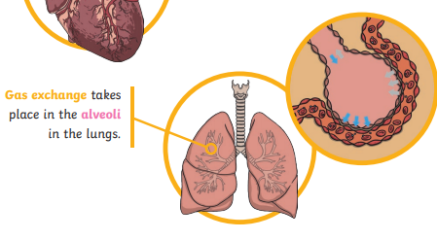  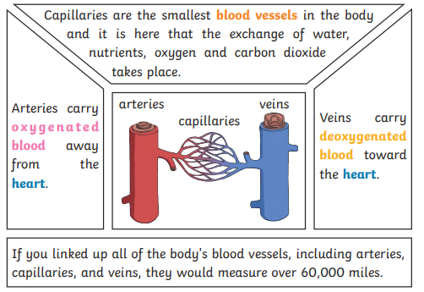  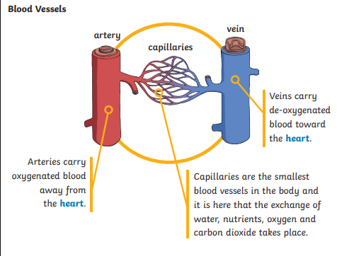
LO: I can describe the functions of the heart and what different parts do  SC – I can:  - Identify the different chambers of the heart and name them accurately  - Link pulse to the muscles in the heart pumping  - Research how and why the heart pumps  - Challenge: How does your pulse change with exercise? What is the most efficient way of presenting this data? | 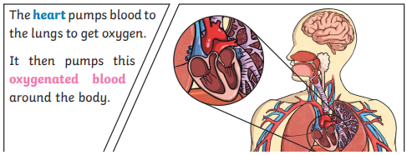  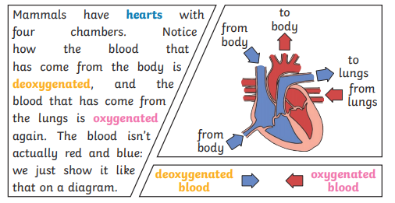
LO: I can recognise the impact of diet, exercise and drugs on my lifestyle.  SC – I can:  - Say why exercise is important and describe how it improves the function of particular organs  - Identify choices that can harm the circulatory system and research the effects that they have e.g. taking various drugs  - Investigate the impact consuming different food groups have on the circulatory system  - Challenge: plan three steps you will take to improve your own circulatory function and explain the impact that you hope these will have | 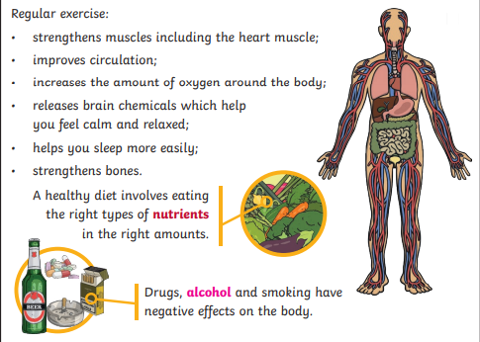  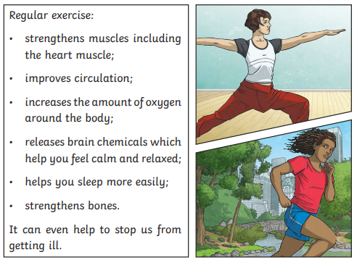  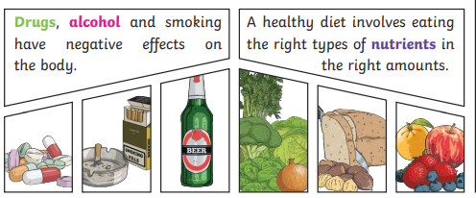
LO: I can explore how nutrients and water are transported within animals  SC – I can:  - Identify the small intestine  - Research how nutrients and water are absorbed by the small intestine  - Describe how these then reach the rest of the body  - Challenge: consider how an animal’s diet may impact on the way in which the small intestine needs to function. | 

