Year 6 Science Electricity
LO and SC | Knowledge organiser
LO: I am investigating how to make a light brighter in a circuit (where there is only one bulb) or a buzzer louder  SC – I can:  - Plan a fair test to investigate how the number of batteries affects the output of a circuit  - Explain why this might be the case  - Plan a fair test to investigate how the length of the wires affects the output of a circuit  - Research why this might be the case – Hint: it’s to do with resistance  - Challenge: what happens if I add more bulbs to the circuit? Why? | 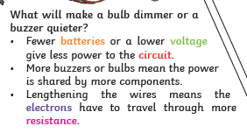  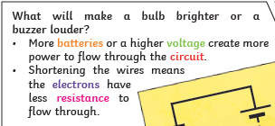
LO: I can compare and explain how different components function.  SC – I can:  - Identify the different components in a circuit  - Describe the function of each circuit  - Investigate the impact of removing that component from the circuit  - Challenge: Does the order of the components in the circuit affect the output? | 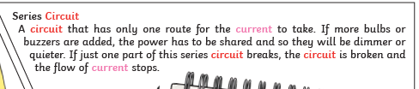
LO: I can recognise different symbols and use them to represent my own circuit.  SC – I can:  - Match components to their symbol  - Match a circuit to a circuit diagram  - Draw my own circuit diagram and then construct a circuit to match it and vice versa  - Challenge: Who might use circuit diagrams? Why? | 

