Year 6 Science – Evolution and Inheritance
LO and SC | Knowledge organiser
LO: I can recognise that living things change over time and that fossils can be used as evidence of this  SC – I can:  - Explain what a fossil is and how it is formed  - Observe fossils and use these to identify the features of an ancient organism  - Compare this to an organism that is still alive today  - Research the evolution of a particular species and relate this to adaptive traits  - Challenge: I can consider why animals and plants have had to evolve and what happens in the case of ‘bad’ adaptations | 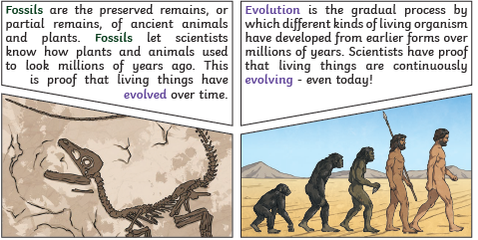
LO: I am exploring what parts of an offspring are similar their parents and why this is the case SC – I can:  - Give examples of inherited traits  - Observe which traits have been inherited by offspring  - Demonstrate how a species may change through inheritance or mutation  - Challenge: Are we exactly half of each of our parents? Why might this be? | 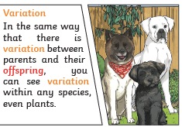  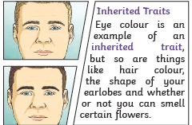  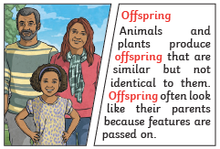
LO: I am investigating how animals and plants have adapted to their environment.  SC – I can:  - Observe how particular species have adapted to their habitats  - Compare species living in different habitats  - Consider how a species would need to change if the environment were to change e.g. through global warming  - Challenge: why do rapid environmental changes lead to some species becoming extinct? | 

