Year 6 Science – Light
LO and SC | Knowledge organiser
LO: I am investigating how light travels.  SC – I can:  - Use a light source to observe how light travels  - Prove that light is made of all the colours of the spectrum  - Identify natural and man-made light sources | 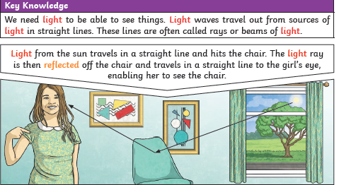  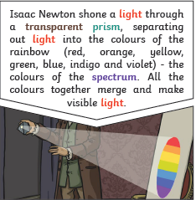
LO: I am investigating how and why objects reflect and how that impacts sight:  SC – I can:  - Reflect a beam of light  - Compare the angle of reflection to the angle of incidence  - Use this to show how we see something by the light reaching out eye  - Observe how travelling through water affects the beam of light  - Challenge: how can we see something that is not directly in our line of sight? | 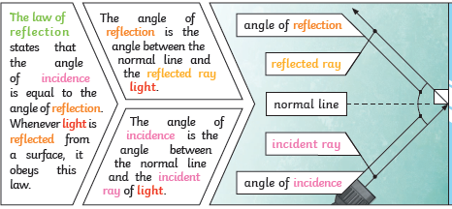
LO: I can explain how light travels in straight lines and why shadows form.  SC – I can:  - Use an opaque object to create a shadow  - Observe what shape the shadow is  - Investigate how to change the size and position of the shadow  - Use diagrams to show how this is related to light travelling in a straight line  - Challenge: why do shadows appear differently at different points in the day? | 

