Year 6 Science – Living things and their habitats
LO and SC | Knowledge organiser
LO: I can describe how living things are classified according to observable features and I can classify living things accordingly  SC – I can:  - Describe what is meant by micro-organisms, plants and animals  - Classify some examples of living things into these groups  - Say which features I have used to make this classification  - Challenge: consider some organisms than are difficult to put in one group and explain my reasons for this e.g. Which group does moss fall into? Why?  (Not actually using a classification key)  (Split into 2 lessons – one on micro organisms – the other on classification groups). | 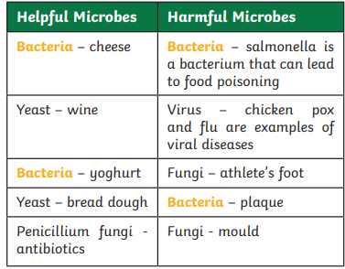  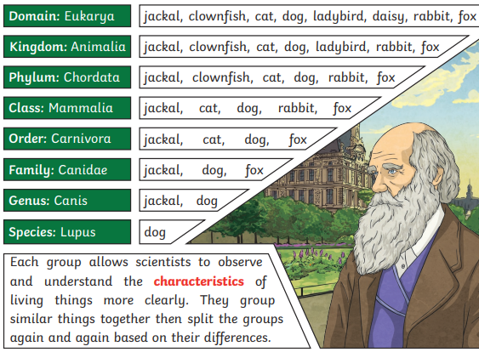  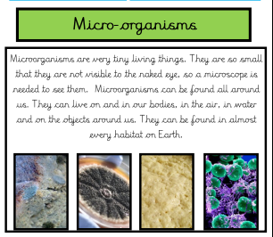  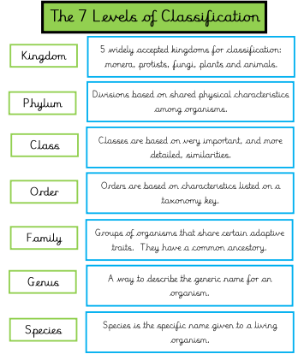
LO: I can says how living organisms are similar and different  SC – I can:  - Describe the functions that all living things have in common (MR GRENS)  - Identify how these functions are different in humans and plants  - Challenge: Why are rocks not living organisms? Is wood a living organism? | - Nothing on Knowledge organiser
LO: I can give reasons why classification is useful  SC – I can:  - Use a sorting key to classify an object  - Consider why I may need to do this  - Investigate different types of scientists who use classification  - Challenge: is classification important in any other jobs?  (One lesson researching Carl Linnaeus – Seesaw activity)  (Another lesson on classification keys) | 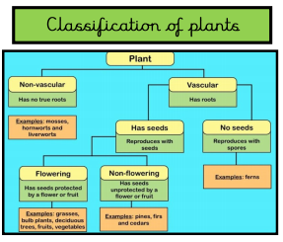  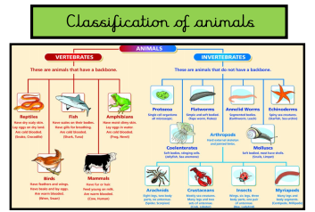
LO: I can learn about an influential scientist who influenced the classification of living things  SC – I can:  - Use a sorting key to classify an object  - Consider why I may need to do this  - Investigate different types of scientists who use classification  - Challenge: is classification important in any other jobs?  (One lesson researching Carl Linnaeus – Seesaw activity)  (Another lesson on classification keys) | 

